September 28, 2015

POLE LOADING METHODOLOGY

Prepared by:

Southern California Joint Pole Committee

INTRODUCTION

With the realization that “pole loading” analyses being conducted by the many Joint Owners and their contractors were yielding inconsistent results, representatives of the Southern California Joint Pole Committee and their contractors undertook the development of a consensus methodology for assumptions, collecting field measurements and analyzing field data such that pole analyses performed by independent parties should yield similar results. Four task groups were formed and led the development of recommendations for specific line components:
- Poles
- Anchors and Guys
- Insulators and Crossarms
- Wires
These task groups investigated the methods and practices used by various Joint Owners and their contractors for the purpose of understanding and documenting their past and current material standards, and construction, data collection, and pole loading analysis practices. This data formed the basis for developing the requirements and recommendations set forth herein.

Table of Contents

1.0 SCOPE 1
2.0 DEFINITIONS 1
3.0 GENERAL REQUIREMENTS 1
3.1 Introduction 1
3.2 Measurement and Data Collection 1
3.3 Load Cases 2
3.4 Conditions 3
4.0 POLES 4
4.1 Wood Poles 4
4.2 Manufactured Poles 11
5.0 GUYS AND ANCHORS 12
5.1 General Requirements 12
5.2 Guy Wires 12
5.3 Anchors 14
6.0 INSULATORS AND CROSSARMS 16
6.1 Insulators 16
6.2 Crossarms 18
7.0 WIRES 20
7.1 Electrical Wires 20
7.2 Communication Wires 21
7.3 Tensions 23
8.0 MISCELLANEOUS EQUIPMENT 24
C.1.0. SCOPE 25
C.2.0. DEFINITIONS 25
C.3.0. GENERAL REQUIREMENTS 25
C.3.2. Measurement and Data Collection 25
C.3.4. Conditions 25
C.4.0. POLES 27
C.4.2. Manufactured Poles 27
C.5.0. GUYS AND ANCHORS 28
C.5.2. Guy Wires 28
C.5.3. Anchors 28
C.6.0. INSULATORS AND CROSSARMS 29
C.6.1. Insulators 30
C.6.2. Crossarms 32
C.7.0. WIRES 34
C.7.1. Electrical Wires 34
C.7.2. Communication Wires 35
C.7.3. Tensions 35
C.8.0. MISCELLANEOUS EQUIPMENT 36
9.0 APPENDIX A: Insulator Data and Photos 37
10.0 APPENDIX B: SCE Wire Library 51
11.0 APPENDIX C: LADWP Wire Library 55
12.0 APPENDIX D: SCE Telco Library 57
13.0 APPENDIX E: SCE CATV Library 59
14.0 APPENDIX F: TruPulse 360/360R Range Finder 61
15.0 APPENDIX G: SCE and LADWP Pole Circuit Class ID 64
16.0 APPENDIX H: SCE LWSP Properies for SpidaCalc 66
17.0 APPENDIX I: LADWP LWSP Properties for O-Calc 72
18.0 APPENDIX J: Fiberglass Crossarm Properties 73
19.0 APPENDIX K: Wire Identification 74
20.0 APPENDIX L: Connectors, Clamps and Preforms 78
21.0 APPENDIX M: Communication Wire ID 82
22.0 APPENDIX N: Communication Equipment ID 84
23.0 APPENDIX O: Communication Cable Markers 87
24.0 APPENDIX P: Measurement Point Attributes 88
25.0 APPENDIX Q: Common Pole Attachment Dimensions 91
26.0 APPENDIX R: SCE Miscellaneous Equipment 92
27.0 APPENDIX S: LADWP Miscellaneous Equipment 95

POLE LOADING METHODOLOGY

SCOPE

This is a common Pole Loading Methodology documenting best practices for performing pole loading calculations on in-service poles and is not intended for new design. This methodology does not override any individual company standards, General Order 95 (GO 95) or Southern California Joint Pole Committee (SCJPC) agreements. This document was current as of the date on the cover page.

DEFINITIONS

Base Owner: SCJPC Member Utility that set the original pole. Refer to Section 20 of the SCJPC Routine Handbook for identification.

Joint Owner: The SCJPC Members that own any proportion of a utility pole on an undivided basis, as tenants in common.

Inspector: A person that collects data, takes measurements and/or performs pole loading calculations.

GENERAL REQUIREMENTS

Introduction

The default values stated throughout this document have been agreed upon by the SCJPC members. However, if the Inspector has knowledge of more specific values, those values may be applied.

Measurement and Data Collection

Due to inherent variability, measurements taken in the field cannot be expected to be perfect. In recognition of this variability, Table 3-1 provides best-practice tolerances for field measurements.
As a minimum, the Inspector shall collect the attribute measurements listed in Table 3-1 within the tolerances listed. (Reference APPENDIX P: Measurement Point Attributes for sketches depicting Table 3-1 attributes)

Table 3-1: Measurement Tolerances
Attribute | Consensus Tolerances
Height of Attachment  (Crossarms & Equipment) | ±1 inch
*Tangent Pole Angle Leads | ±1°
*Corner Pole Angle Leads | ±1°
*Angle to Anchor | ±1°
Change in Elevation of Anchor (Anchor Height) | ±1 foot
Lead of Anchor | ±6 inches
Equipment and Conductor Offset Values | ±3 inches
Pole Embedment | ±6 inches
Pole Ground Line Circumference | ±0.5 inch
Span Length | ±5 feet
* A larger deviation on the tolerance is permissible provided the deviation is more conservative.

Note: SCE has implemented a web based database (SpidaMin) for its pole loading calculations, including reference pictures. Overtime, as SCE performs pole loads on its poles, the calculations will be added to the database. The database is available to all attachers. Inspectors are encouraged to use the database for all SCE poles.

Load Cases
All components shall be capable of supporting the loads specified in GO95 Rule 43.1 (Heavy Loading) or Rule 43.2 (Light Loading) as applicable, for the given grade of construction as required by Rule 43 and with the safety factors required by Rule 44.
Furthermore, if known local conditions require a higher standard than specified in GO95, the company shall follow the higher standard per Rule 31.1.
(Note: A future version of this document will include the loading criteria to be used once the fire threat zones are established pursuant to R.08-11-005.)

GO 95 describes typical Distribution circuits:
- Class H: 5 kV and above but less than 300 kV
- Class L: less than 5 kV
- Class C: communications

For reference purposes, the applicable safety factors for the components discussed herein are listed in Table 3-2.
Table 3-2: Minimum Safety Factors
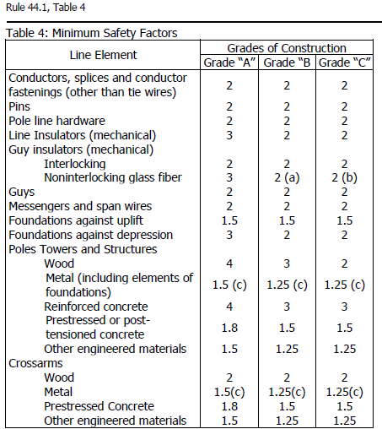

Conditions

As-Built
Any field changes made to pole configurations that deviate from the design as shown in the pole calculation shall require a new pole load analysis to be completed.

Damage Assessment

When facilities are found to be damaged, the damage shall be accounted for in the pole loading calculation.

Inspectors shall follow GO95 Rule 18-B, Notification of Safety Hazards when a safety hazard is discovered. (Reference Section C.3.4.2: Damage Assessment)

POLES

Wood Poles

Physical Properties
The properties in Table 4-1 shall be used for wood pole analysis purposes:
Table 4-1: Wood Pole Properties
 | Modulus of Rupture (psi) | Density (pcf) | Poisson's Ratio | Modulus of Elasticity (psi) | Taper (in/ft)
Douglas Fir | 8,000 | 60 | 0.3 | 2.38 | 0.21
Douglas Fir with through-boring at groundline - 5% reduction | *7,600 | 60 | 0.3 | 2.38 | 0.21
Western Red Cedar | 6,000 | 50 | 0.3 | 1.59 | 0.38
Ponderosa Pine | 6,000 | 50 | 0.3 | 1.84 | 0.29
Southern Pine | 8,000 | 60 | 0.3 | 2.13 | 0.25
*This reduced value should only be used if bending stress near groundline controls.

Measurement and Data Collection

Identifying Wood Pole Characteristics

There are three characteristics needed for the pole loading assessment:
- Species
- Class
- Length
These characteristics may be identified with visible brands either burned into the pole (Figure 4-1) or a medallion nailed to the pole (Figure 4-2).
Lengths can also be determined by a length nail (Figure 4-3) located below and to the left of the original pole tag. Also, year set date nails (Figure 4-3) can be found below and to the right of the original pole tag.

Figure 4-1: Burned into Pole
Species: WC – Western Cedar  Class: 1  Length: 75 feet | Species: DF – Douglas-fir  Class: 5  Length: 45 feet | Species: SP – Southern Pine  Class: 4  Length: 45 feet
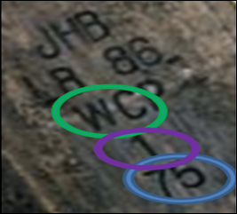  Western Cedar | 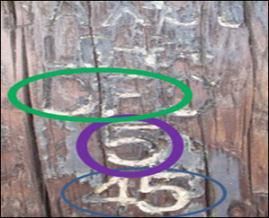  Douglas Fir | 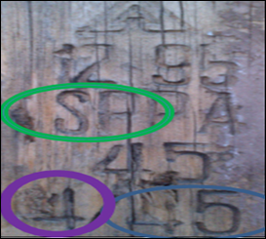  Southern Pine

Figure 4-2: Medallion
Species: WC – Western Cedar  Class: 2  Length: 70 feet | Species: DF – Douglas-fir  Class: 1  Length: 55 feet | Species: WP – Western Pine  Class: 5  Length: 35 feet
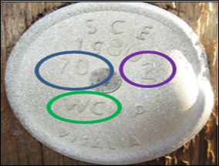  Western Cedar | 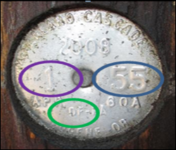  Douglas Fir | 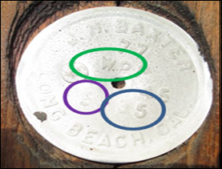  Western Pine
Note: If a through-bored pattern of ½ inch holes extending 18" – 24” above groundline is found, the pole is a Douglas Fir. However, not all Douglas Fir poles are through-bored.
Figure 4-3: Length (45 & 50 ft.) and Date (1965&1964) Nails

Determining Groundline (GL) Location
It is important that a repeatable GL location is determined so consistent measurements can be obtained on all poles. There are two measurements impacted by groundline location:
- GL Circumference
- Attachment heights determined from the GL measurement point (See Figure 4-4)
Figure 4-4: Attachment Height above GL Measurement Point
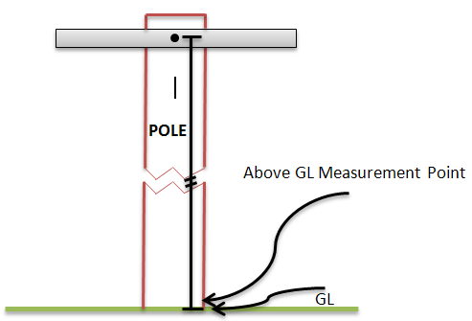

Methods to Determine GL Location for Various Scenarios:
- Level Grade
If the pole is set on a level grade, the GL is defined as the point where the pole touches the earth. The GL circumference and attachment height measurements shall be in reference to this point. (See Figure 4-5)
Figure 4-5: Level Grade

- Dirt Mound
  - The GL circumference measurement shall be taken at the top of the mound. No taper adjustment factor is to be applied. (See Figure 4-6)
  - The GL location for measuring attachment heights above GL shall be the lowest point at which the natural grade intersects with the pole. (See Figure 4-6)

Figure 4-6: Dirt Mound
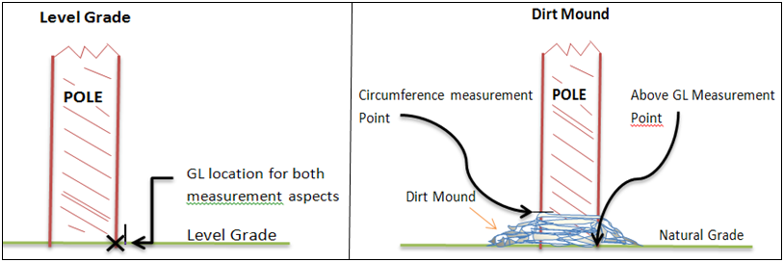

- Level Grade with an Obstruction
  - If the obstruction is less than or equal to 1 foot above the natural grade, the GL Circumference measurement shall be taken at the top of obstruction. No taper adjustment factor is to be applied. (See Figure 4-7)
  - If the obstruction is greater than one foot from the natural grade, measure up the pole three feet from the natural grade, measure the pole circumference and add the taper adjustment factor. (See Figure 4-7 & Table 4-2 for taper adjustment factor)
  - The GL location for measuring attachment heights above GL shall be the lowest point at which the natural grade intersects with the pole. (See Figure 4-7)

Figure 4-7: Obstructions ≤1ft and >1ft from the Natural Grade
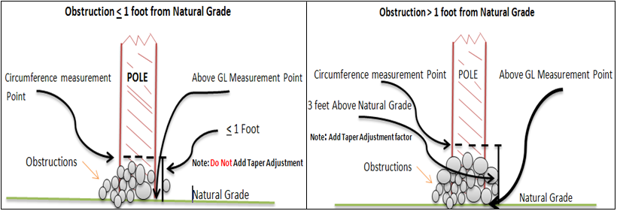

Table 4-2: Taper Adjustment Factors
The taper adjustment shall be calculated as follows: Measured circumference at 3 Feet above GL + Taper Adjustment Factor = Adjusted GL Circumference
Taper Adjustment Factors
Douglas Fir | Western Red Cedar | Pine (All)
1/2 inch | 1 inch | 1/2 inch

- Slope Grade
  - If the highest point is one foot or less from the lowest point, the GL circumference measurement shall be taken at the highest point at which the slope grade intersects with the pole. No taper adjustment factor is to be applied. (See Figure 4-8)
Figure 4-8: Slope Grade ≤1 foot
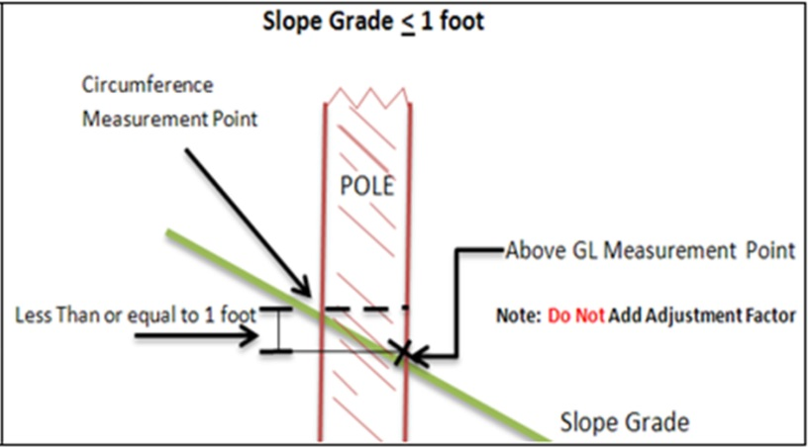

  - If the highest point is greater than one foot from the lowest point, measure up the pole three feet from the lowest point at which the slope grade intersects with the pole. At that three foot measurement point, measure the pole circumference and add the taper adjustment factor. (See Figure 4-9 & Table 4-2 for taper adjustment factor)
  - The GL location for measuring attachment heights above GL shall be the lowest point at which the slope grade intersects with the pole. (See Figure 4-9)
Figure 4-9: Slope Grade ≥1 foot
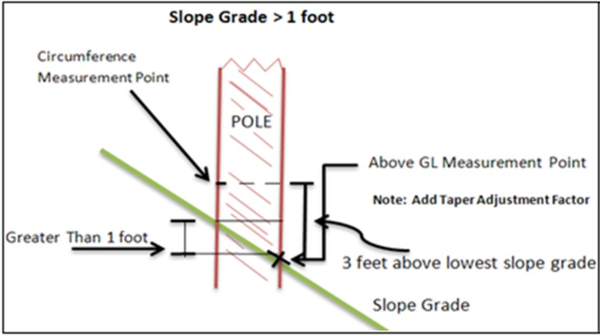

- Erosion
  - If the natural grade is one foot or less from the lowest erosion point, the GL circumference measurement shall be taken at the highest point at which the natural grade intersects with the pole. No taper adjustment factor will be applied. (See Figure 4-10)
  - If the natural grade is greater than one foot from the lowest erosion point, measure up the pole three feet from the lowest erosion point. At that three foot measurement point, measure the pole circumference and add the taper adjustment factor. (See Figure 4-10 & Table 4-2 for taper adjustment factor)
  - The GL location for measuring attachment heights above GL shall be the lowest erosion point at which earth contacts the pole. (See Figure 4-10)
Figure 4-10: Erosion ≤1ft and >1ft from the lowest point
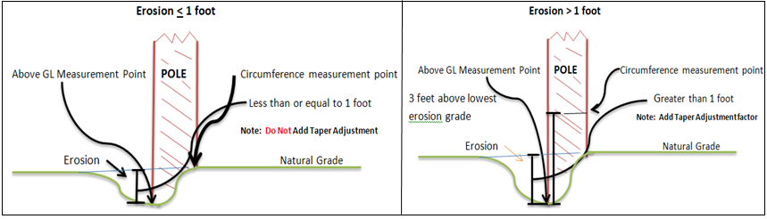

Measuring Groundline Circumference
SAFETY NOTE: Prior to measuring GL circumference, ensure there are no exposed conductors at the base of pole. If an exposed conductor is found at the base of pole, perform the measurement at 3 feet AGL if no exposure issue exists at the 3’ AGL level. Use Table 4-2 to adjust for taper.

GL circumference measurements shall be taken as close to the groundline as possible. The measurements shall be taken by wrapping a flat tape, such as a Loggers tape or d-tape, around the pole, keeping it perpendicular, or 90 degrees to the pole’s longitudinal axis. If risers are present, measurements shall be taken behind the risers to get a clean GL circumference. However, if there is a wood ground molding, for safety reasons do not measure behind the molding. In such situations, the pole circumference shall be obtained by measuring over the top of the wood ground molding and then subtracting ¾ of an inch from the measured circumference.
If a U-Guard riser obstructs taking a pole circumference measurement, for safety reasons do not measure behind the U-Guard riser. Instead, the measurement shall be attained in the following way:
- Measure the available surface of the pole between obstructions (Figure 4-11)
- Caliper the width of the riser and/or U-Guard (Obstructions) (Figure 4-12)
- Add the measurements together (See below example)
Available Surface | Calipered Obstructions | GL Circumference
64” (Figure 4-11) | 3.7” (Figure 4-12) | = 67.7”

Figure 4-11: Measurement of available surface with Loggers Tape (64”)
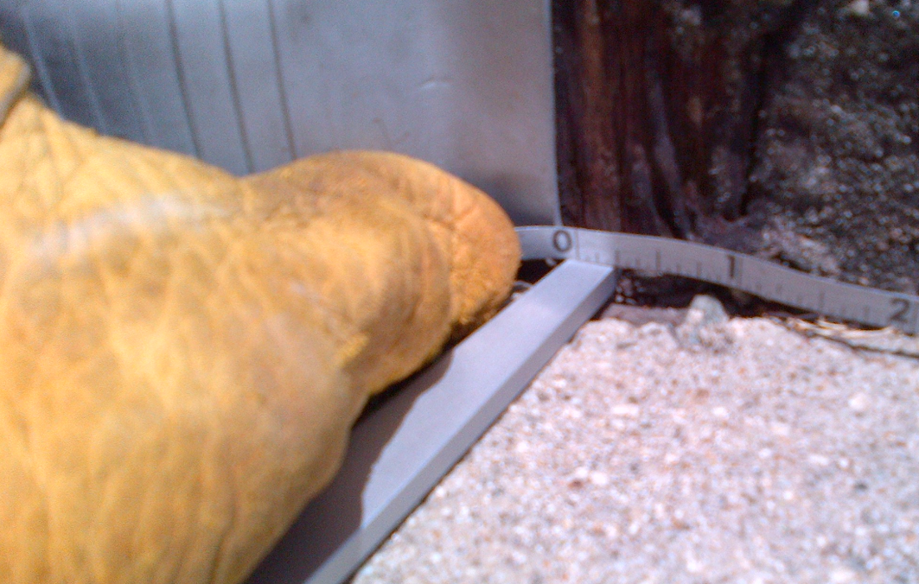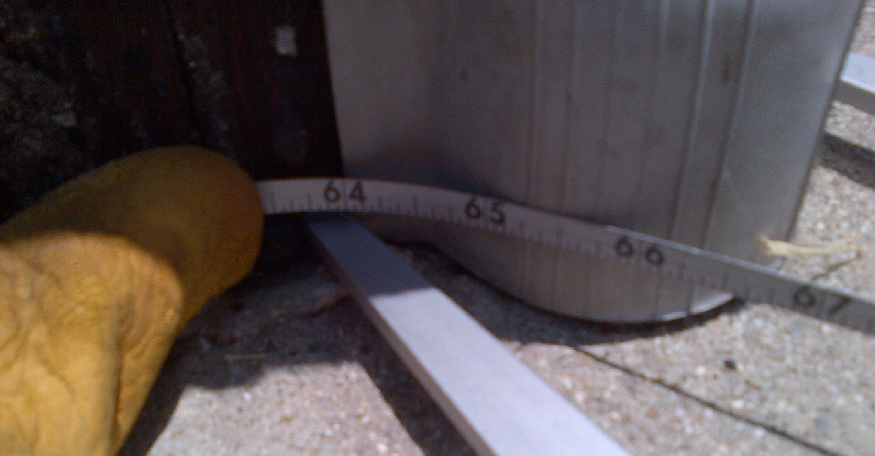

Figure 4-12: U-Guard Measurement with Calipers (3.7”)
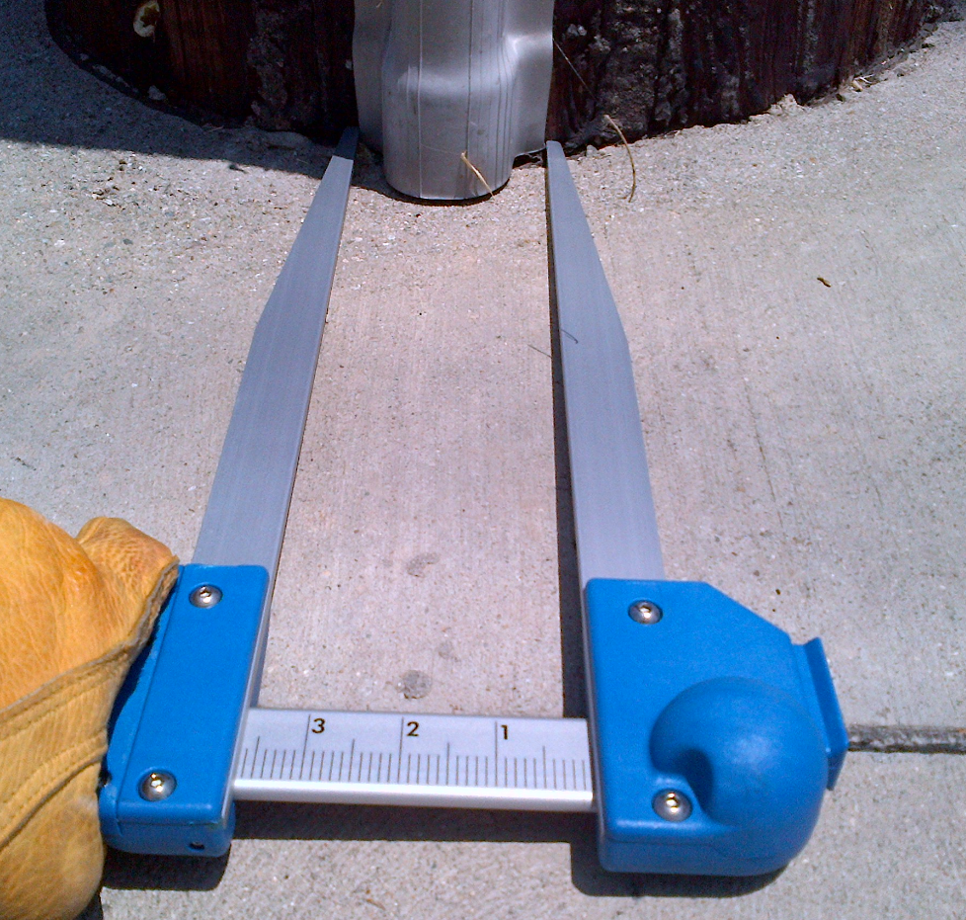

Condition Assessment
GO95 Rule 44.2 requires intrusive inspection results to be incorporated into pole loading calculations on wood poles more than 15 years old. Pole Loading Calculations shall include the findings of the most recent intrusive pole inspection, which shall be requested from the Base Owner.

Manufactured Poles

Steel Poles
The analyses of steel poles shall be in compliance with the provisions set forth in ASCE Standard 48-11, Design of Steel Transmission Pole Structures.

Physical Properties
The appropriate input properties listed in APPENDIX H: SCE LWSP Properies for SpidaCalc shall be applied when SpidaCalc is used to perform a pole analysis and those in APPENDIX I: LADWP LWSP Properties for O-Calc shall be applied when using O-Calc. If the steel pole being analyzed is not listed in either table, the Base Owner shall be contacted requesting the appropriate properties.

Concrete, Fiber-reinforced and Ductile Iron Poles

Physical Properties
Contact Base Owner for physical properties.

GUYS AND ANCHORS

General Requirements
In determining the correct safety factor to be used for guying, the following rules shall be applied:
- If a pole is being replaced, all guying components shall pass with a safety factor of 2.0.
- If a Down Guy or Span Guy is replaced due to damage or a change in size, that particular guy shall meet a safety factor of 2.0. (exception in rural areas)
- If rearranging facilities on a pole, but not changing/adjusting the Down Guy or Span Guy (i.e. wire replacement or equipment change), it shall meet a safety factor based on the appropriate grade for in-service structures.

Guy Wires

Physical Properties
All existing guy wires are stranded steel cables that are classified as either high strength (HS) or extra high strength (EHS). Table 5-1 lists the various guy sizes and strength values currently in use by the various Joint Owners.
If the guy cannot be determined to be high strength or extra high strength, the default selection shall be a high strength guy.

Table 5-1: Guy Wire Sizes and Maximum Rated Breaking Strength Values (lbs)
Size |  | SCE | Verizon | AT&T | SDG&E | LADWP | T- Mobile | Cox | Rated Breaking Strength (lbs)
 | 7/32" | O (4,800) |  |  |  |  |  |  | 4,800
2.2M |  |  |  | C
4M | 1/4" | O (4,750) | C | C | C | C- HS (4,750) | C |  | 4,750
6.6M | 1/4" | O | C (6,650) | C | C (6,650) |  |  | *C- EHS (6,650) | 6,650
 | 9/32" | *C- EHS (8,950) |  |  |  |  |  |  | 8,950
6M | 5/16" | O (8,000) |  |  | O (6,000)
 | 5/16" |  | *C- EHS (11,200) |  |  |  |  | *C- EHS (11,200) | 11,200
10M | 3/8" | *C- EHS (15,400) |  |  | C (11,500) | C- HS (10,800) |  | C- EHS (15,400)
16M | 7/16" | *C- EHS (20,800) | C (20,800) | C | C (18,000) | C- EHS (20,800) |  |  | 20,800
25M | 1/2" | O | C (26,900) |  | C (25,000) |  |  |  | 26,900
26M |  |  |  | C
32M |  |  |  | C
O= Not approved for new install; C= Currently in use; Blank = No history of use; *represent most commonly used sizes

Measurement and Data Collection
The following describes the measurements that shall be made and the processes that shall be used in collecting field data on down guys: (See APPENDIX P: Measurement Point Attributes)
- Guy Height shall be measured from the through bolt of the cleat to where the groundline circumference is taken.
- Guy Diameter shall be measured by using a wire gauge to determine size. Alternatively, if the diameter of the span guy or messenger is known, the guy can be assumed to have the same diameter.
- Span guys should be similar in size to the down guy that is backing it up. If no such down guy exists, Table 5-1 shall be used to determine guy sizes and strengths used by each Joint Owner.

Condition Assessment
When down guys are found to be damaged, the damage shall be accounted for in the pole loading calculation.

Anchors

Physical Properties
Refer to Table 5-2 for anchor rod lengths if a default needs to be selected. Values marked with asterisks are lengths that shall be used for analysis purposes when the actual length is unknown.
On shared anchors, the shortest common length shall be selected from the companies attached to the anchor. For example, select 6ft if the following companies were attached to the same anchor:
- ATT common size is 8ft
- Charter common size is 6ft

Since anchors are buried, it is not possible to assume proper selection due to the variety of types used (Reference Section C.5.3.1). If available field data is insufficient to determine an appropriate value for an anchor’s holding strength, then a new anchor shall be set for use with additional guying that is required by each Joint Owner.

Table 5-2: Anchor Rod Lengths
Length (ft) | SCE | ATT | Charter | LADWP | SDG&E | Cox | Verizon
5.5 |  |  |  |  |  |  | X
6 | X |  | *X |  |  |  | X
7 | *X | X |  | *X |  |  | *X
8 | X | *X |  |  | X | *X | X
9 |  | X |  |  |  |  | X
10 | X | X |  | X | *X |  | X
14 |  |  |  |  | X
*most commonly used sizes

Measurement and Data Collection
Field measurements of anchors generally require the collection of four data points. The following describes the measurements that shall be made and the processes that shall be used: (See APPENDIX P: Measurement Point Attributes)
- Anchor Leads shall be the distances measured from the face of the pole to where the anchor enters the ground.
- Anchor Heights shall be the measured elevation differences between where the GL circumference was taken and the elevation where the anchor rod enters the ground.
- Anchor Rod Diameters shall either be measured with calipers, or by using a tape to measure the rod circumferences and then dividing the circumferences by π.
- Anchor Angles shall be measured in direct relationship to the other attachment angles on the pole. Example: If true North is utilized at 0 degrees, then the anchor angle will be relative to 0 degrees.

The Inspector shall use caution when taking these measurements because the required inputs and measurement methods vary depending on the pole loading software being used. For example, some software requires that measurements be taken to the center of the pole rather than to the face of the pole. The Inspector must be familiar with the software requirements in order to ensure the most accurate pole loading possible.

Condition Assessment
If an accurate assessment of minimum anchor strength cannot be determined based on field data collection, any new guys shall be placed on a newly installed anchor.

INSULATORS AND CROSSARMS

Insulators

Physical Properties

The properties in Table 6-1 shall be used for insulator properties. (Reference Figure 6-1 for Table 6-1 characteristics.)

Figure 6-1: Insulator Material Specification (Table 6-1) Characteristics
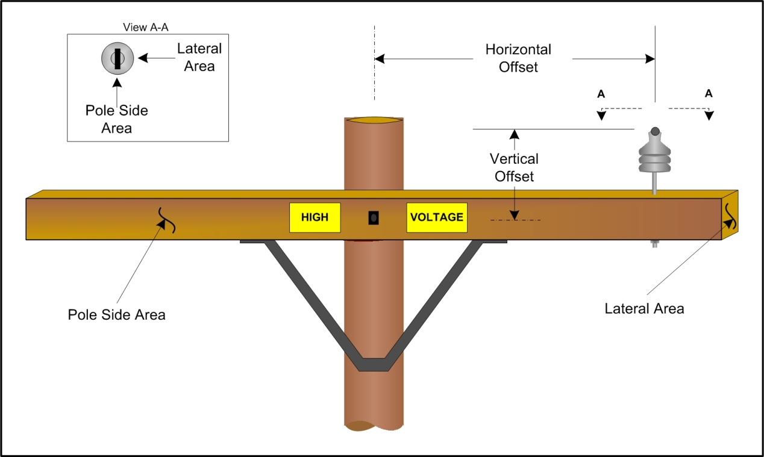

Table 6-1: *Insulator Material Specification
Type | Voltage (kV)** | Horizontal Offset (inches) | Vertical Offset (inches) | Maximum Rated Strength (lbs) | Length (inches) | Width (inches) | Weight (lbs) | Lateral Area (ft²) | Pole Side Area (ft²) | Bolt Hole Diameter (inches) | Polymer or Porcelain | Circuit Class | Owner
Pin or Post | 4 | 0 | 4 to 15 | 2,800 | 8.50 | 7.50 | 2.60 | 0.44 | 0.44 | 1/2 | Polymer | H | SCE
Pin or Post | 4.8**** | 0 | 0 | 2,500 | 7.00 | 4.00 | 4.00 | ***** | ***** | 5/8 | Porcelain | H, L | LADWP
Pin or Post | 4.8 | 0 | 0 | 3,000 | 9.00 | 8.00 | 2.00 | ***** | ***** | 5/8 | Polymer | H | LADWP
Pin or Post | 4.8 | 0 | 0 | 3,000 | 7.00 | 5.00 | 5.00 | ***** | ***** | 5/8 | Porcelain | H | LADWP
Pin or Post | 12 | 0 | 7 to 13 | 2,800 | 8.50 | 7.50 | 17.00 | 0.44 | 0.44 | 1/2 | Polymer | H | SCE
Pin or Post | 16 | 0 | 11 to 17 | 3,000 | 8.50 | 7.50 | 26.00 | 0.44 | 0.44 | 1/2 | Polymer | H | SCE
Pin or Post | 33 | 0 | 10 to 11 | 3,000 | 10.25 | 7.50 | 15.00 | 0.53 | 0.53 | 1/2 | Polymer | H | SCE
Pin or Post | 34.5 | 0 | 0 | 2,800 | 20.00 | 8.00 | 6.00 | ***** | ***** | 3/4 | Polymer | H | LADWP
Pin or Post | 34.5 | 0 | 0 | 2,800 | 17.00 | 10.00 | 44.00 | ***** | ***** | 3/4 | Porcelain | H | LADWP
Pin or Post | 66 | 0 | 24 | 2,800 | 31.00 | 7.00 | 15.00 | 1.51 | 1.51 | 1/2 | Both | H | SCE
Deadend, Running Angle, Suspension | *** | 0 | 0 | 2,500 | 5.00 | 3.00 | 2.00 | ***** | ***** | 5/8 | Porcelain | L | LADWP
Deadend, Running Angle, Suspension | 4 | 12.5 | -12.5 | 15,000 | 12.70 | 3.95 | 1.50 | 0.09 | 0.35 | 1/2 | Polymer | H | SCE
Deadend, Running Angle, Suspension | 4.8 | 0 | 0 | 15,750 | 13.00 | 6.00 | 1.00 | ***** | ***** | 5/8 | Polymer | H | LADWP
Deadend, Running Angle, Suspension | 4.8 | 0 | 0 | 15,750 | 8.00 | 6.00 | 5.00 | ***** | ***** | 5/8 | Porcelain | H | LADWP
Deadend, Running Angle, Suspension | 12 | 12.5 | -12.5 | 15,000 | 12.70 | 3.95 | 1.50 | 0.09 | 0.35 | 1/2 | Polymer | H | SCE
Deadend, Running Angle, Suspension | 16 | 21 | 21 | 15,000 | 17.00 | 3.95 | 1.80 | 0.09 | 0.47 | 1/2 | Polymer | H | SCE
Deadend, Running Angle, Suspension | 33 | 17 | -17 | 20,000 | 19.00 | 3.95 | 2.50 | 0.09 | 0.52 | 1/2 | Polymer | H | SCE
Deadend, Running Angle, Suspension | 34.5 | 0 | 0 | 20,000 | 25.00 | 6.00 | 2.00 | ***** | ***** | 5/8 | Polymer | H | LADWP
Deadend, Running Angle, Suspension | 34.5 | 0 | 0 | 20,000 | 29.00 | 10.00 | 50.00 | ***** | ***** | 5/8 | Porcelain | H | LADWP
Deadend, Running Angle, Suspension | 66 | 36 | -36 | 20,000 | 34.00 | 6.50 | 45.00 | 0.23 | 1.53 | 1/2 | Both | H | SCE
Deadend, Running Angle, Suspension | 115 | 48 | -48 | 20,000 | 46.00 | 6.50 | 45.00 | 0.23 | 2.08 | 1/2 | Both | H | SCE
Horizontal Line Post | 66 | 32 | -1 | 2,800 | 43.00 | 7.00 | 20.00 | 1.33 | 0.64 | 15/16 | Both | H | SCE
Horizontal Line Post | 115 | 47 | 0 | 2,800 | 54.00 | 7.00 | 20.00 | 1.95 | 0.64 | 15/16 | Both | H | SCE
*Takes the worst case for each field (i.e. heaviest weight by voltage, lowest Maximum Rated Strength, etc.); ** Supports conductors up to specified voltage (kv);
***120/240/480 voltage; **** 4.8 KV and 120/240/480 LADWP Voltage; ***** LADWP uses O-Calc. O-Calc does not require Lateral or Pole Side area on insulators to perform calculations.

Measurement and Data Collection

Inspectors shall use the photos in APPENDIX A: Insulator Data and Photos to identify insulators and match with corresponding properties in Table 6-1.

Insulator type and material specifications are tied to the voltage on a circuit. Higher voltage circuits typically require additional insulator length that translates into larger insulators or additional “bells” to meet required insulator specifications. Insulator voltage can be determined by circuit via the SCJPC Pole Card or by contacting the Joint Owner. Also, general observations on wire size may help with voltage determination.

See APPENDIX G: SCE and LADWP Pole Circuit Class ID photos.

Crossarms

Physical Properties

Crossarms come in different configurations depending on their intended application. Wood arms are typically Douglas Fir in Southern California, but they may also be Southern Pine. Douglas Fir shall be the default crossarm selected for pole loading calculations if the actual properties are not known.

Non wood arms such as composite, fiberglass and steel arms are also found in Southern California.

The properties in Table 6-2 shall be used for wood crossarms.

Table 6-2 Douglas Fir Crossarm Properties
Length |  | Width (inches) | Height (inches) | Max Allowable Stress (psi) | Poisson's Ratio | Modulus of Elasticity (psi) | Density (pcf) | Weight (lbs) | Joint  Owner
(feet) | (inches)
4 | 48 | 3.75 | 4.75 | 7,400 | 0.3 | 1,920,000 | 39 | 20 | SCE
5 | 60 | 3.75 | 4.75 | 7,400 | 0.3 | 1,920,000 | 39 | 25 | SCE
6 | 72 | 3.75 | 4.75 | 7,400 | 0.3 | 1,920,000 | 39 | 29 | LADWP
8 | 96 | 3.75 | 4.75 | 7,400 | 0.3 | 1,920,000 | 39 | 39 | SCE
10 | 120 | 3.75 | 4.75 | 7,400 | 0.3 | 1,920,000 | 39 | 49 | SCE, LADWP
12 | 144 | 3.75 | 4.75 | 7,400 | 0.3 | 1,920,000 | 39 | 58 | LADWP
12 | 144 | 3.75 | 5.75 | 7,400 | 0.3 | 1,920,000 | 39 | 71 | SCE
16 | 192 | 3.75 | 5.75 | 7,400 | 0.3 | 1,920,000 | 39 | 94 | SCE

Fiberglass crossarm properties shall be obtained either from:
- APPENDIX J: Fiberglass Crossarm Properties
- Contacting the manufacturer to obtain the material properties

Measurement and Data Collection

Crossarms shall be identified in the field as wood, composite/fiberglass or steel. Typically wood arms are found on wood poles, but some composite/fiberglass poles have had fiberglass arms replaced with wood arms.

Crossarm size shall be determined in the field by one of two methods.
- Measure from the ground with a laser or booking wheel.
- Approximate the size based on the how much wood is on the arm relative to the crossarm brace.

Condition Assessment
When crossarms are found to be damaged, the damage shall be accounted for in the pole loading calculation.

WIRES

Electrical Wires

Physical Properties
SCE’s Southwire material properties shall be used for wire properties.

Reference the following for properties:

- APPENDIX B: SCE Wire Library
  - SCE’s Wire library consists of weighted averages of MOE and Expansion Coefficient for both steel and aluminum based on Southwire properties for those materials.

Measurement and Data Collection
Figure 7-1 is provided as an aid to Inspectors to determine overhead wire sizes. The diameters stated are approximate.
Figure 7-1: Overhead Wire Sizes
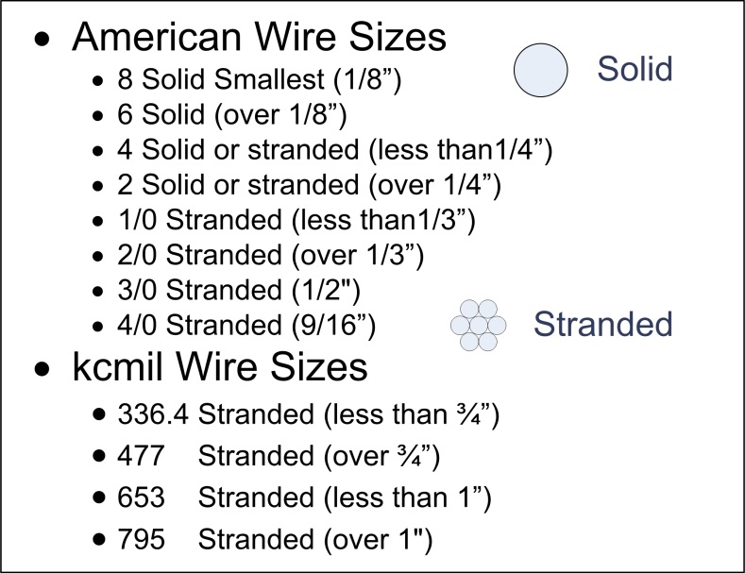

Wire type and size shall be determined using the following resources:

- Wire Identification
  - See APPENDIX K: Wire Identification for pictures of ACSR and copper:
    - ACSR Wires commonly used for Primary and rarely for Secondary. Standard sizes are 653, 336 and 1/0.
    - ACSR Wires commonly used for Secondary, but can be used for Service.
    - ACSR Wires commonly used for Secondary and Service.
    - Copper Wires used for Primary and Secondary. Typically used near coastal areas to minimize corrosion. Standard sizes are #6, #4, #2, 2/0 and 4/0.
  - Reference APPENDIX B: SCE Wire Library and APPENDIX C: LADWP Wire Library
  - Call the Joint Owner
  - See APPENDIX L: Connectors, Clamps and Preforms for pictures associated with ACSR and copper wire.
  - See APPENDIX Q: Common Pole Attachment Dimensions to aid in determining wire size.

- Establishing Wire End Points
Service Bundling Methodology: Cable and phone services shall be bundled to the same wire end point as electrical services when all services are attached to the same building. When cable and phone services are attached to a building that does not have electrical services, the cable and phone services shall be bundled to a common wire end point at the furthest communication span length. Service bundling applies to services that are not lashed to a messenger. (See example diagram in APPENDIX P: Measurement Point Attributes)

Communication Wires

Physical Properties

The properties in the following tables shall be used for communication wire:

- Table 7-1: CATV Bundle Sizes and Weights
- Table 7-2: Telco Bundle Sizes and Weights
  - Contact the owner for weight if lead wire is suspected
- Table 7-3: Messenger Sizes and Weights

Table 7-1: CATV Bundle Sizes and Weights
Coaxial Bundle  Diameter  (inches) | Coaxial Bundle Weights  (lbs/ft)*
0.75 | 0.21
1.00 | 0.32
1.25 | 0.48
1.5 | 0.52
1.75 | 0.61
2 | 0.7
2.25 | 0.87
2.5 | 1.16
2.75 | 1.25
3 | 1.41
3.25 | 1.81
3.5 | 2.17
3.75 | 2.37
4 | 2.56
*Weights include ¼” EHS messenger

Table 7-2: Telco Bundle Sizes and Weights
Telco Bundle  Diameter  (inches) | Non-Lead Cable Weight  (lbs/ft)
0.5 | 0.58
0.75 | 0.79
2 | 2.05
2.25 | 2.32
2.5 | 2.55
2.75 | 2.82
3 | 3.05
3.25 | 3.22
3.5 | 3.45

Table 7-3: Messenger Sizes and Weights
Messenger Diameter (Inches) | Messenger Weight (lbs/ft)
*7/32 | 0.098
1/4 | 0.121
*9/32 | 0.164
5/16 | 0.205
3/8 | 0.273
7/16 | 0.399
1/2 | 0.517
9/16 | 0.671
*Typically used for span guys

Measurement and Data Collection
Wire type and size shall be determined using the following resources:

- Wire Identification
  - Communication Wire ID Pictures (See APPENDIX M: Communication Wire ID)
  - Communication Equipment ID Pictures (See APPENDIX N: Communication Equipment ID)
  - Call the Joint Owner
  - Communication markers (See APPENDIX O: Communication Cable Markers)
  - See APPENDIX Q: Common Pole Attachment Dimensions to aid in determining wire size.
- Establishing Wire End Points
Service Bundling Methodology: Cable and phone services shall be bundled to the same wire end point as electrical services when all services are attached to the same building. When cable and phone services are attached to a building that does not have electrical services, the cable and phone services shall be bundled to a common wire end point at the furthest communication span length. Service bundling applies to services that are not lashed to a messenger. (See Service Bundle example in APPENDIX P: Measurement Point Attributes)

If an Inspector encounters a wire/bundle in the midrange of the diameters tabulated in Table 7-1 and Table 7-2, the Inspector shall round up to the next largest size.

Tensions

NOTE: Wire tensions have a significant effect on the results of pole loading/safety factor calculations, especially for angle and deadend structures and structures with unbalanced spans.
One of the two following sources of tension data shall be used for pole loading calculations: 1) tension values tabulated herein, or 2) tensions determined from a survey of as-built catenaries.

Physical Properties

The tension values presented in the appendices of this document shall be used.
- SCE Wires
  - APPENDIX B: SCE Wire Library
  - APPENDIX D: SCE Telco Library
  - APPENDIX E: SCE CATV Library
- LADWP Wires
  - APPENDIX C: LADWP Wire Library

The Inspector has the option of conducting a survey to calculate actual tension values in lieu of using the default tension values tabulated in the above referenced appendices.

MISCELLANEOUS EQUIPMENT

Physical Properties
The following properties in shall be used for Miscellaneous Equipment:
- APPENDIX R: SCE Miscellaneous Equipment
- APPENDIX S: LADWP Miscellaneous Equipment

Measurement and Data Collection

Condition Assessment

Assumptions

POLE LOADING METHODOLOGY
Commentary

- SCOPE
Information presented in the commentary is not included to provide Inspectors direction in performing pole load calculations. It is intended to provide background information to sections in the main body of this document that do provide direction.

- DEFINITIONS
Pre-Engineered Steel Poles: “Pre-Engineered Steel Poles” is a term that the ASCE standard uses to describe what has previously been called “Wood Pole Equivalents.” The later term is a misnomer as one should not assume that any given class of steel pole can, in fact, be directly substituted for the same class wood pole.

- GENERAL REQUIREMENTS
  - Measurement and Data Collection
The following sample of data collecting tools used by SCJPC members are presented for reference only:

- TruPulse 360/360R Range Finder (See APPENDIX F: TruPulse 360/360R Range Finder)
- Hilti PD42 Laser Range Meter
- Osmose Digital Measurement Technology (DMT)

  - Conditions
- As-Built
Requiring new pole load analyses for poles that have undergone field changes will help ensure that as-built conditions are safe and reliable and that accurate records are kept by all Joint Owners, which reflect the actual field conditions.

- Damage Assessment
Additional guidance to Rule 18-B:

The SCJPC further clarifies “safety hazard” as an existing condition in danger of failing that poses a significant threat to human life or property. The following list of safety hazards is a guideline and is not all inclusive. Discretion should be used in determining all reportable conditions.

- Poles
  - Broken/Damaged
  - Deformed
  - Excessive Lean (Rule of thumb: 1ft per 10ft)
  - Shallow (washed out, set shallow, landscaping changes)
- Anchors Rods
  - Broken/ Damaged
  - Shallow
  - Overpopulated (More guys than anchor head designed for and supplemental guy eyes – “piggybacking”)
- Ground Wires (Electric or Communication)
  - Broken (separated ground wires at any level)
  - Exposed (ground molding missing - ground-line to – 10ft)
  - Unauthorized attachment (Communication bonded to Electric ground)
- Cable Risers (Electric – all Classes)
  - Broken/Damaged w/exposed cable
- Vegetation
  - Insufficient clearance to high voltage lines
  - Contact w/ low voltage lines and deflection impacting pole
  - Contact w/ communication cables and deflection (12 inches or more) impacting pole
- Attachments
  - Crossarms
    - Broken/Damaged
  - Guys
    - Span
      - Broken/Damaged
      - Contact with other facilities
    - Anchor (Down)
      - Broken/Damaged (detached)
      - Slack
      - Contact with other facilities
  - Cables (Communication or Electric)
    - Detached (from pole, crossarm insulator, messenger)
    - Insufficient vertical clearances (above ground level, below electric lines- all classes)
    - Excessive Dancing/Galloping (observed on windy days)
    - Broken/Damaged lashing wire (where support messenger and cable are within 6 ft. of high voltage lines)
  - Conductors (Electric – All Classes)
    - Detached (from pole, crossarm insulator or messenger)
    - Insufficient vertical clearances (ground level, communication lines, buildings/structures)
    - Excessive Dancing/Galloping (observed on windy days)
    - Conductive debris (e.g. Mylar balloons)
  - Gross mechanical defects (Electric or Communication)
    - Equipment leaking or loose
- Handholes (Electric)
  - Broken/Damaged
  - Lid not secure

- POLES
  - Manufactured Poles
    - Steel Poles
There are a number of steel pole manufacturers that provide Pre-Engineered Steel Poles, including Valmont, T&B-Meyer, Sabre, Trinity, and Fort Worth Tower. All of these manufacturers have designed their poles in accordance with the provisions set forth in ASCE Standard 48-11, Design of Steel Transmission Pole Structures. Each manufacturer has a catalog of its pre-engineered poles describing the range of lengths and strength classes it can provide. Some may also provide some of the actual physical property values needed for pole analyses.

- Physical Properties
In order to conduct a steel pole analysis, certain properties of the pole need to be identified. These properties include both the physical properties of the steel itself and the geometric properties of the actual pole at the point of investigation (e.g. groundline). Among these properties, two of them shall be considered to have fixed actual values: Modulus of Elasticity (MOE or E) = 29,000 ksi, and Steel Density (δ) = 490 lbs/ft³.

Steel is a homogenous material whose properties can be physically quantified. The actual physical properties of the steel are defined by the ASTM standard for the steel used in the fabrication of the pole. For the purpose of pole analyses, only certain of these properties are of interest, namely: Modulus of Elasticity (MOE or E), Yield Strength (Fy), Ultimate or Tensile Strength (Fu), and density (). The two most common types of steels used in the manufacture of these steel are ASTM A572 (painted or galvanized) and ASTM A871 (weathering steel). For both types of steel, the predominant grade used for manufacture for the last many years has a Yield Strength of F_{y} = 65ksi.
In addition to the physical properties of the steel itself, the geometric properties of the pole cross section are also needed in order to conduct a pole analysis. These pole properties include the observed property of cross-sectional shape (e.g. round, 12-sided, 8-sided) and its measured dimensions: Pole Diameter (D) and Wall Thickness (T). From these observed and measured properties, the additional geometric properties needed for analysis can be computed: Moment of Inertia (I), Section Modulus (S) and Cross-sectional Area (A). It may be noted that most of the pre-engineered poles will have 12-sided (dodecagonal) cross-sectional shape. Appendix II of ASCE 48-11 provides formulae for calculating the geometric properties for most shapes of tubular members.
For the two software programs being used to analyze poles, SpidaCalc and O-Calc, each uses different sets of physical property values as inputs into its program. SpidaCalc analyzes each pole as an actual hollow tubular member, such as it is, and thus utilizes actual physical properties for input. These properties are derived from the applicable ASTM standard and/or Manufacturers Catalog information along with the measured and calculated geometric properties described above. While these physical property values can be looked up directly in the appropriate reference source and/or directly calculated using the formulae in ASCE 48-11, the values needed for most pole analyses work can be found in APPENDIX H: SCE LWSP Properies for SpidaCalc and APPENDIX I: LADWP LWSP Properties for O-Calc.
O-Calc, on the other hand, uses the premise that the pole has a solid round cross-section, the same as a wood pole. As such, all of the physical properties for each pole must be converted to “equivalent” values such that, when analyzed, the solid round pole of the same diameter will behave in the same way as the actual tubular pole does with regard to both its strength and stiffness. Spreadsheet applications have been typically used to convert actual physical properties of the steel and pole into “equivalent” properties that are needed for input values into O-Calc.

- GUYS AND ANCHORS
  - Guy Wires
    - Condition Assessment
Degradation of down guys is generally attributed to either mechanical damage or corrosion. Mechanical damage is often the result of things such as vehicular accidents, vandalism (e.g. cutting of guys), trees growing into the guys, etc. In many such instances the guys may be subjected to increased loads, which could cause them to stretch excessively or fail. Corrosion is less likely, unless the guy ends become buried as the result of grade changes around the anchor.

- Anchors
- Physical Properties
There are a variety of anchor types in use across Southern California. Table C5- 1 lists the known anchor types that have been used by various Joint Owners.

Table C5- 1: Known Anchor Types
 | SCE | LADWP | SDG&E | Cox | Verizon
PISA | X | X |  |  | X
Expanding | X | X |  |  | X
Manta Ray |  | X
Rod & Plate | X |  | X | X | X
Swamp |  |  |  |  | X

Table C5- 2 provides a list of the different anchor rods that have been used by the various Joint Owners across Southern California.

Table C5- 2: Anchor Rod & Guy Wire Size Combinations
Rod Diameter (inches) | Max Rated Strength  (lbs) | VZ / ATT / TW Cable / Cox / Charter | VZ Wireless / T Mobile, etc  (Fiber Optics) | Cox | LADWP  (inches) | SDG&E  (inches) | SCE  (inches)
1 1/2 | 50,000 |  |  |  | 1/4  3/8 7/16
1 1/4 | 29,000 | 32M | 6.6m | 6.6M |  | n/a
1 | varies | 26M |  | 6.6M | 1/4  3/8 7/16 | 1/4  3/8 7/16 | 3/8 9/32 7/16
3/4 | varies | 16M / 18M |  |  |  | 3/8" | 3/8 9/32 7/16
5/8 | varies | 6M / 6.6M / 12M |  | 6.6M |  |  | 3/8 9/32 7/16
1/2 | varies | 6M

    - Condition Assessment
Degradation of anchors is generally attributed to either mechanical damage or corrosion. Mechanical damage is often the result of things such as vehicular accidents, or vandalism. In many such instances the guys, and therefore the anchors, may be subjected to increased loads, which could cause them to fail. Being in direct contact with soil, anchors are subject to corrosion. While such corrosion in Southern California has not been reported as a common occurrence, certain instances of corrosion failures have occurred.

The breast block and key configuration is typically used where guying cannot be placed. This application is consistent with all Joint Owners. Currently, this is not something used in SpidaCalc for pole assessment, and it is impossible to determine, based on field conditions, if it has been installed in the field.

- INSULATORS AND CROSSARMS
Pole loading software tools are capable of calculating a safety factor for crossarms and insulators. However, not all companies have elected to use this feature, nor determine when to replace a crossarm or insulator based on the individual calculated safety factor. Instead, the overall safety factor of the pole is calculated based on the physical properties of the insulator or crossarm. Most companies are using SpidaCalc or O-Calc.

For insulators, SpidaCalc Software associates a rated strength to an insulator. The source of a particular rated strength typically comes from the insulator manufacturer or is provided by the client directly as input into a client file. SpidaCalc utilizes the cantilever strength for pin or post insulators as the rated strength. O-Calc does not perform an insulator analysis. Instead, the amount of bending moment and vertical buckling that insulators contribute to the pole safety factor is considered in the overall safety factor. Insulator safety factors are calculated on the insulator itself and not on the insulator pins.

For crossarm safety factors, SpidaCalc does not factor in the crossarm brace when calculating the associated crossarm safety factor. O-Calc calculates the crossarm safety factor when evaluating the pole, but crossarm bracing is also not factored into the crossarm safety factor nor the overall pole safety factors.

- Insulators
- Physical Properties
Table 6-1: *Insulator Material Specification, consists of worst case for each field. (i.e. heaviest weight by voltage, lowest Maximum Rated Strength, etc.)

Typically ceramic insulators are heavier than the corresponding polymer insulator. The voltage displayed for an insulator is the voltage capability rating. For example a 12 kV insulator is rated up to and including 12 kV. A topic of discussion is whether to show the insulator rating, which in many instances is greater than the circuit voltage. For example, a 4 kV circuit may use a 12 kV rated insulator that may be confusing to the field Inspector when circuit voltage is not immediately known. In this case a field assumption of 12 kV based on the insulator may imply a higher voltage than what is actually being used by the circuit.

An alternative is to group the insulators by voltage ranges. Smaller insulators can be grouped as up to 4 kV, between 5 kV and 12 kV, 13 kV to 16 kV and greater than 17 kV. Another solution is to use class of circuits to group and classify insulators. The circuit classes are specified in GO 95 as class L circuits for voltage less than 5 kV, Class H circuits for voltages between 5 kV – 300 kV and Class E circuits for voltages greater than 300 kV.

O-Calc and SpidaCalc share some required fields but there are many fields that are dissimilar. Only the Horizontal offset and the weight are physical characteristics that appear to be shared between the two applications. A hybrid approach towards concatenating the physical properties together is shown in Table C6- 1 for an LADWP dead end insulator (Figure C6- 1). The fields required by O-Calc as well as SpidaCalc are brought together underneath the picture to represent a proposed physical properties table that would combine the data required by both applications that can be utilized by the SCJPC members as inputs into their respective pole loading software tools. Physical properties shared between the two applications have been highlighted in yellow.
Figure C6- 1: LADWP Dead End Insulator
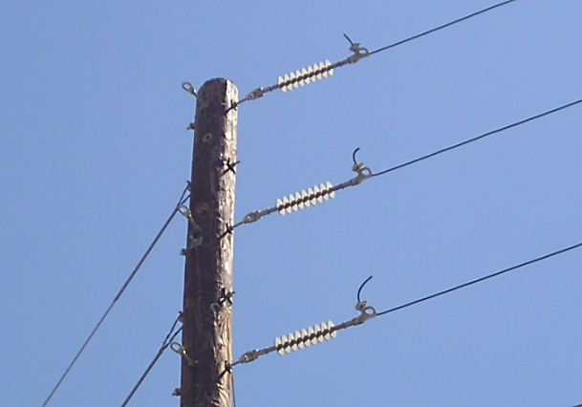

Table C6- 1: O-Calc and SpidaCalc Insulator Attributes
Attribute Values | Units
Description | 45kV dead-end
Voltage (kV) | 45
Horizontal Offset | 0
Vertical Offset | 0
Maximum Rated Strength | 20,000
Weight | 1.4
Lateral Area | 5.54"
Pole Side Area | 25.4"
Bolt Hole Diameter / 16" | 5/8"
None (Checkbox) | None
Shape | Round
Material | Silicone
Owner | LADWP
Length (inches) | 25.4
Width (inches) | 5.54
Number of Sheds | 8
Title | 0
Type
Crab Angle | 0
Install Height | feet
Attachment to Pole
Rotation | degrees
Side
Wind Drag Coefficient
Line End Fitting

- Crossarms
- Physical Properties
APPENDIX J: Fiberglass Crossarm Properties assumes worst case dimensions and weights for crossarm size.

The density of Douglas Fir crossarms used by LADWP and SCE is 39 lbs/ft³. The density of a Douglas Fir depends on moisture content as well the type of preservative used and heartwood vs sapwood content. Crossarms are typically cut from heartwood, which is inherently heavier and denser than sapwood.

The ANSI O5.3.2008 references the Modulus of Rupture or fiber strength as two values depending on inclusion in Table C6- 2 or Table C6- 3. Identification of class of knots and relative location from the ground level is challenging. Table C6- 3 (with a 7,400 psi MOR) is used by LADWP and SCE as inputs into their respective pole loading applications.

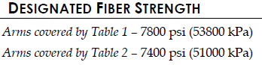
Table C6- 2
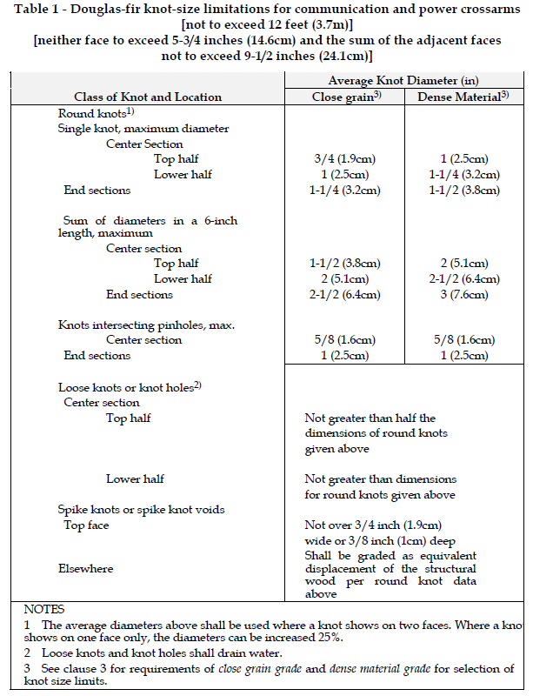
Table C6- 3
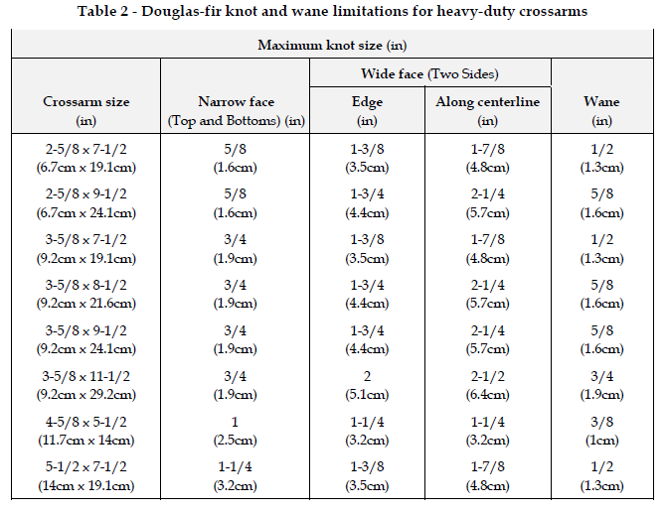

Modulus of Elasticity value of 1,900,000 lb/in² is consistent between LADWP and SCE and is the recommended value to use for Douglas fir crossarms as input in the pole loading software client libraries. This value is supported by Brooks Manufacturing, which has supplied the majority of Douglas fir crossarms to LADWP and SCE in the past.

- Measurement and Data Collection
Data collection for crossarms from the ground level is limited to determining their size and whether the crossarms are wood or non-wood.
LADWP and SCE use Douglas fir wood crossarms that are typically purchased through Brooks Manufacturing.
Due to variations in manufacturing processes and custom designs, the material properties to be used for composite or fiberglass crossarms should be determined by contacting the Joint Owner or the crossarm manufacturer.

- Condition Assessment
A crossarm that appears to have safety and reliability issues should be reported to the Joint Owner for corrective actions. The crossarm should be in relatively good condition without any significant cracks that would compromise internal integrity of the wood member.

- WIRES
- Electrical Wires
- Physical Properties
LADWP’s wire library is included in the appendix for reference only. (See APPENDIX C: LADWP Wire Library)

- Measurement and Data Collection
- Establishing Wire End Points
  - Bundling Advantages:
    - Reduce time spent collecting and inputting data into Pole Loading Software
    - Minimize variation to Safety Factors
    - Reduce potential data entry errors
  - Bundling Methodology:
Several potential building methods were analyzed on a sample of 120 poles. The method determined to be the most effective involved bundling cable and phone services to the same wire end point as electrical services when all services were attached to the same building. When cable and phone services went to a building that did not have electrical services, the cable and phone services were bundled to a common wire end point at the furthest communication span length.
  - The following is a case analyzed in SpidaCalc:

- Communication Wires
- Physical Properties
Table 7-1 includes “Worst Case” weights using ¼” EHS strand. The bundles were created using O-Calc and consist of feeder-trunk and fiber TV conductors.

Table 7-2 was based on AT&T’s properties for Non-lead cables. The following table illustrates the sampling and calculations performed to produce Table 7-2: Telco Bundle Sizes and Weights.
NON-LEAD CABLES
Diameter | Count of Cables in Sample | Min Conductor Diameter | Max Conductor Diameter | Average Conductor Diameter | Default Weight (lbs/ft)* | Proposed % of Max
0.5 | 30 | 0.45 | 0.62 | 0.548 | 0.584 | 0.942
0.75 | 48 | 0.64 | 0.84 | 0.747 | 0.794 | 0.945
2 | 18 | 1.91 | 2.1 | 2.001 | 2.051 | 0.976
2.25 | 14 | 2.2 | 2.36 | 2.289 | 2.325 | 0.985
2.5 | 16 | 2.38 | 2.61 | 2.489 | 2.550 | 0.977
2.75 | 14 | 2.64 | 2.87 | 2.769 | 2.819 | 0.982
3 | 10 | 2.88 | 3.11 | 2.996 | 3.053 | 0.982
3.25 | 7 | 3.14 | 3.25 | 3.181 | 3.216 | 0.989
3.5 | 2 | 3.41 | 3.46 | 3.435 | 3.448 | 0.996
*(Max lbs/ft of diameter + Avg lbs/ft)/2)

- Measurement and Data Collection
- Establishing Wire End Points
  - See C.7.1.2 Establishing Wire End Points

SCE’s Telco and CATV wire libraries are included in the appendix for reference only. (See APPENDIX D: SCE Telco Library and APPENDIX E: SCE CATV Library)

- Tensions
- Physical Properties
LADWP primarily uses the Sag to Tension mode in O-Calc, where the user inputs an estimate or measurement of the span length and the program determines the tension.

- MISCELLANEOUS EQUIPMENT

- Physical Properties

- Measurement and Data Collection

- Condition Assessment

- Assumptions

APPENDIX A: Insulator Data and Photos

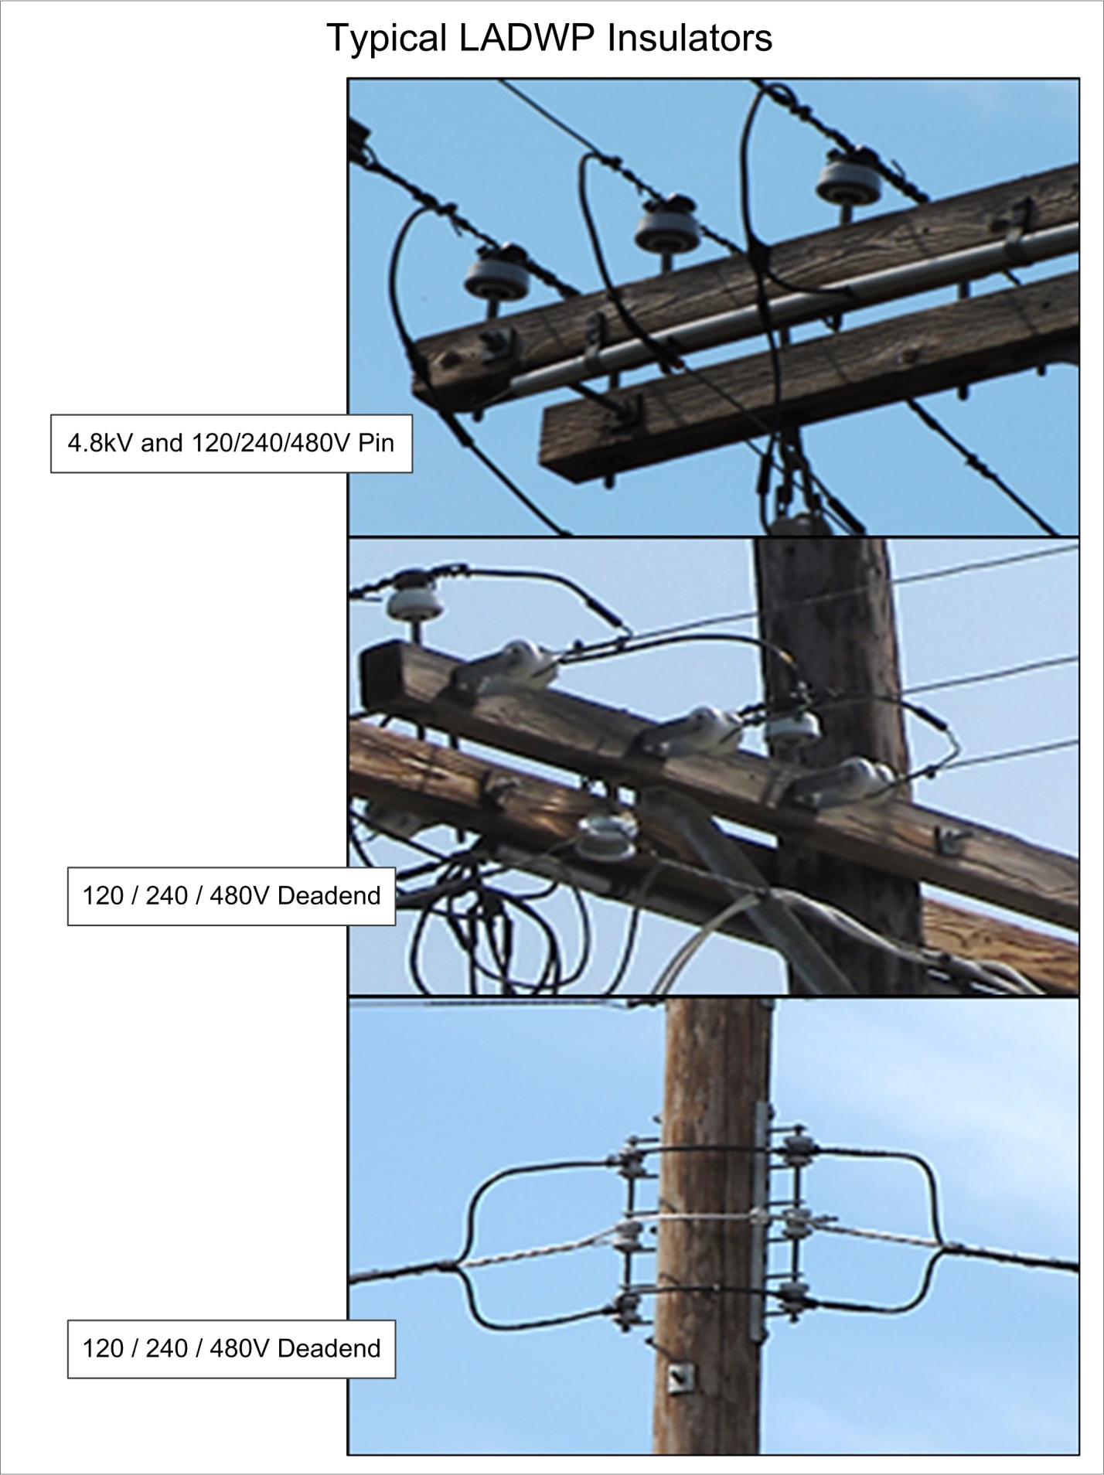

APPENDIX A: INSULATOR DATA AND PHOTOS continued

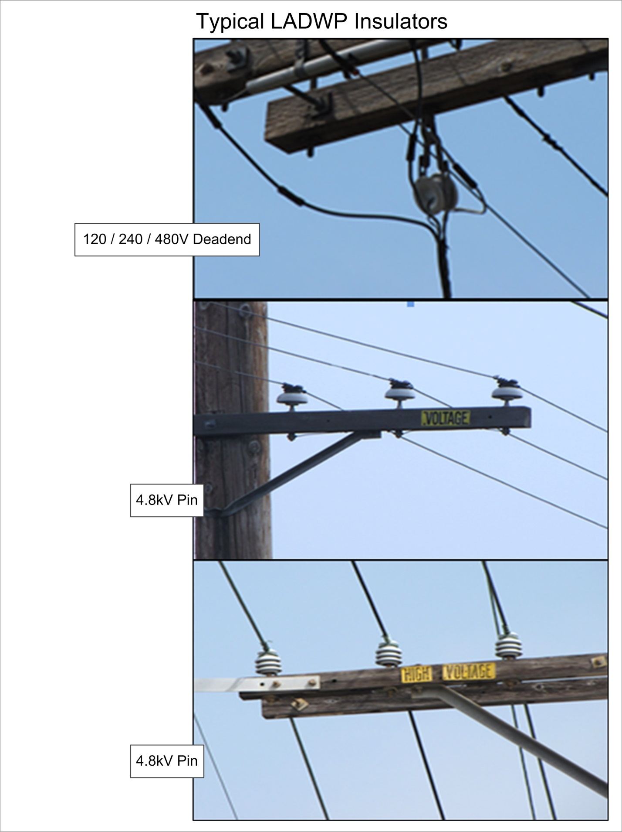

APPENDIX A: INSULATOR DATA AND PHOTOS continued

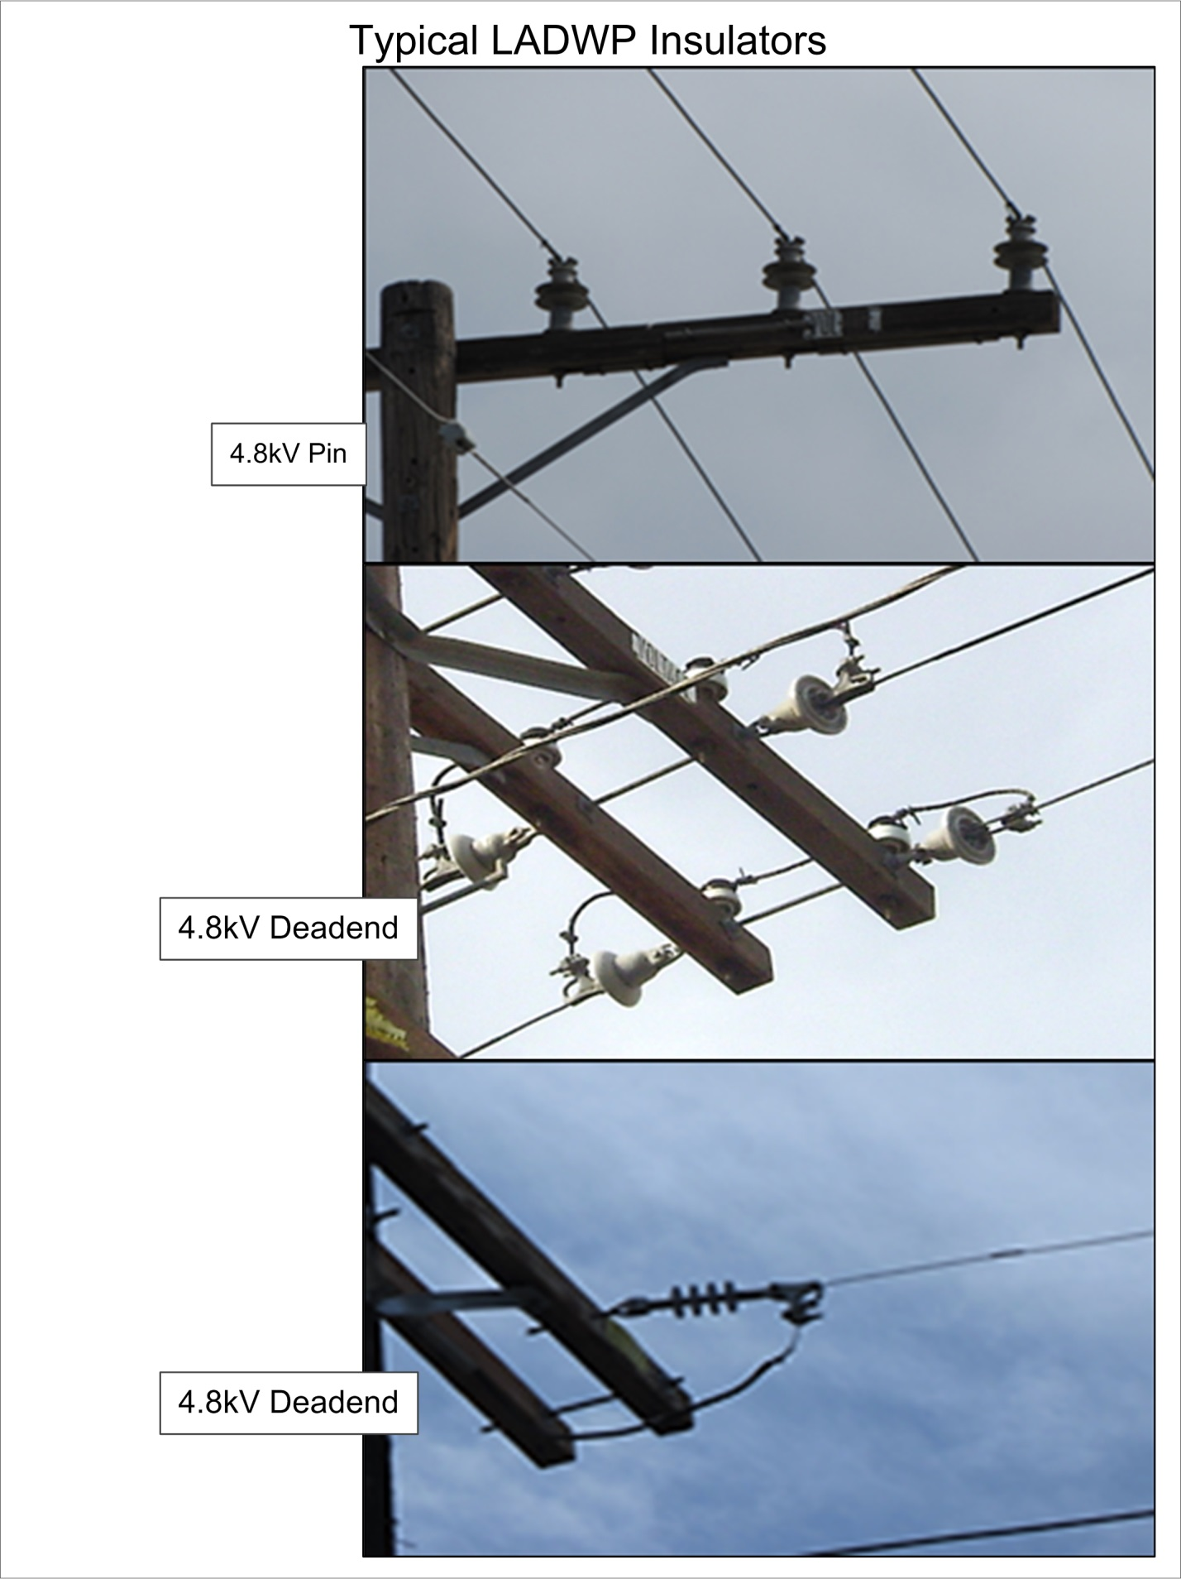

APPENDIX A: INSULATOR DATA AND PHOTOS continued

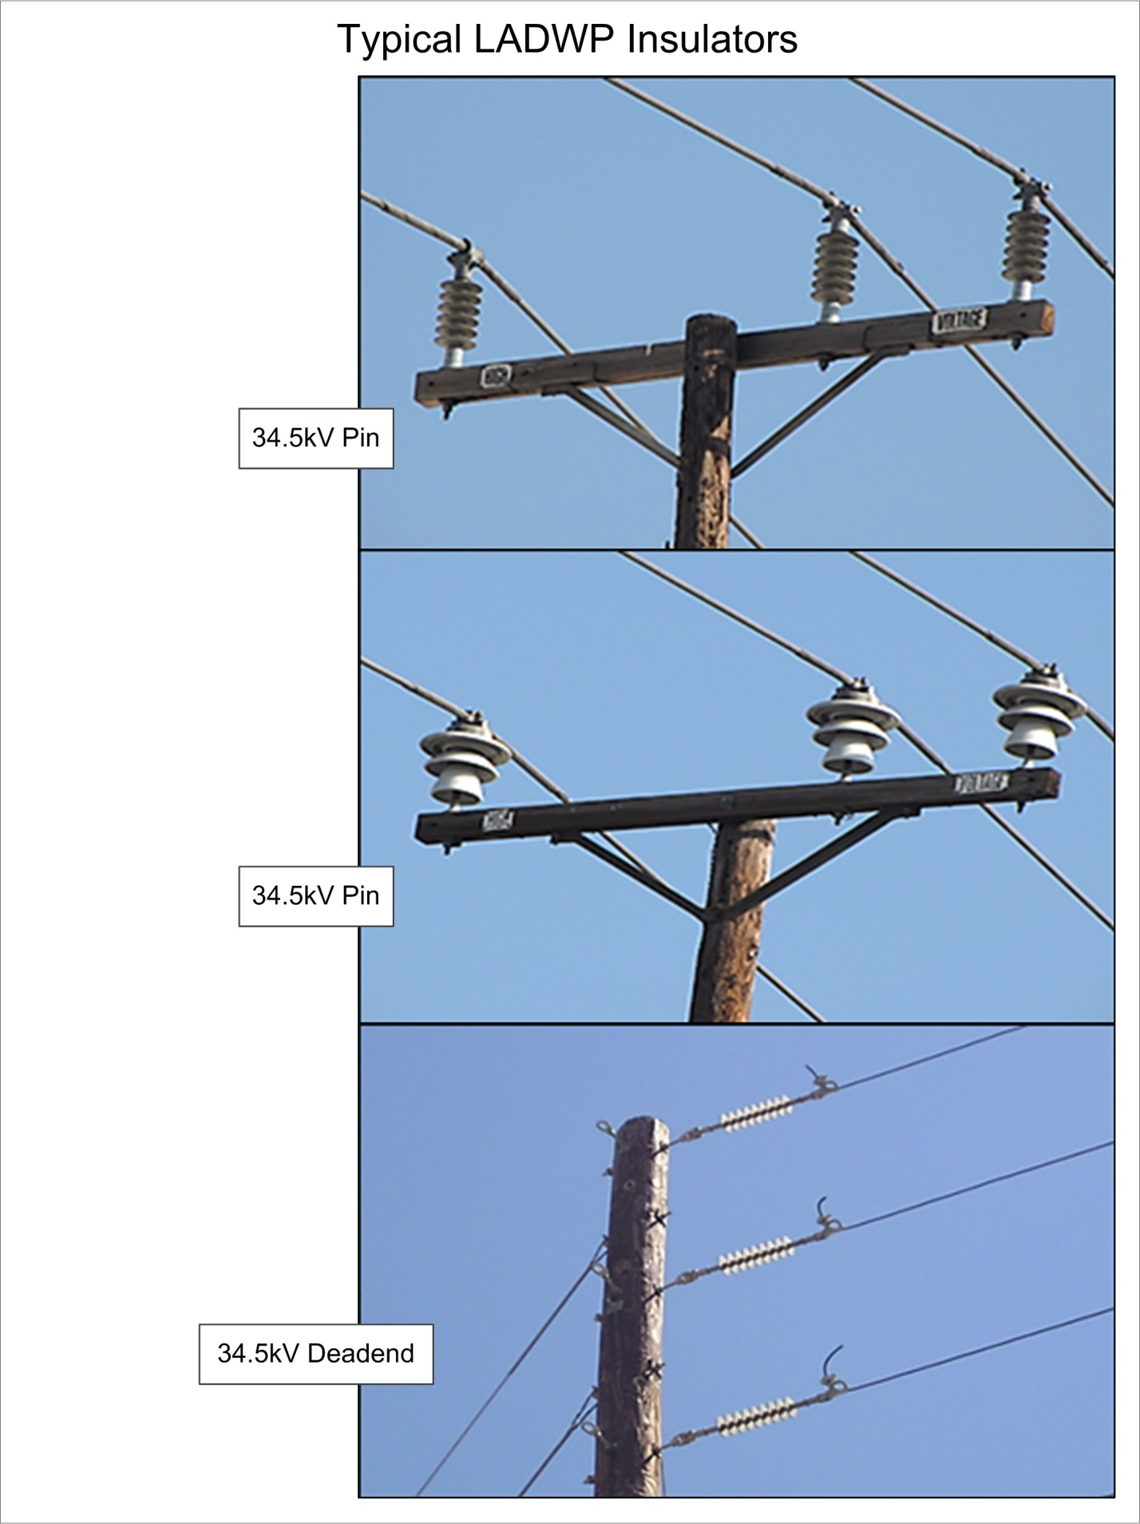

APPENDIX A: INSULATOR DATA AND PHOTOS continued

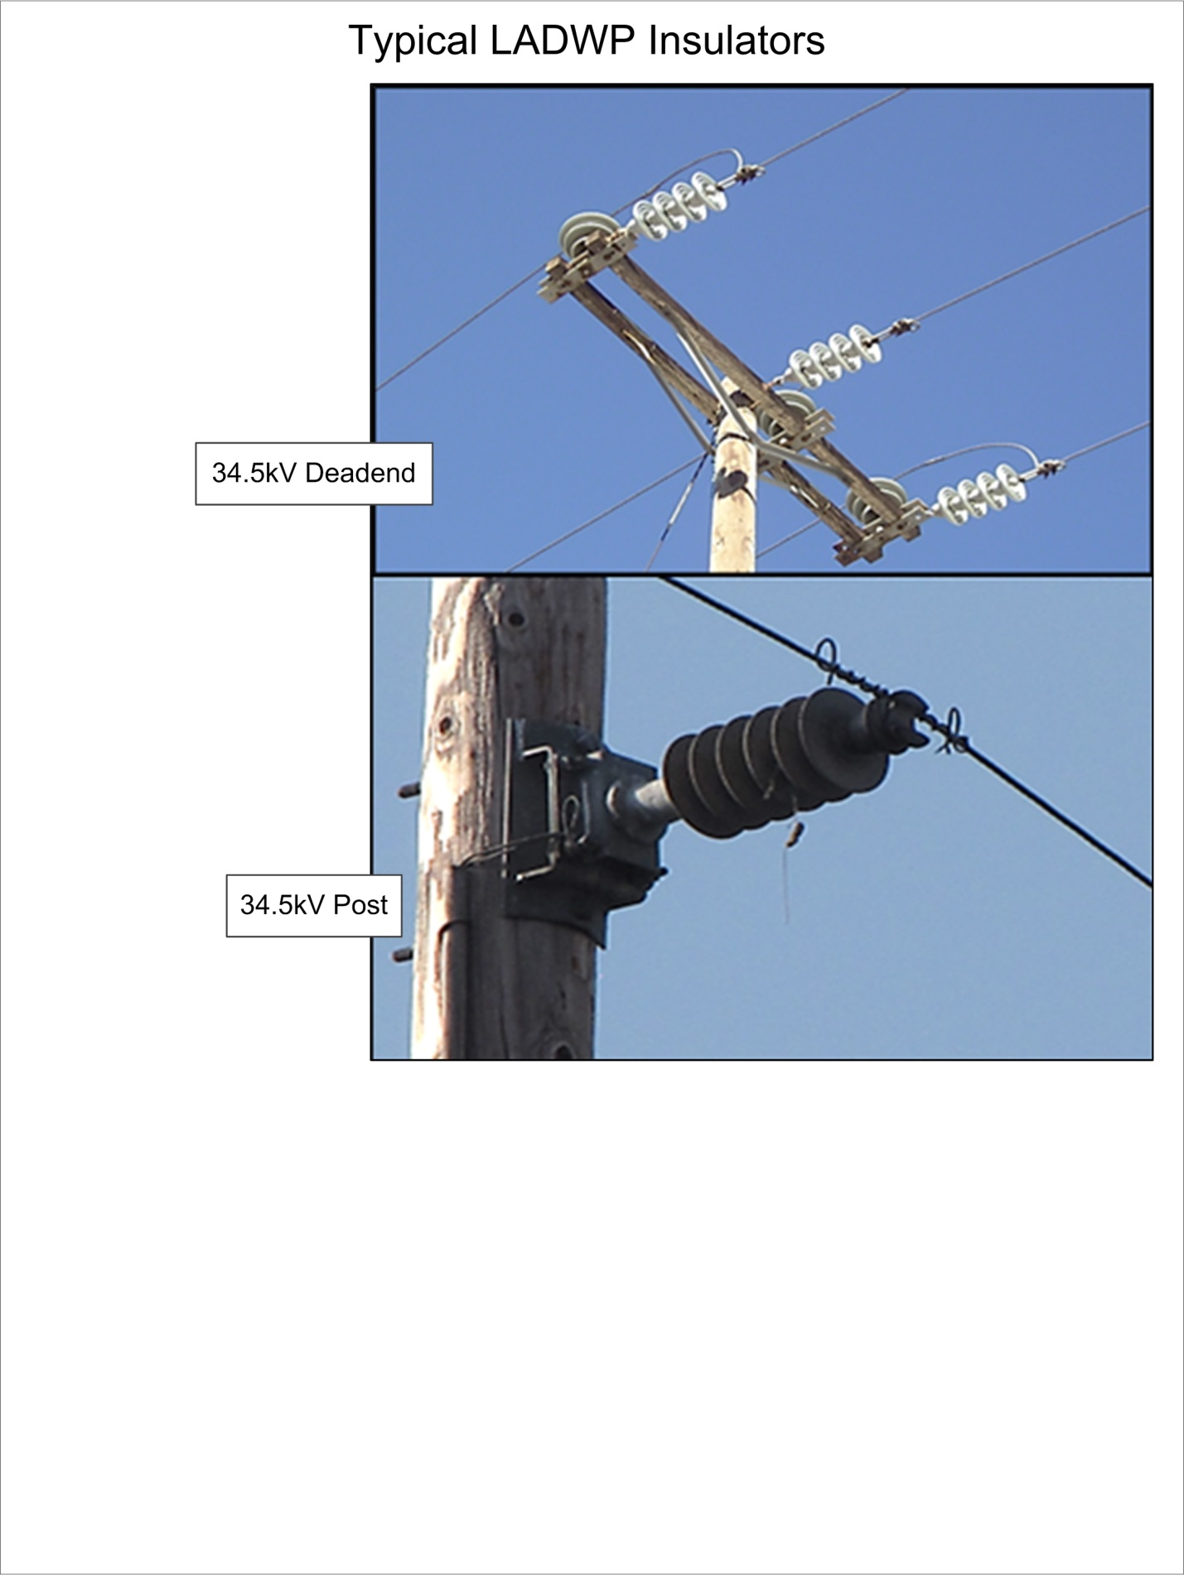

APPENDIX A: INSULATOR DATA AND PHOTOS continued

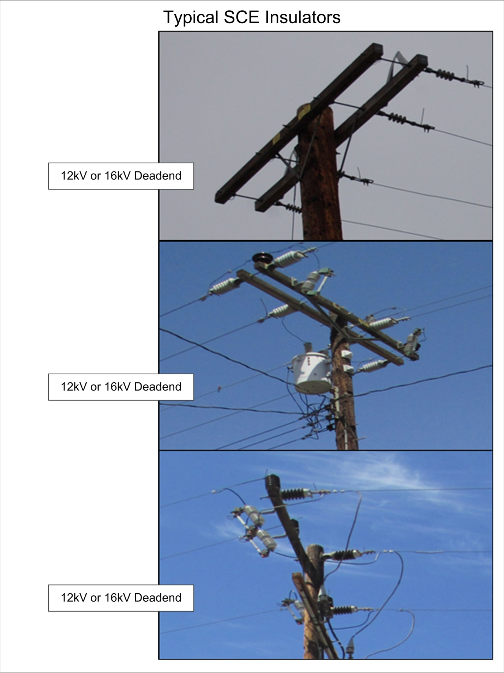

APPENDIX A: INSULATOR DATA AND PHOTOS continued

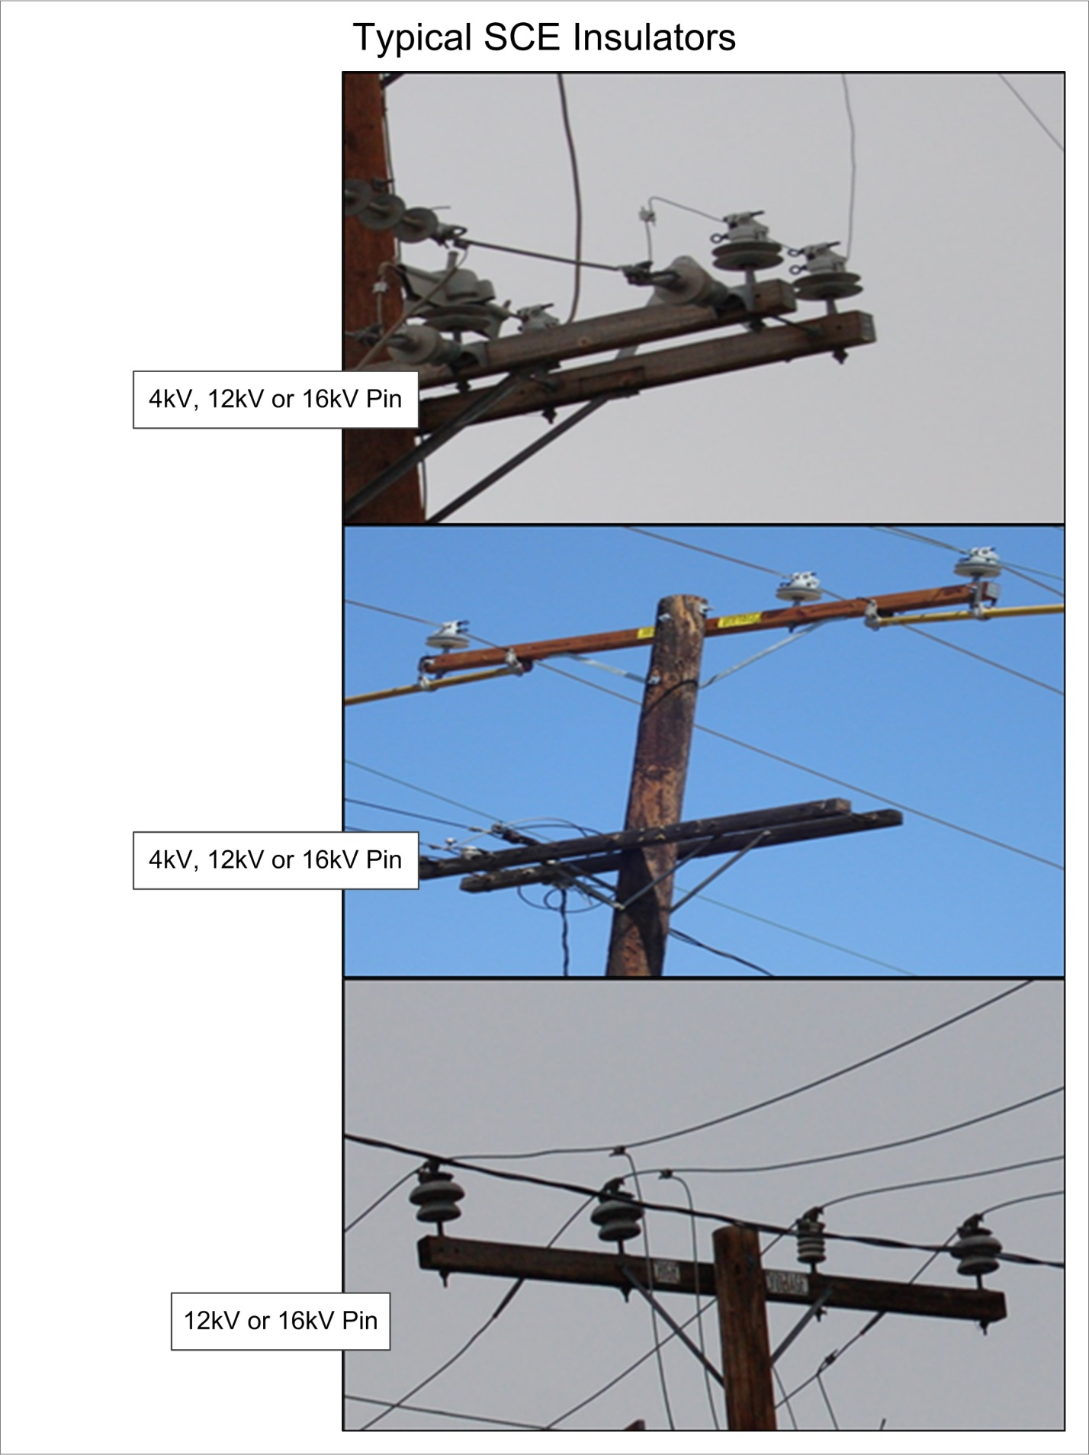

APPENDIX A: INSULATOR DATA AND PHOTOS continued

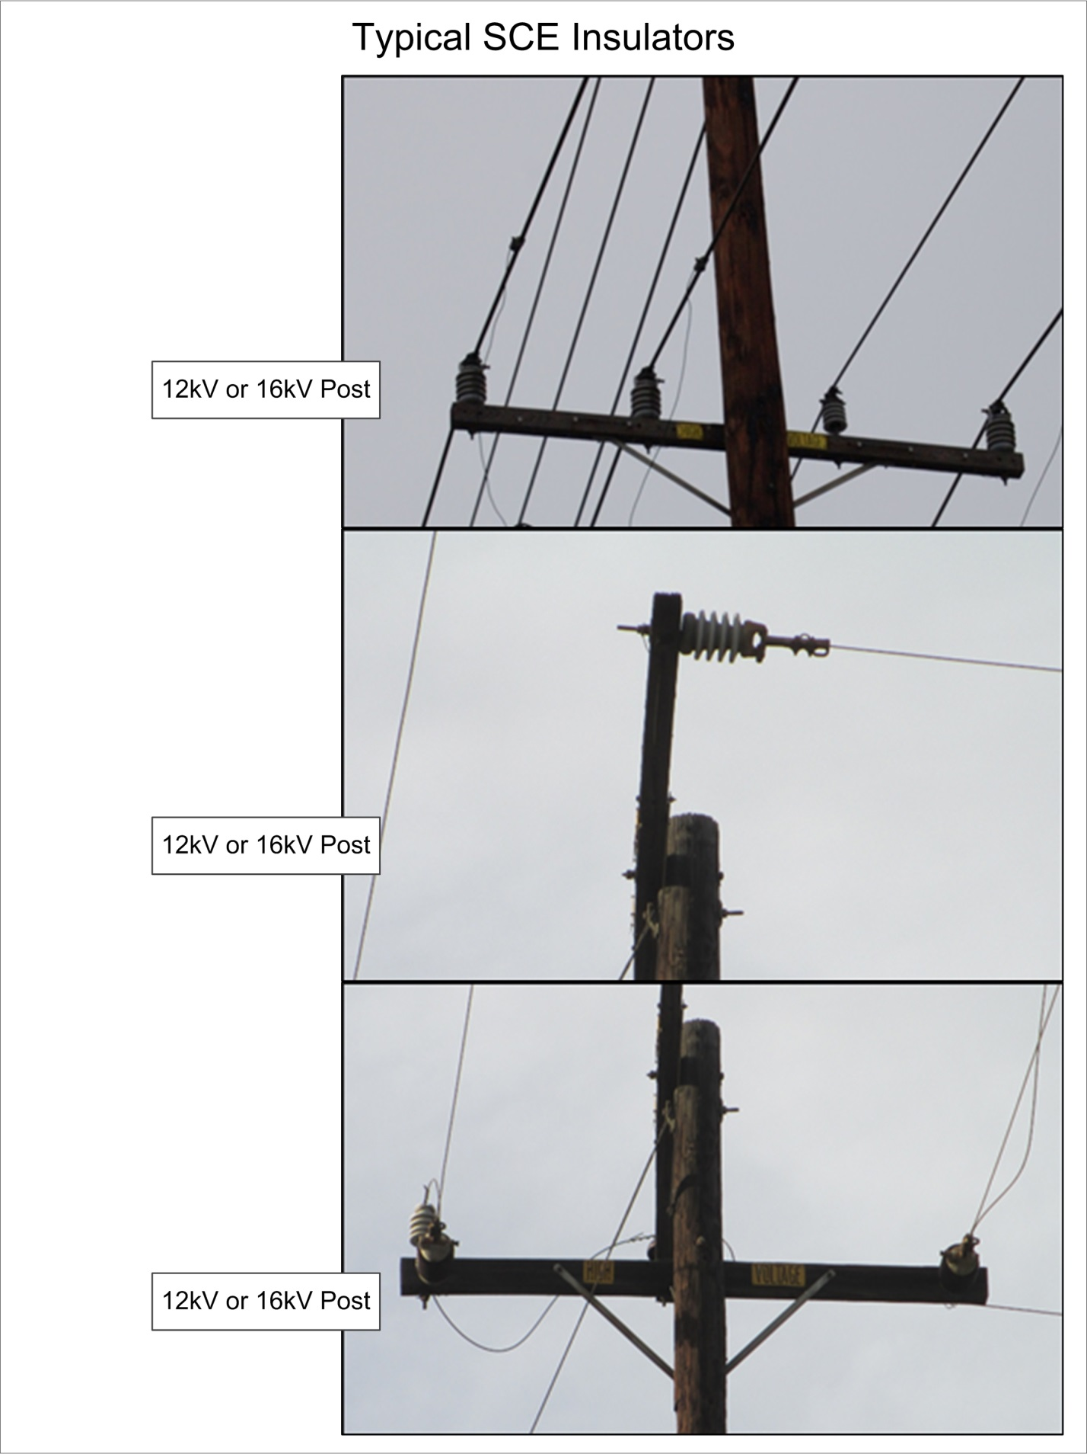

APPENDIX A: INSULATOR DATA AND PHOTOS continued

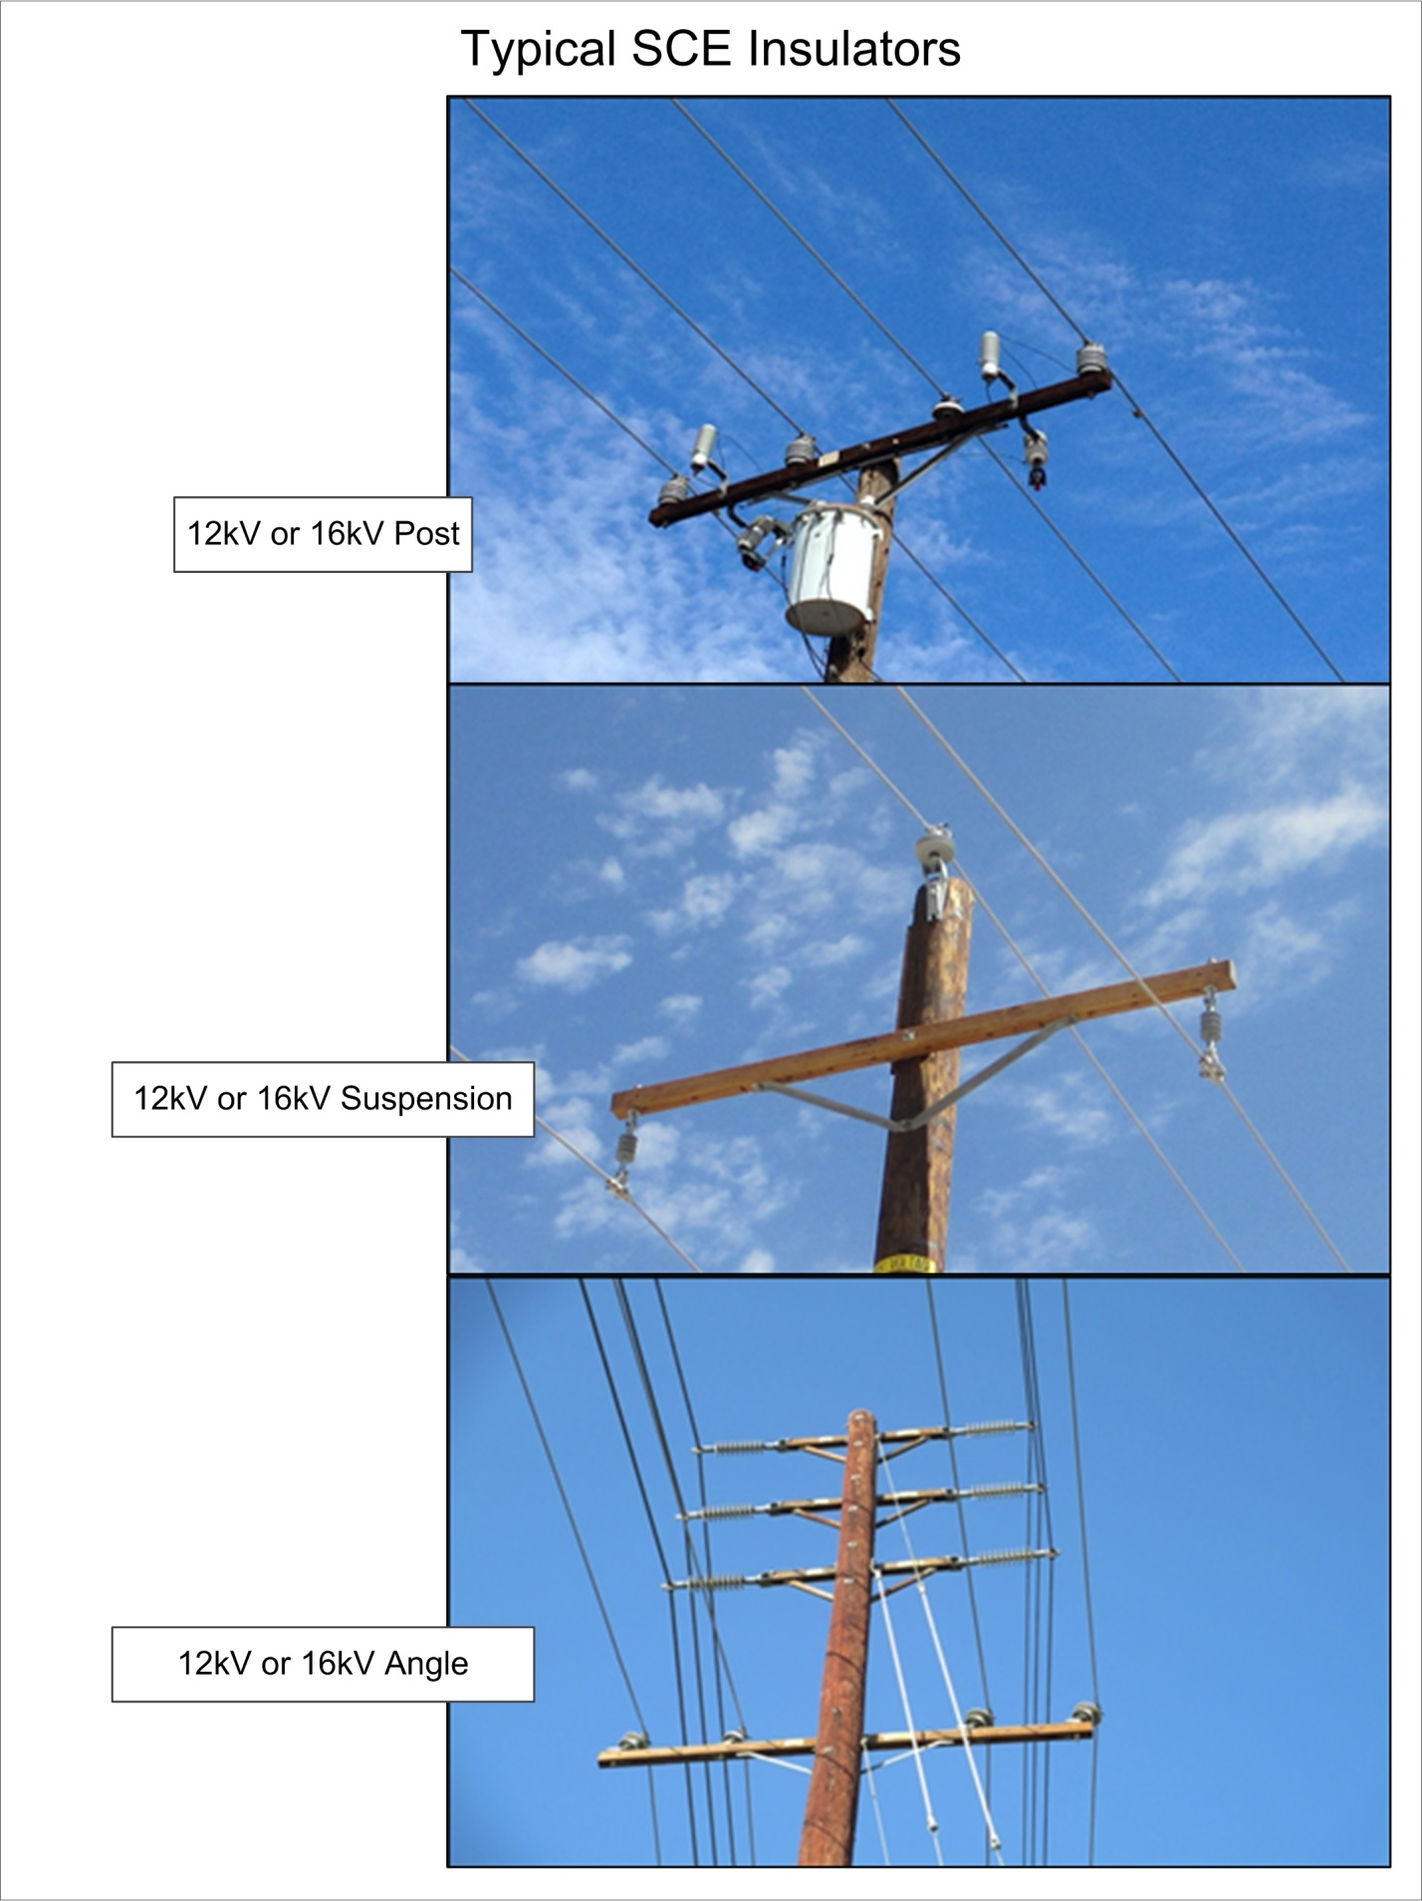

APPENDIX A: INSULATOR DATA AND PHOTOS continued

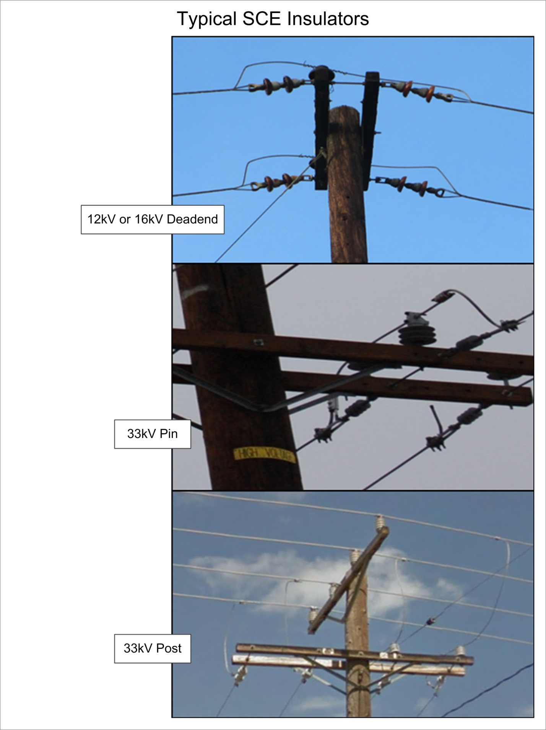

APPENDIX A: INSULATOR DATA AND PHOTOS continued

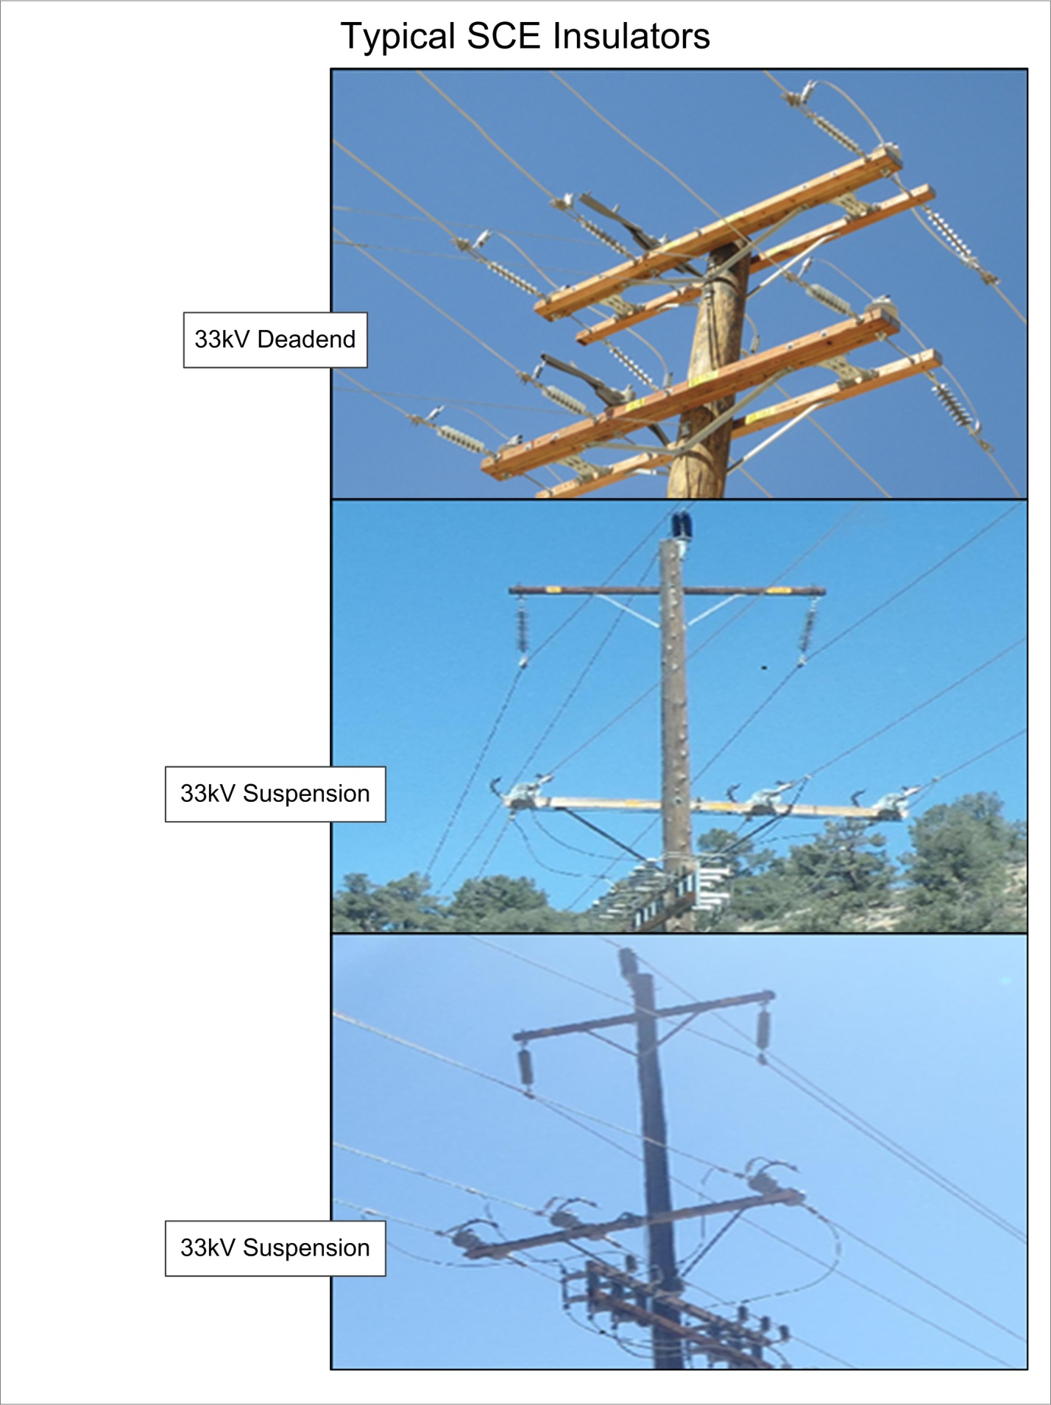

APPENDIX A: INSULATOR DATA AND PHOTOS continued

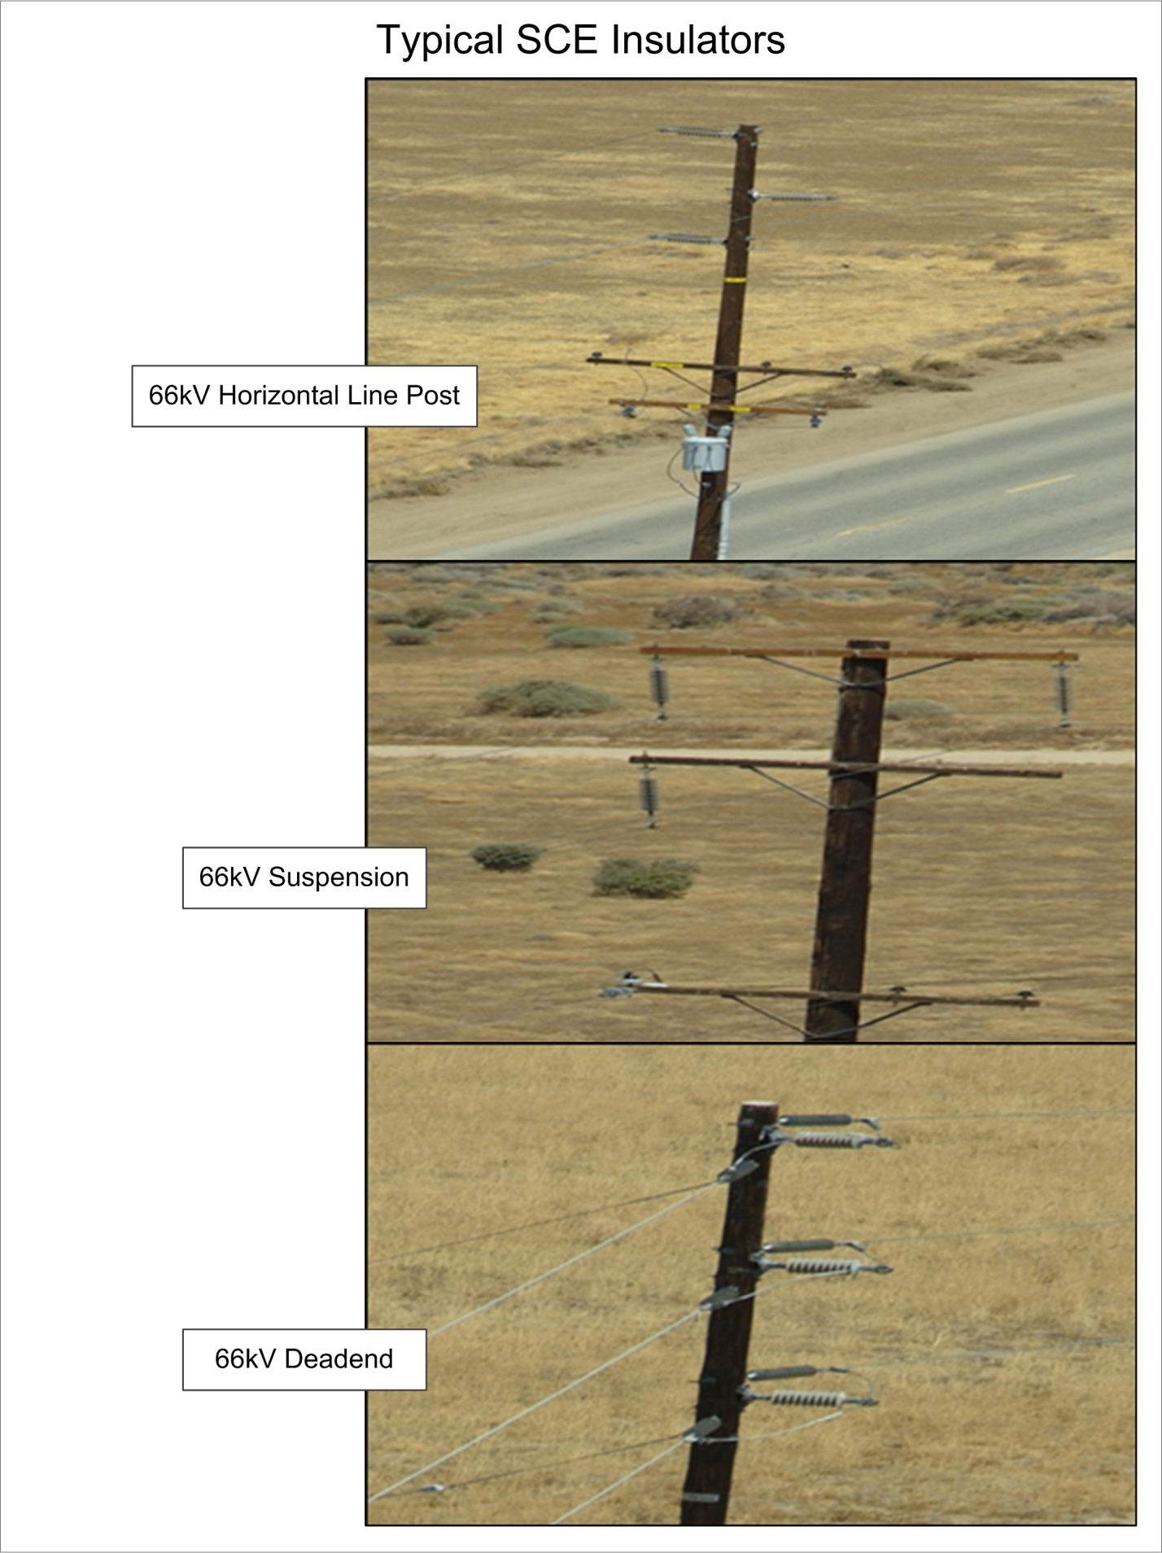

APPENDIX A: INSULATOR DATA AND PHOTOS continued

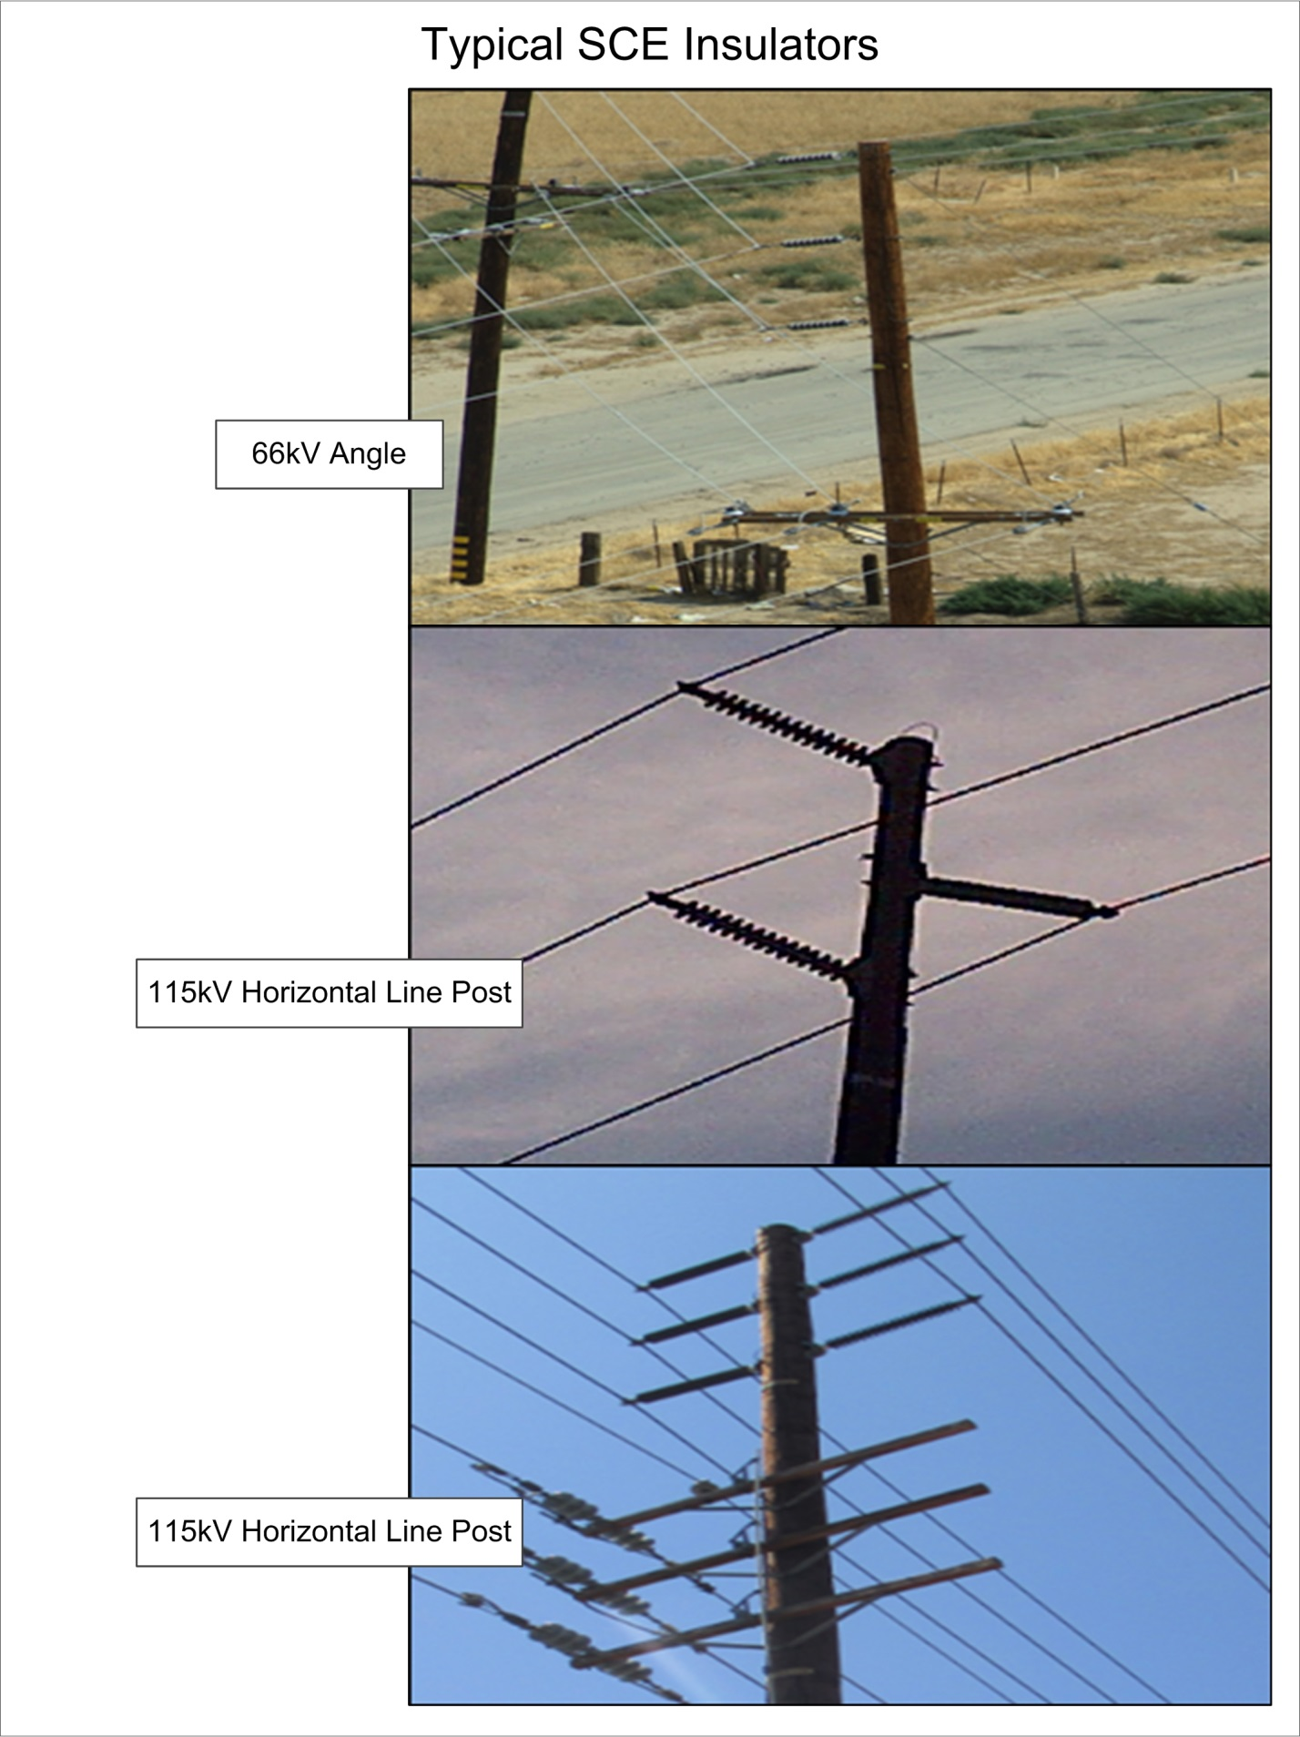

APPENDIX A: INSULATOR DATA AND PHOTOS continued

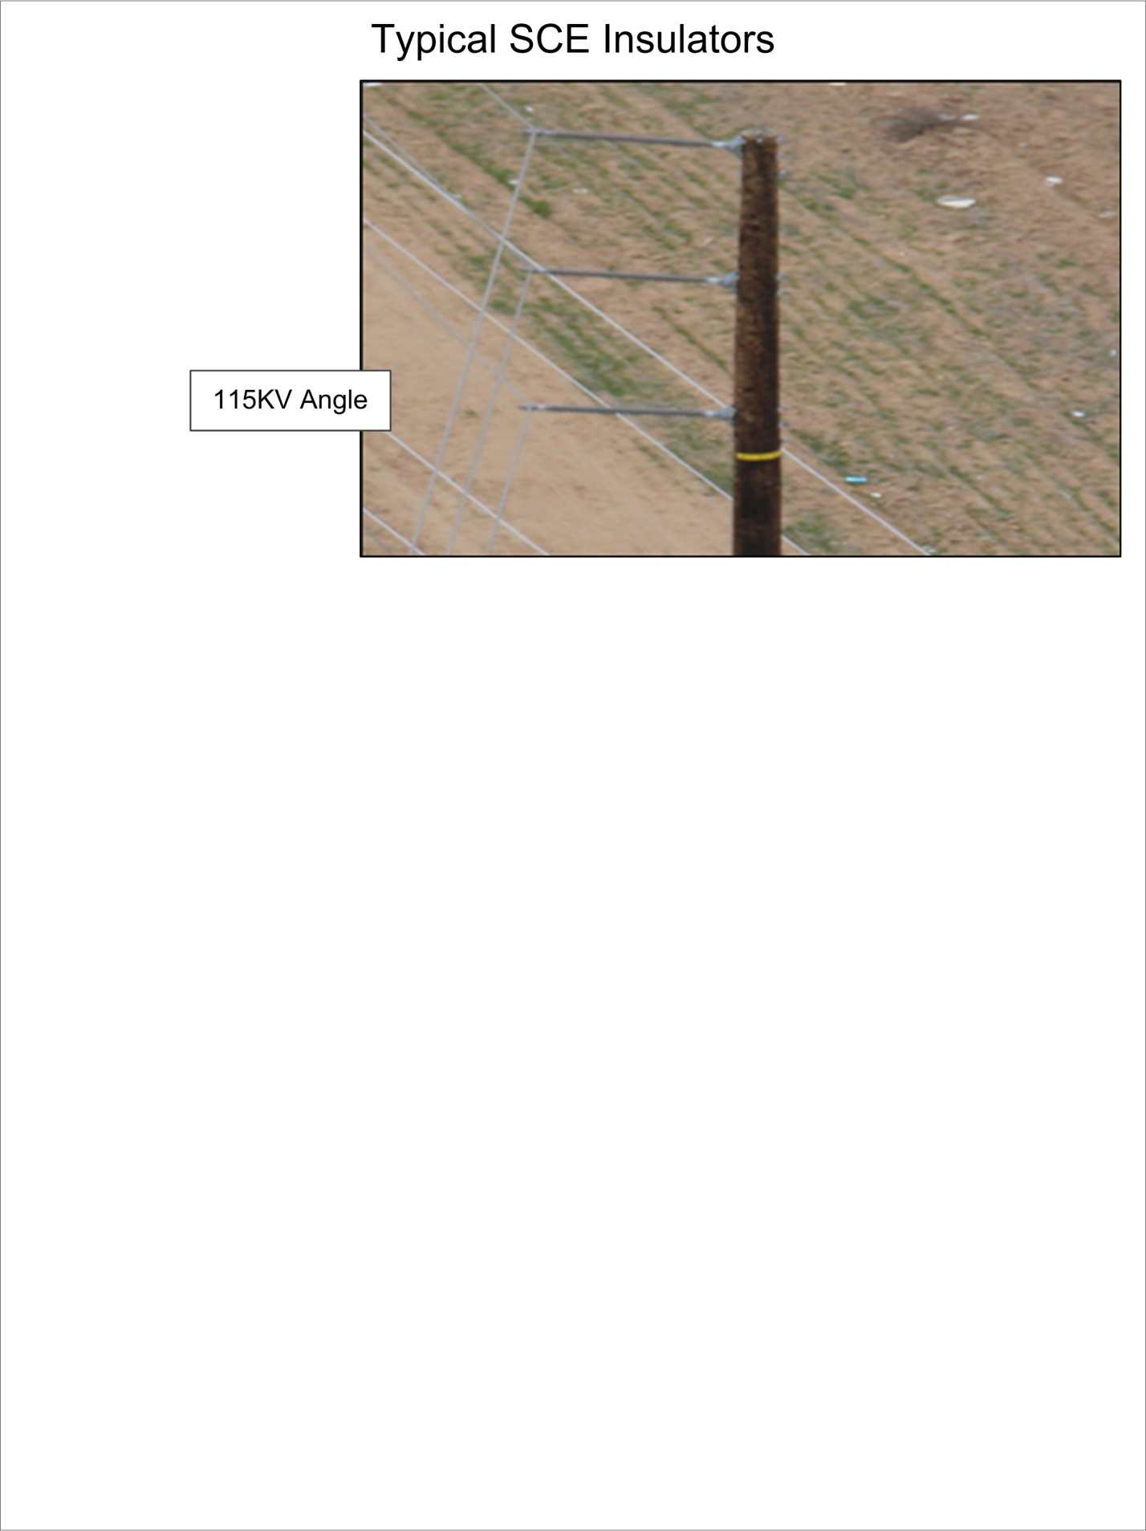

APPENDIX B: SCE Wire Library

APPENDIX B: SCE WIRE LIBRARY Continued

APPENDIX B: SCE WIRE LIBRARY Continued

APPENDIX B: SCE WIRE LIBRARY Continued

APPENDIX C: LADWP Wire Library

APPENDIX C: LADWP WIRE LIBRARY Continued

APPENDIX D: SCE Telco Library

APPENDIX D: SCE TELCO LIBRARY Continued

APPENDIX E: SCE CATV Library

APPENDIX E: SCE CATV LIBRARY Continued

APPENDIX F: TruPulse 360/360R Range Finder

The TruPulse 360/360R Range Finder is used to measure span lengths, angles, pole heights and heights of attachment. It can be utilized as a standalone instrument to measure missing lines and elevation changes or it can be attached to the TruAngle.

The TruAngle is used in situations where objects (autos, street signs, fences, etc) are present and have the potential to cause magnetic interference to the TruePulse. (See Figure 14-1)

Figure 14-1: TruAngle mounted with TruPulse
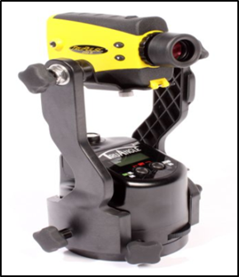

It is important to note that the azimuth function in the TruePulse can be inaccurate due to magnetic interference. In situations where there is potential for magnetic interference (autos, street signs, fences, etc) the TruPulse should not be used to measure angles. Table 14-2 is a list (TruPulse Quick Reference Field Guide) of objects and or materials that could cause interference with the TruPulse 360 compass, this list is NOT all inclusive and there are other items that need to be considered. See Table 14-3 to test for local magnetic interference.

The tool should be calibrated at least once daily and every time there is a major change in location. See Table 14-1 for manufacturer’s accuracy specifications.

Table 14-1: TruPulse Accuracy
TruPulse 360/360R Specifications
Distance Accuracy to Typical Targets | +/- 30 cm (1 ft)
Distance Accuracy to Very Distant & Weak Targets | +/- 0.3 to 1 m (1 to 3 ft)
Max Range to Reflective Targets | 2000 m (6,560 ft)
Max Range to Non-Reflective Targets | 1000 m (3,280 ft)
Inclination Accuracy | +/- 0.25° Typical
Azimuth Accuracy | +/- 1° Typical
APPENDIX F TRUPULSE 360/360R RANGE FINDER Continued

Table 14-2: Azimuth Magnetic Interference
Required Clearances | Possible Magnetic Interference
6 in (15 cm) minimum | Metal rim glasses, pen/pencil, metal watch band, pocket knife, metal zipper/buttons, belt buckle, batteries, binoculars, cell phone, keys, camera, camcorder, survey nails, metal tape measure.
18 in (50 cm) minimum | Clipboard, data collector, computer, GPS antenna, 2-way radio, hand gun, hatchet, cell phone case with magnetic closure.
6 ft (2 m) minimum | Bicycle, fire hydrant, road signs, sewer cap or drain, steel pole, ATV, guy wire, magnets, chain-link fence, bar-wire fence, data collectors that use a magnet to hold the stylus.
15 ft (5 m) minimum | Electrical box, small car/truck, powerline, building with concrete & steel.
30 ft (10 m) minimum | Large truck, metal building, heavy machinery.

Table 14-3: Testing for Magnetic Interference
Step | Instructions
 | Choose a target that is at least 300 feet away.
 | In the AZ Function, shoot to the target.
 | Note the azimuth.
 | Move the TruPulse backward or forward one yard along the site-line.
Shoot to the target again.
Result: The second azimuth should be within 1/10 to 5/10 of a degree of the first azimuth.
IF | Then
The second azimuth is 1/10 to 5/10 of a degree of the first azimuth | - The area is very likely free of magnetic interference.  - Proceed to Step 6.
The second azimuth is not 1/10 to 5/10 of a degree of the first azimuth | - Choose another location  - Repeat steps 1 – 5 until a satisfactory result is achieved.

 | Confirm the test by repeating steps 1 – 5 on a target approximately 90 degrees to the azimuth of the first target.

Measuring and Collecting Data with the TruPulse 360

Span length measurements are to be taken from the centerline of the pole and to all endpoints that are to be captured in the measurement.
Before shooing an endpoint, care is to be taken to avoid shooting any objects in between that would give an inaccurate measurement. When determining an accurate location to take the span length measurement, the following conditions are taken into consideration:

APPENDIX F TRUPULSE 360/360R RANGE FINDER Continued

- Clear Line of Sight – The area from the subject pole to the pole ahead and the pole behind if free of obstructions.
  - All adjacent poles and endpoints that have a clear line of sight when the Inspector can setup the tripod with no more than a 6 inch horizontal offset from the perimeter of the subject pole. In order to maintain the centerline of the subject pole, the setup location may be re-positioned multiple times in-order to capture accurate measurements.

- Obstructed Sight – Obstructions exist between the subject pole, the pole ahead and/or the pole behind, but the measurement can be taken using an offset.

  - If a clear line of sight cannot be established, the Inspector will need to measure a horizontal offset distance (example 5') from the subject pole that will provide a line of sight to the other poles.
A horizontal offset is a determined distance in feet and/or inches by which something is out of line. In order to achieve accurate measurements, you cannot create an offset on the subject pole greater than 6 inches without creating the same offset on all endpoints being measured. Creating offsets allow accurate measurements to be taken parallel to the subject pole and adjacent endpoints without altering the measured values.
A safety cone or other objects can be used as markers to establish the distance from the center line of the subject pole. The marker is used to establish the same offset distance for the other wire end-points that will be shot.
Once the offset has been established for the subject pole and the other wire end-points, shoot from the instrument location to the markers next to the other wire end-points.
If it is impractical to establish offsets because the obstruction or distance is too great, the measurements can be taken using the missing line process.

- Missing line – Obstructions exist between the subject pole, the pole ahead and/or the pole behind and the measurement cannot be taken using an offset.

  - When it is extremely difficult or impossible to collect data from a position close to the subject pole, the True Pulse 360 has the ability to shoot two targets from a remote location and then it will internally calculate the span length and azimuth. This function is dependent on clear lines of sight from the remote location to both of the targets. It is also dependent on proper calibration of the horizontal and inclination functions of the instrument.
When setting up for the missing line measurement, care must be taken to avoid objects that could cause magnetic interference to the compass. Refer to Table 14-3: Testing for Magnetic Interference for instructions. The internal compass is a vital part of the internal calculation.

APPENDIX G: SCE and LADWP Pole Circuit Class ID

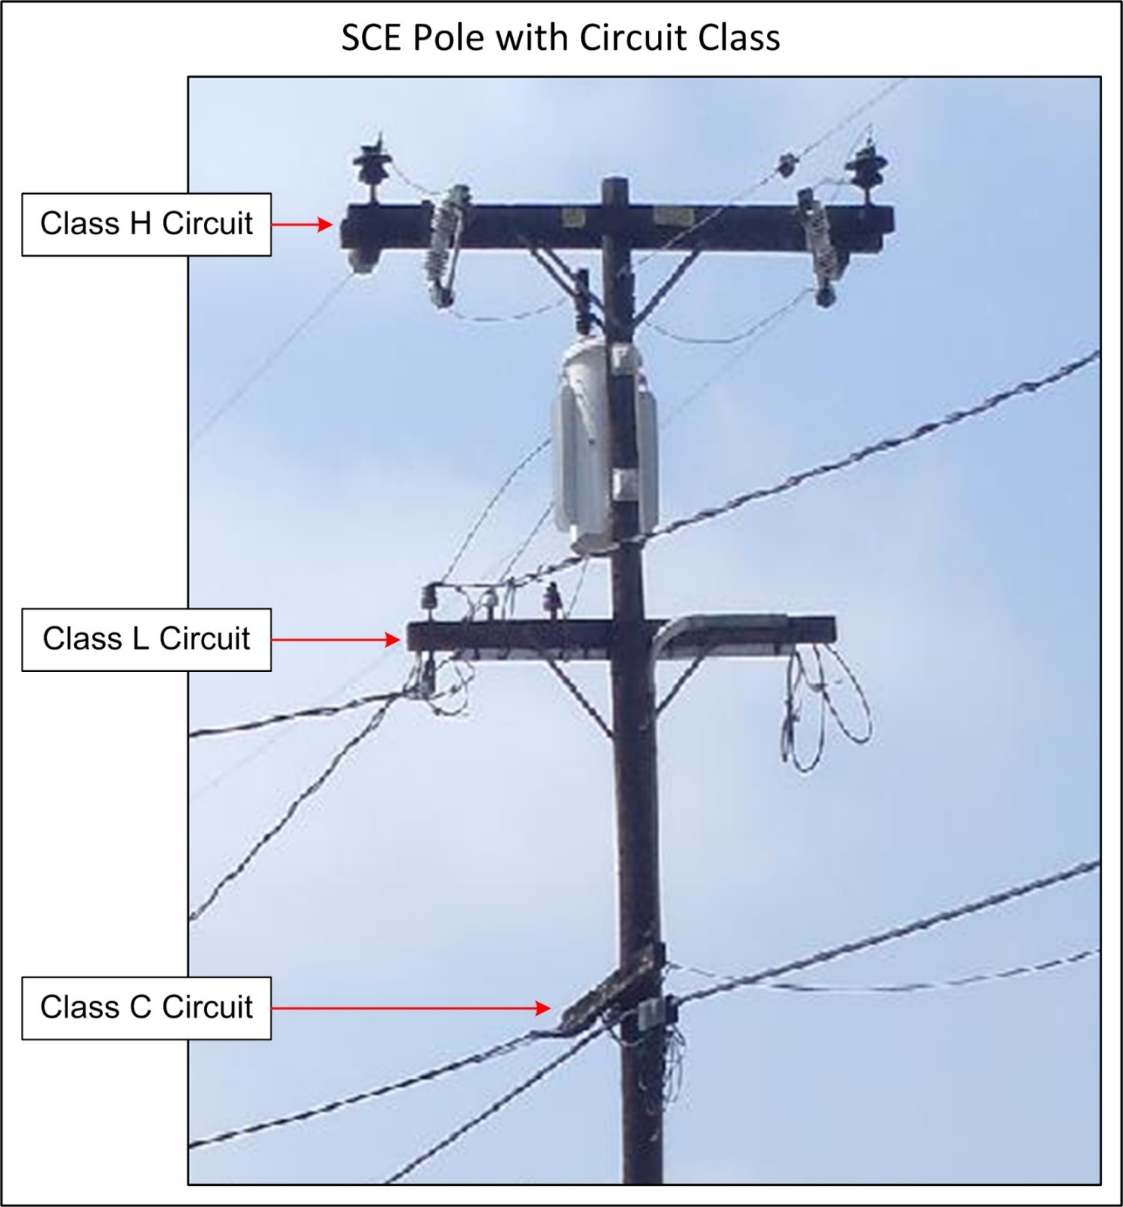

APPENDIX G SCE AND LADWP POLE CIRCUIT CLASS ID Continued

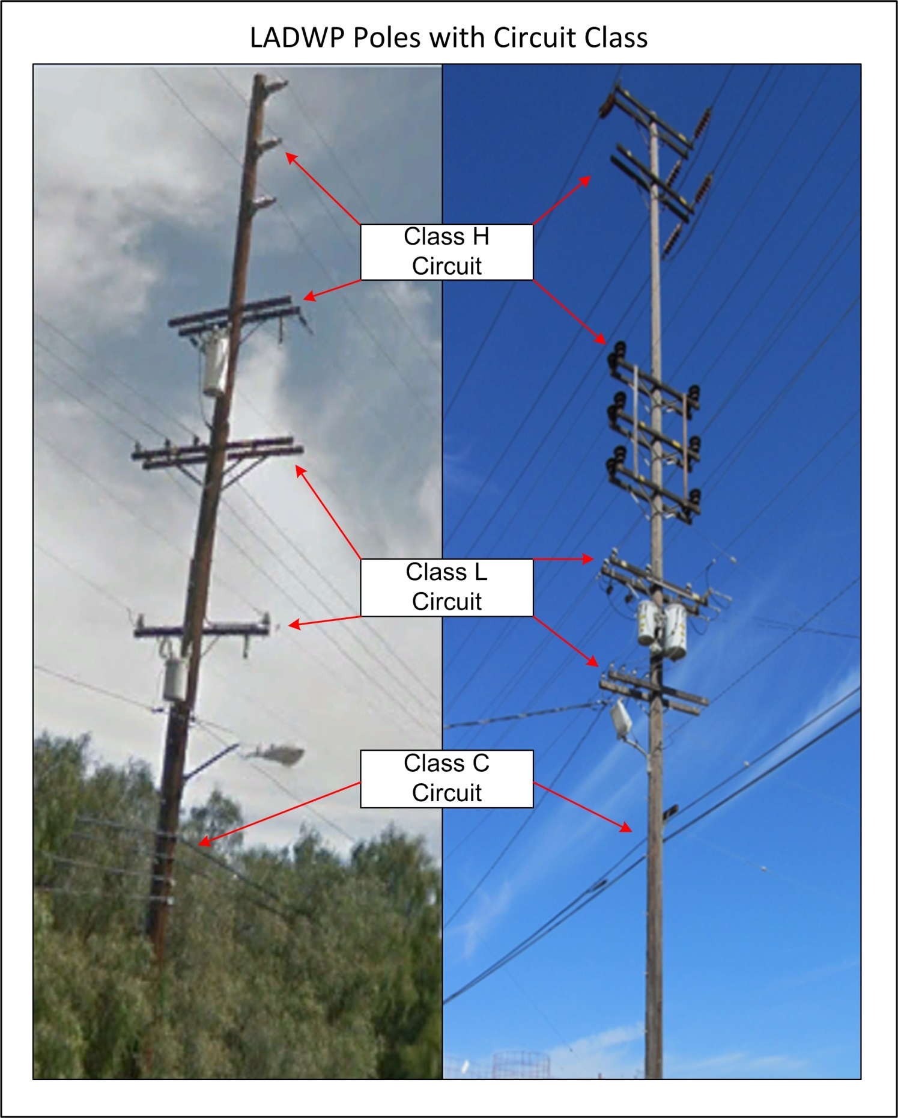

APPENDIX H: SCE LWSP Properies for SpidaCalc

APPENDIX H: SCE LWSP PROPERTIES FOR SPIDACALC Continued

APPENDIX H: SCE LWSP PROPERTIES FOR SPIDACALC Continued

APPENDIX H: SCE LWSP PROPERTIES FOR SPIDACALC Continued

APPENDIX H: SCE LWSP PROPERTIES FOR SPIDACALC Continued

APPENDIX H: SCE LWSP PROPERTIES FOR SPIDACALC Continued

APPENDIX I: LADWP LWSP Properties for O-Calc

APPENDIX J: Fiberglass Crossarm Properties

APPENDIX K: Wire Identification

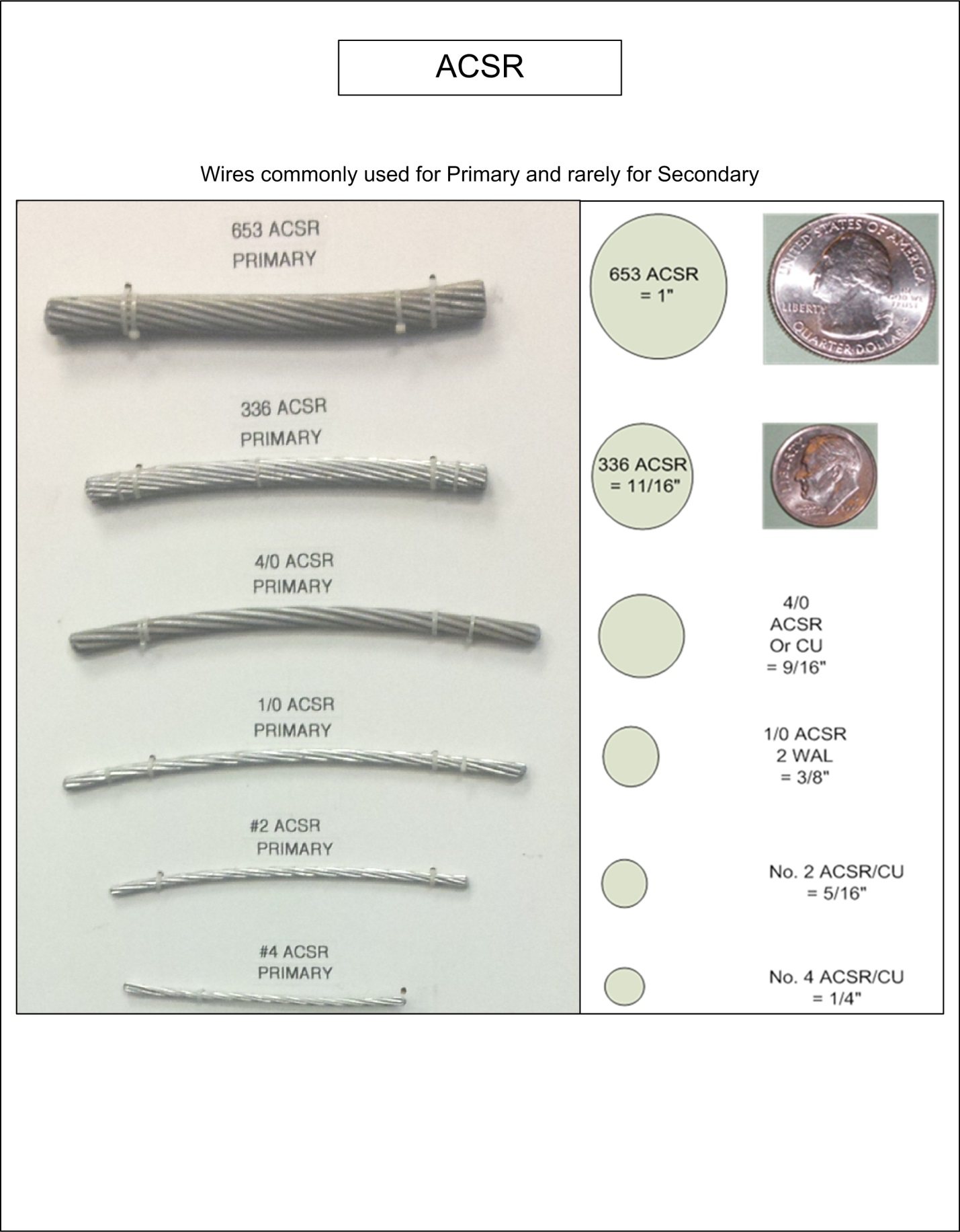

APPENDIX K: WIRE IDENTIFICATION Continued

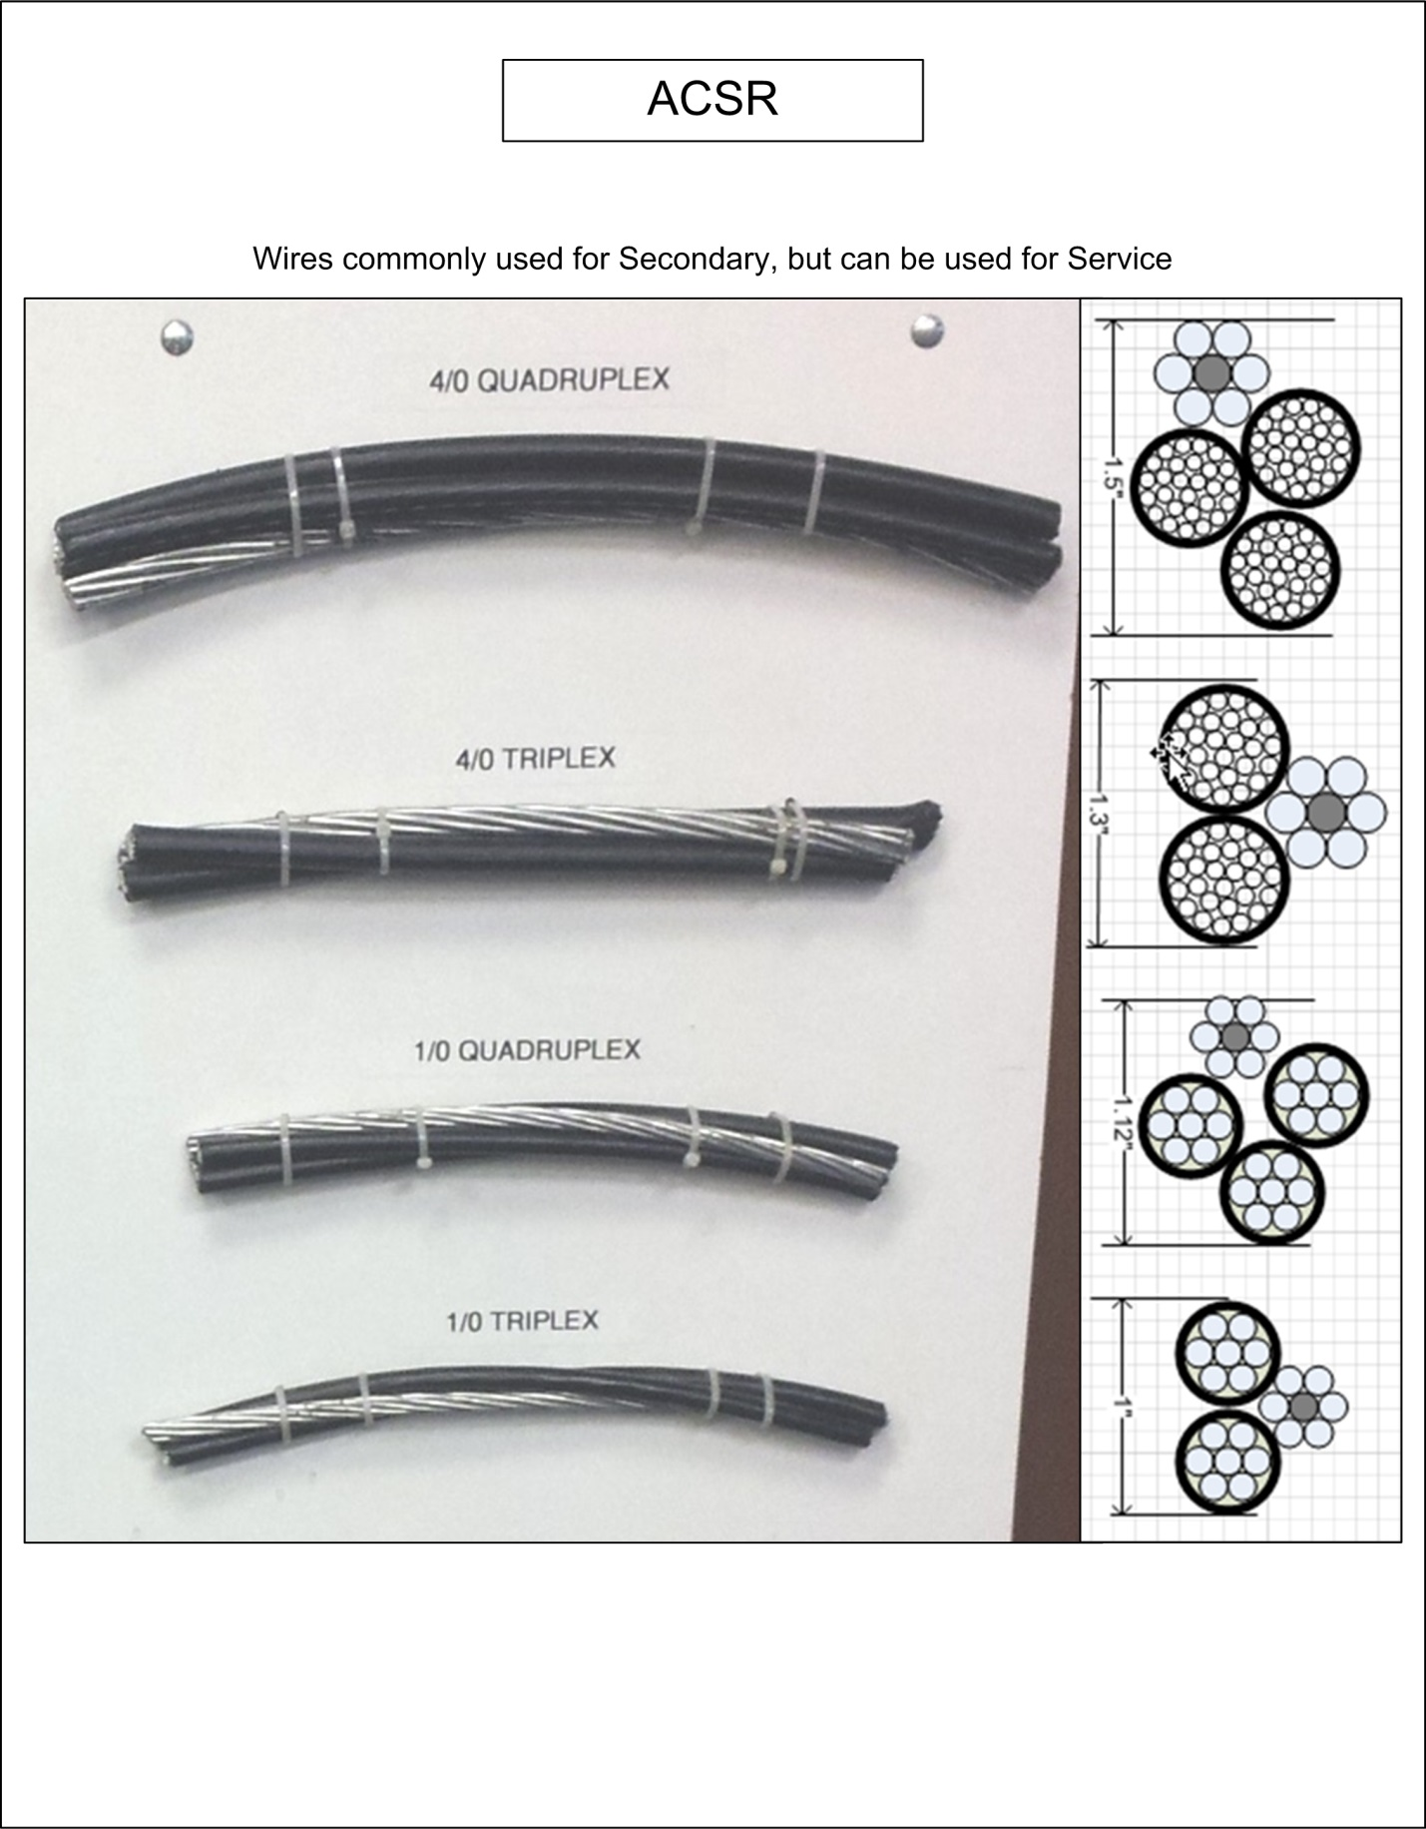
APPENDIX K: WIRE IDENTIFICATION Continued

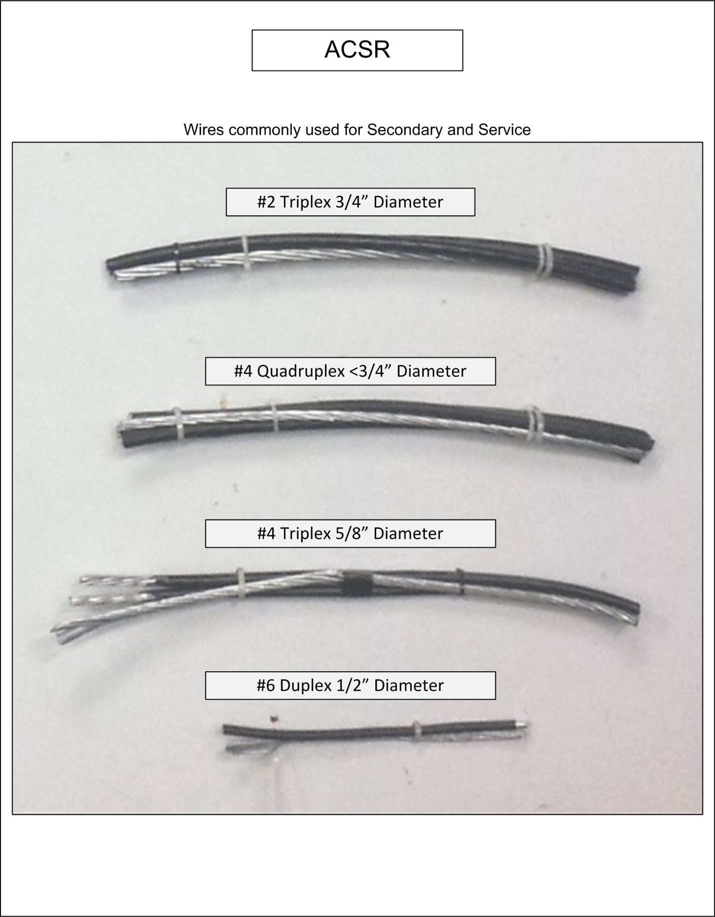

APPENDIX K: WIRE IDENTIFICATION Continued

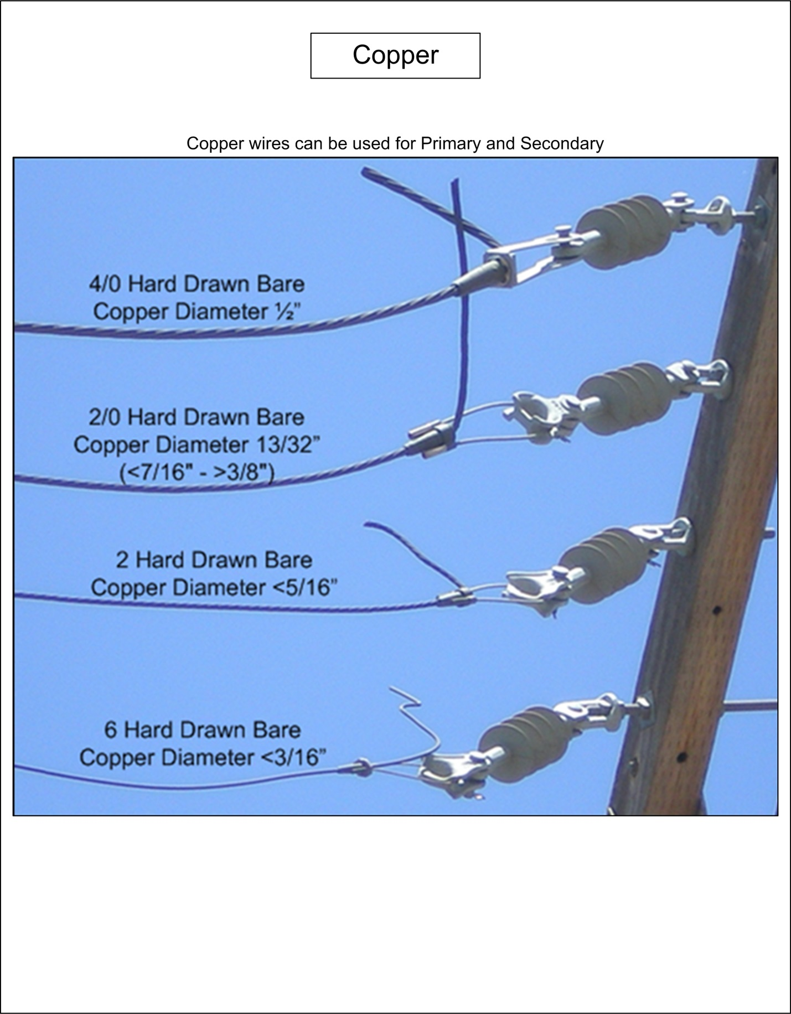

APPENDIX L: Connectors, Clamps and Preforms

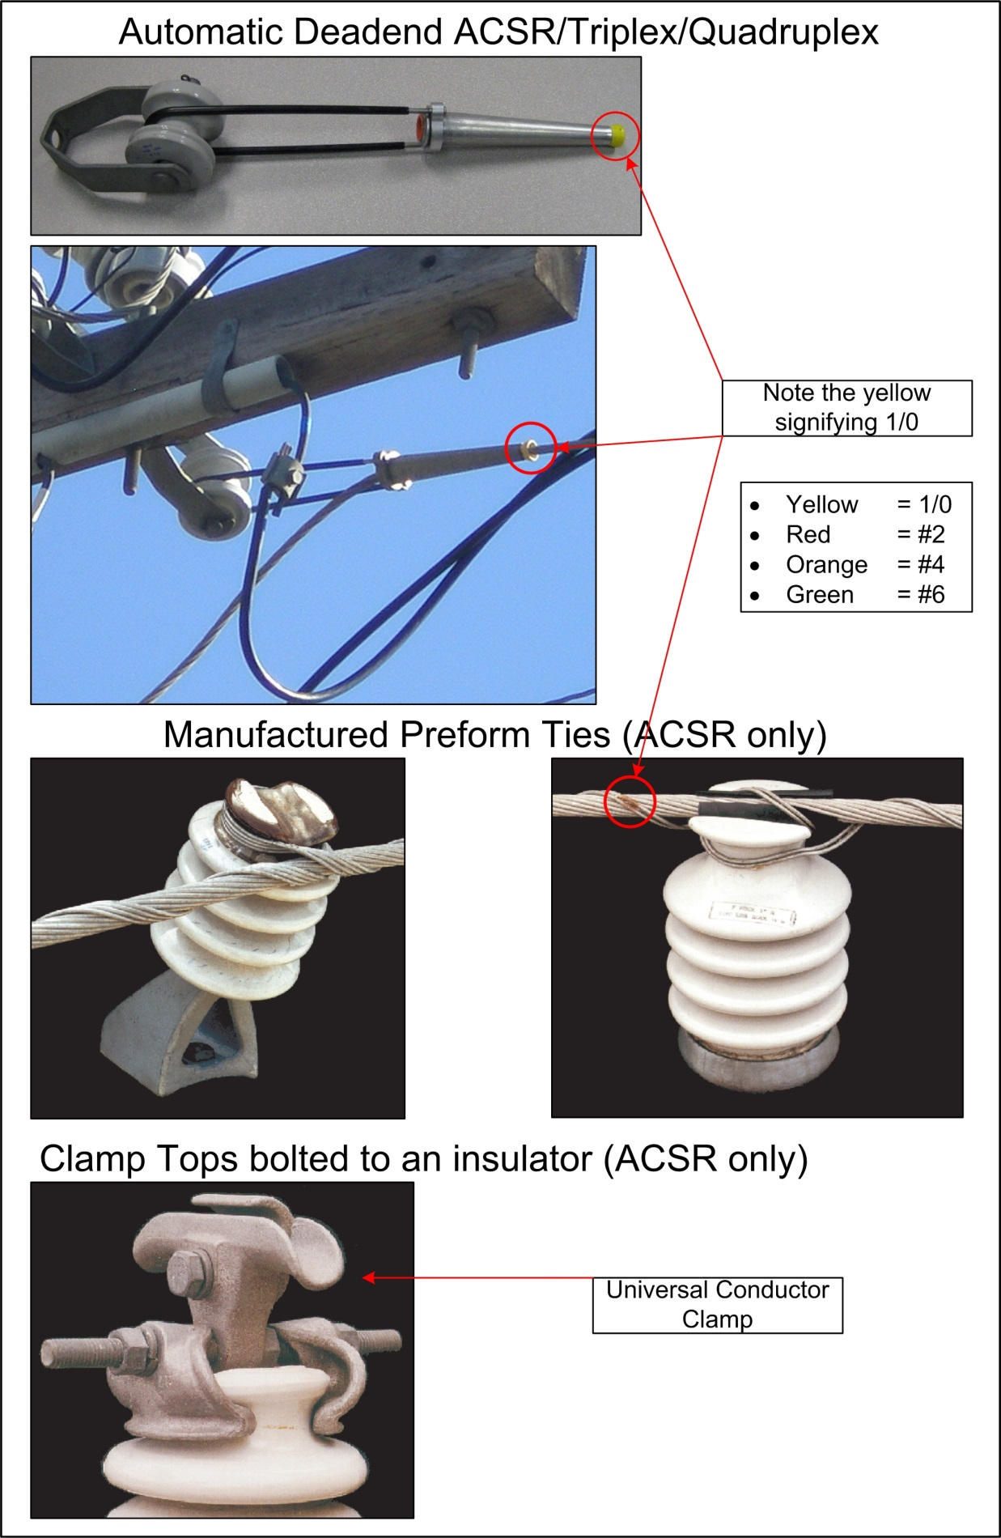

APPENDIX L: CONNECTORS, CLAMPS AND PREFORMS Continued

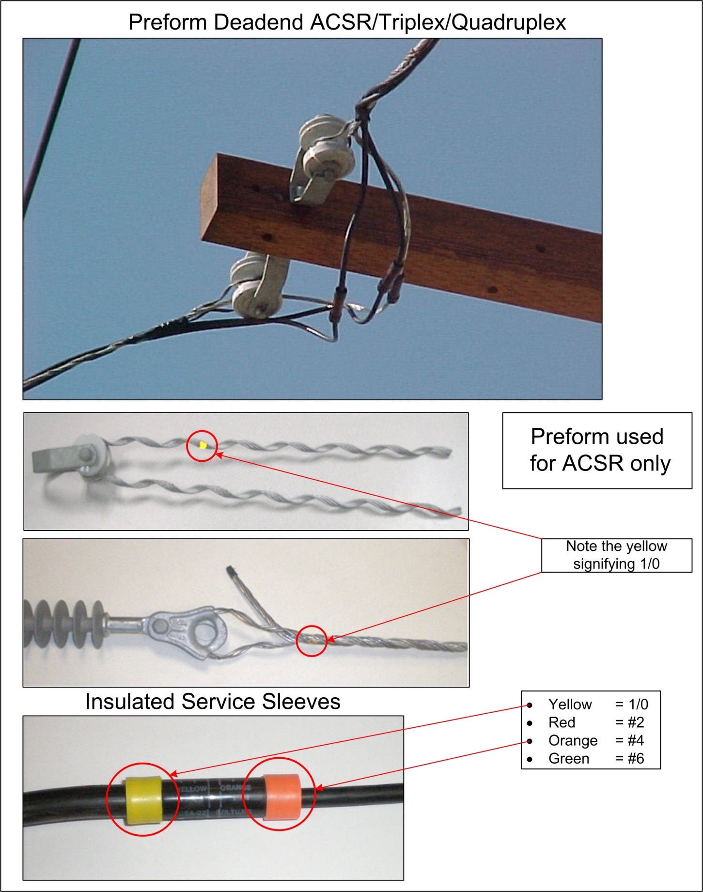

APPENDIX L: CONNECTORS, CLAMPS AND PREFORMS Continued

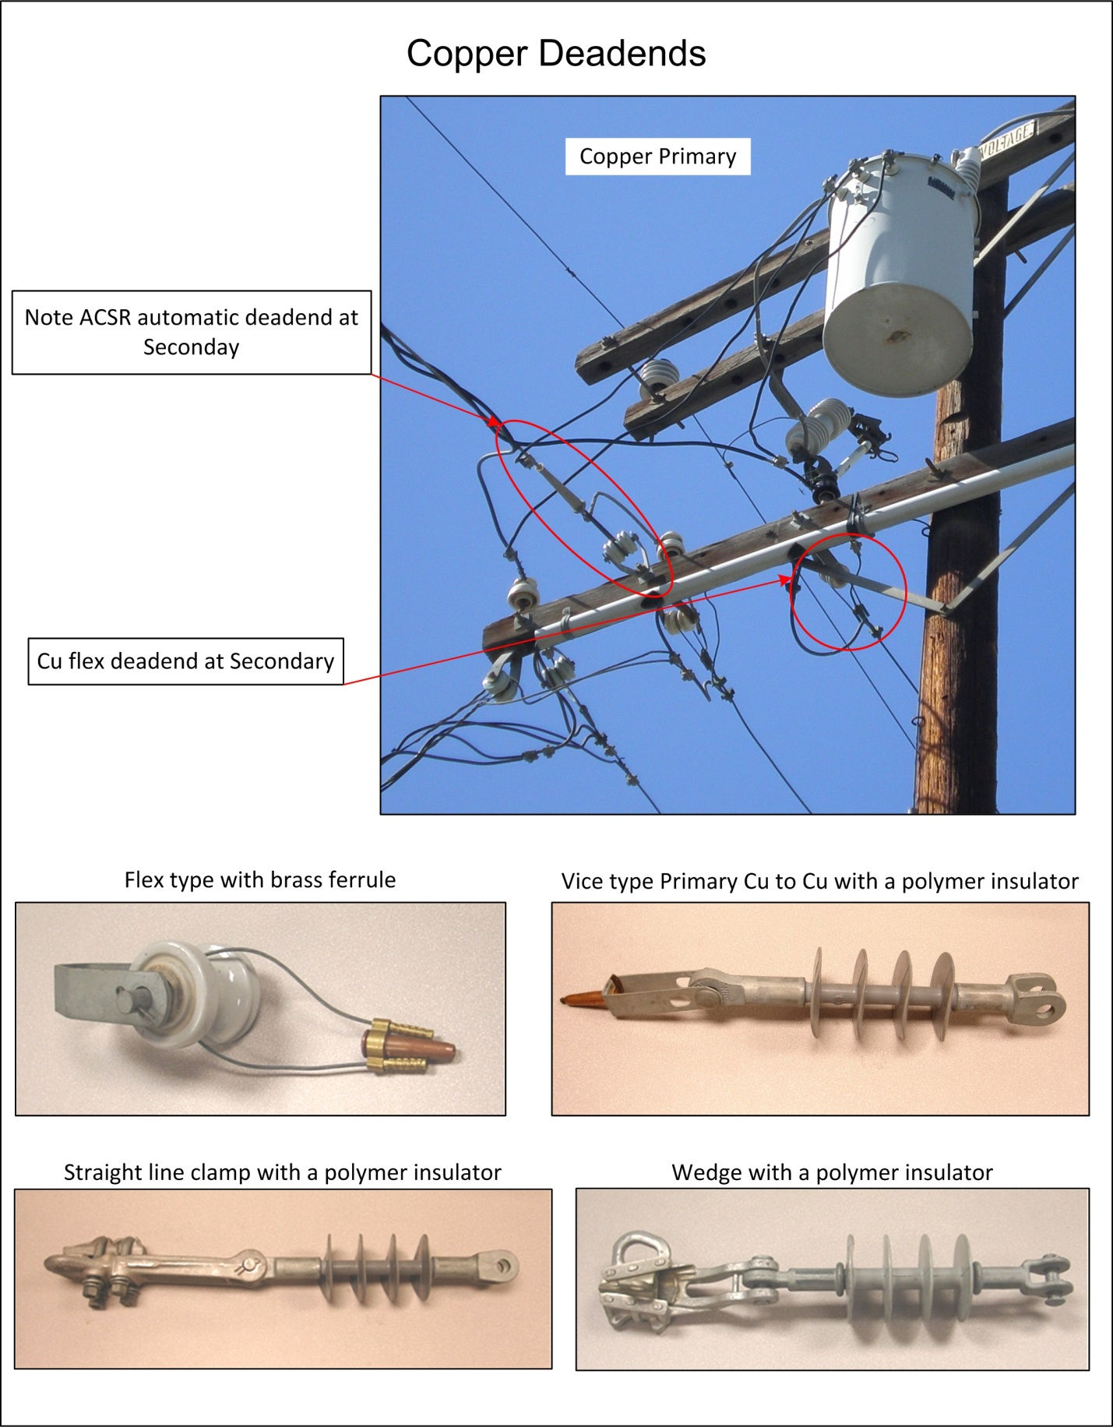

APPENDIX L: CONNECTORS, CLAMPS AND PREFORMS Continued

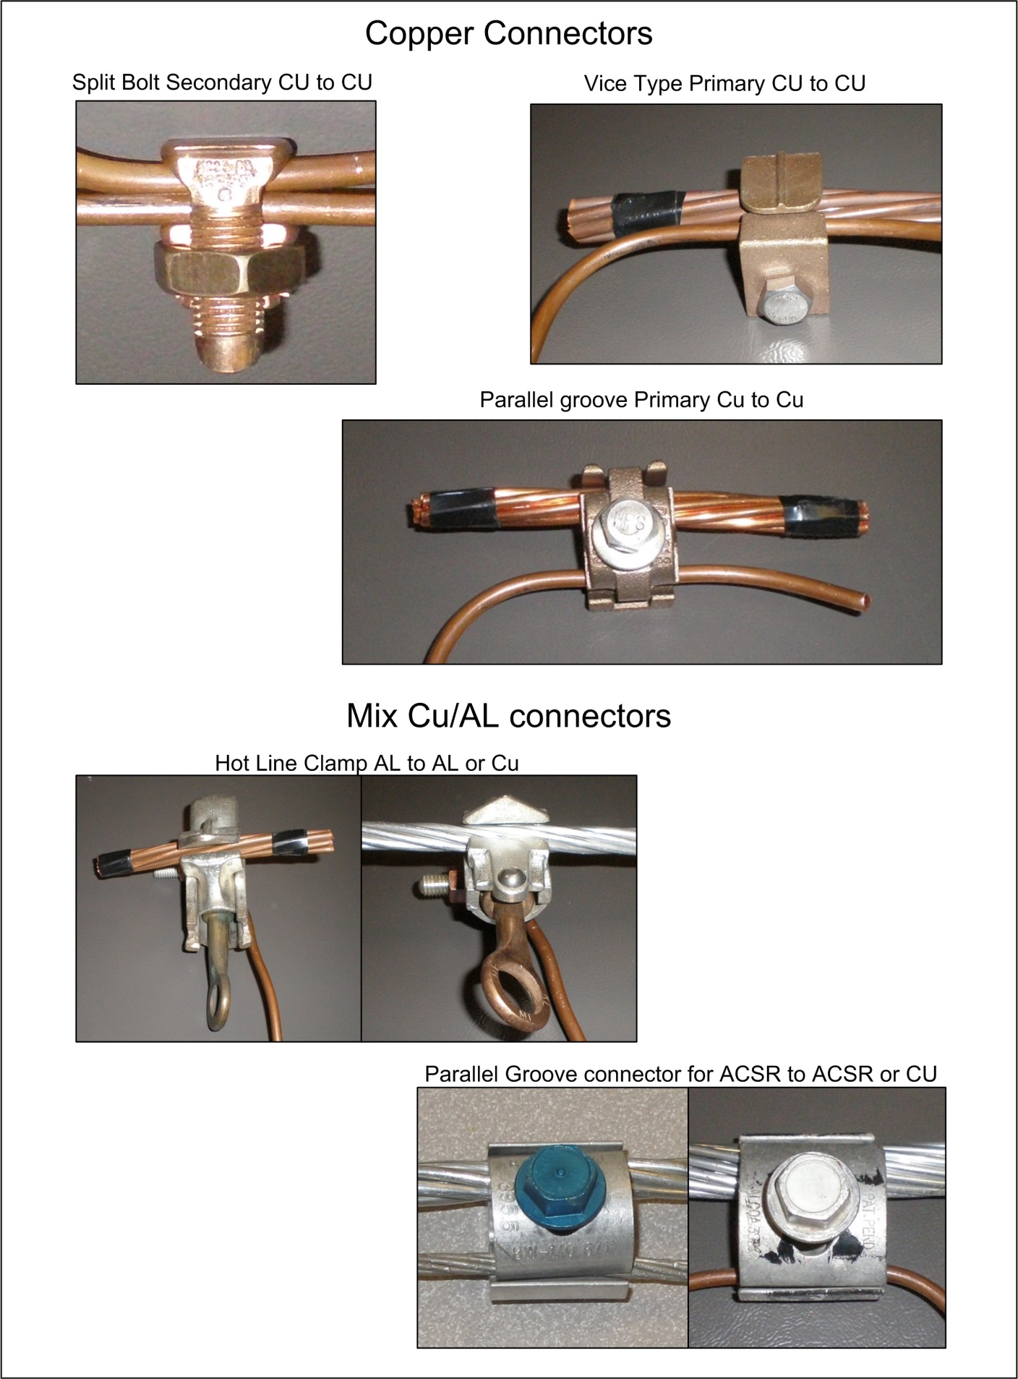

APPENDIX M: Communication Wire ID

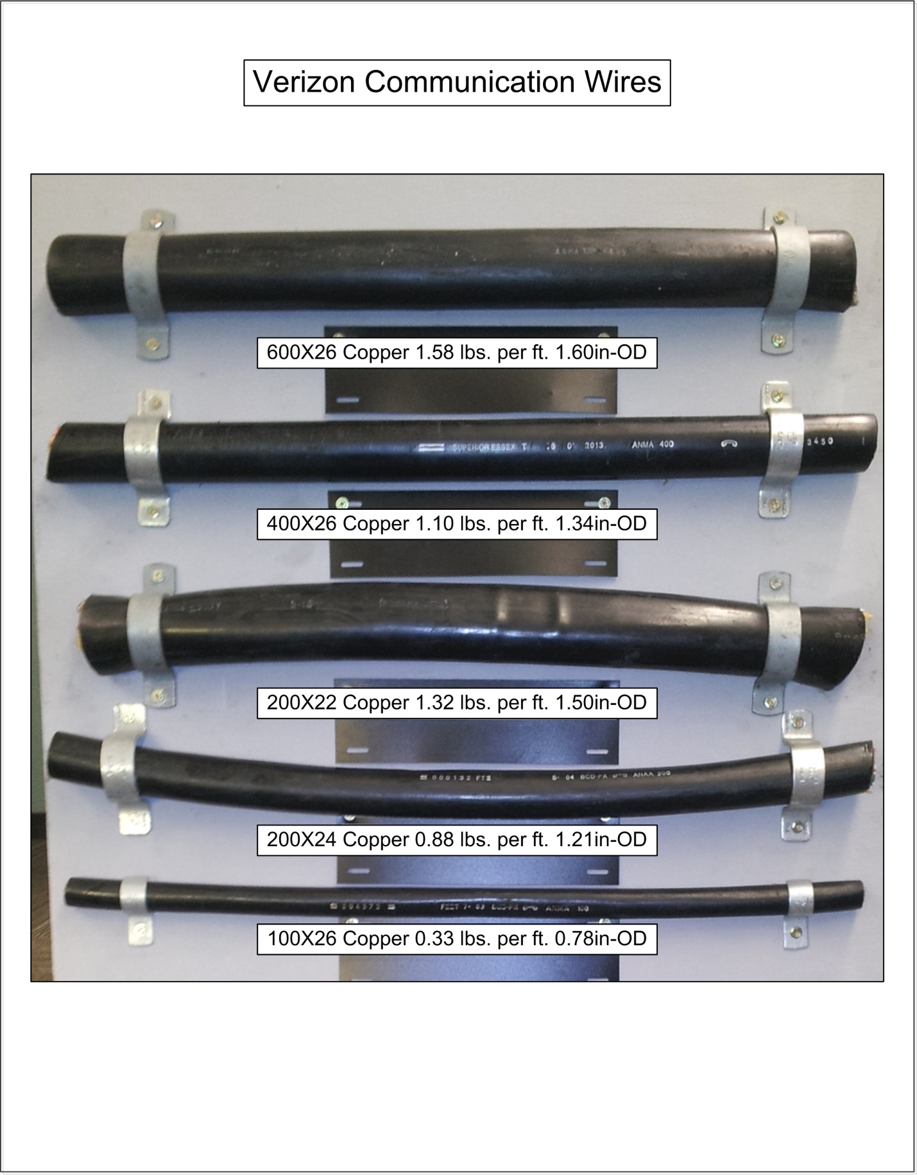

APPENDIX M: COMMUNICATION WIRE ID Continued

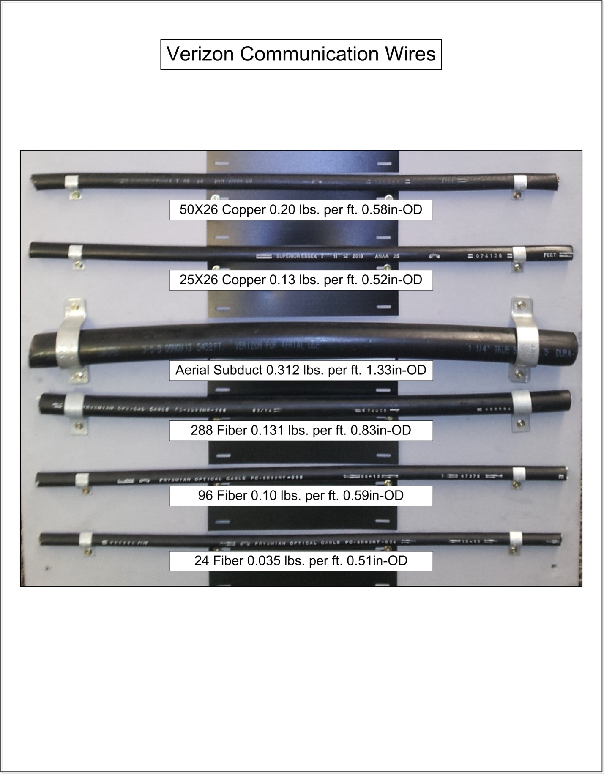

APPENDIX N: Communication Equipment ID

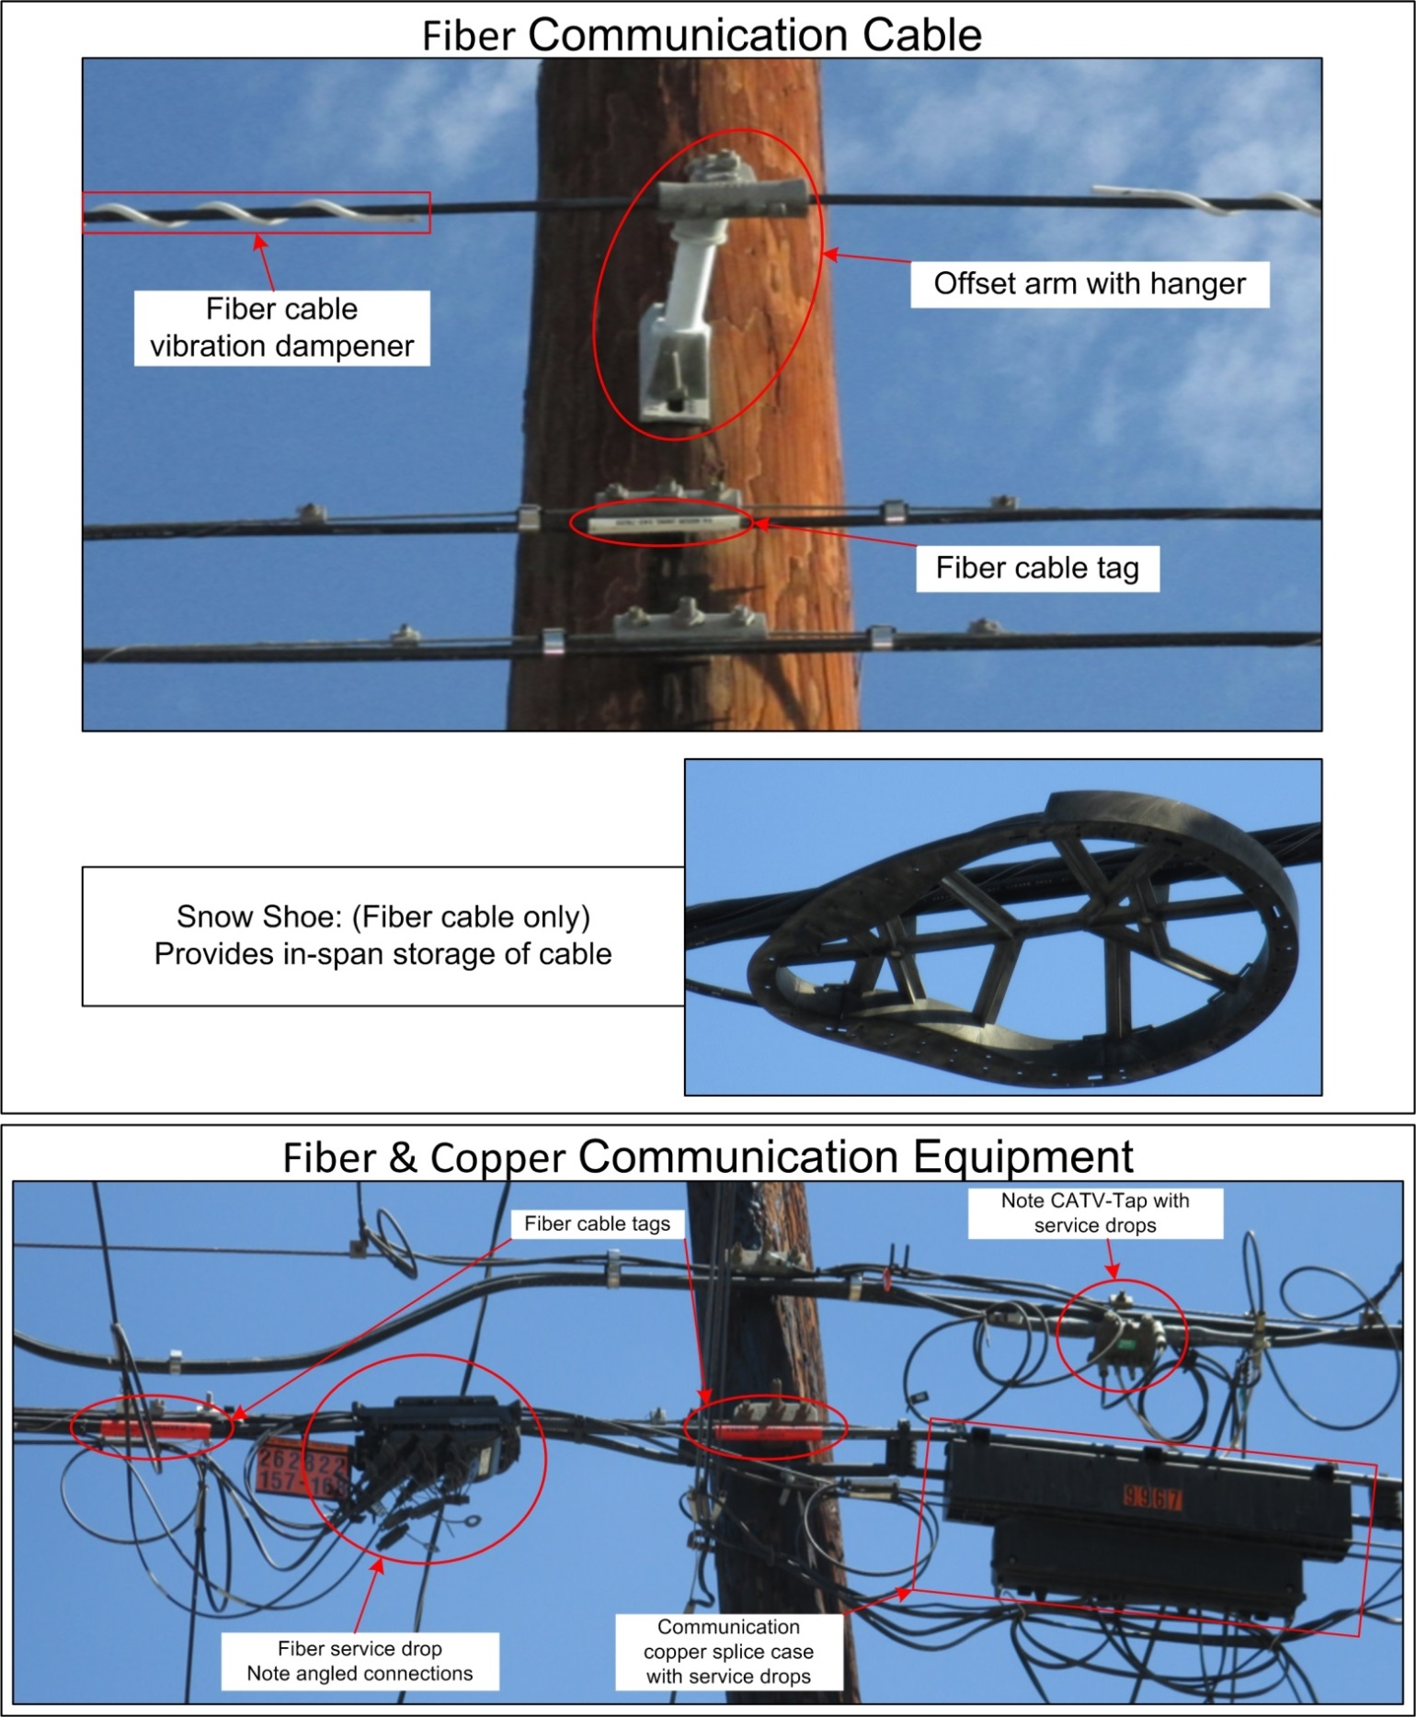

APPENDIX N: COMMUNICATION EQUIPMENT ID Continued

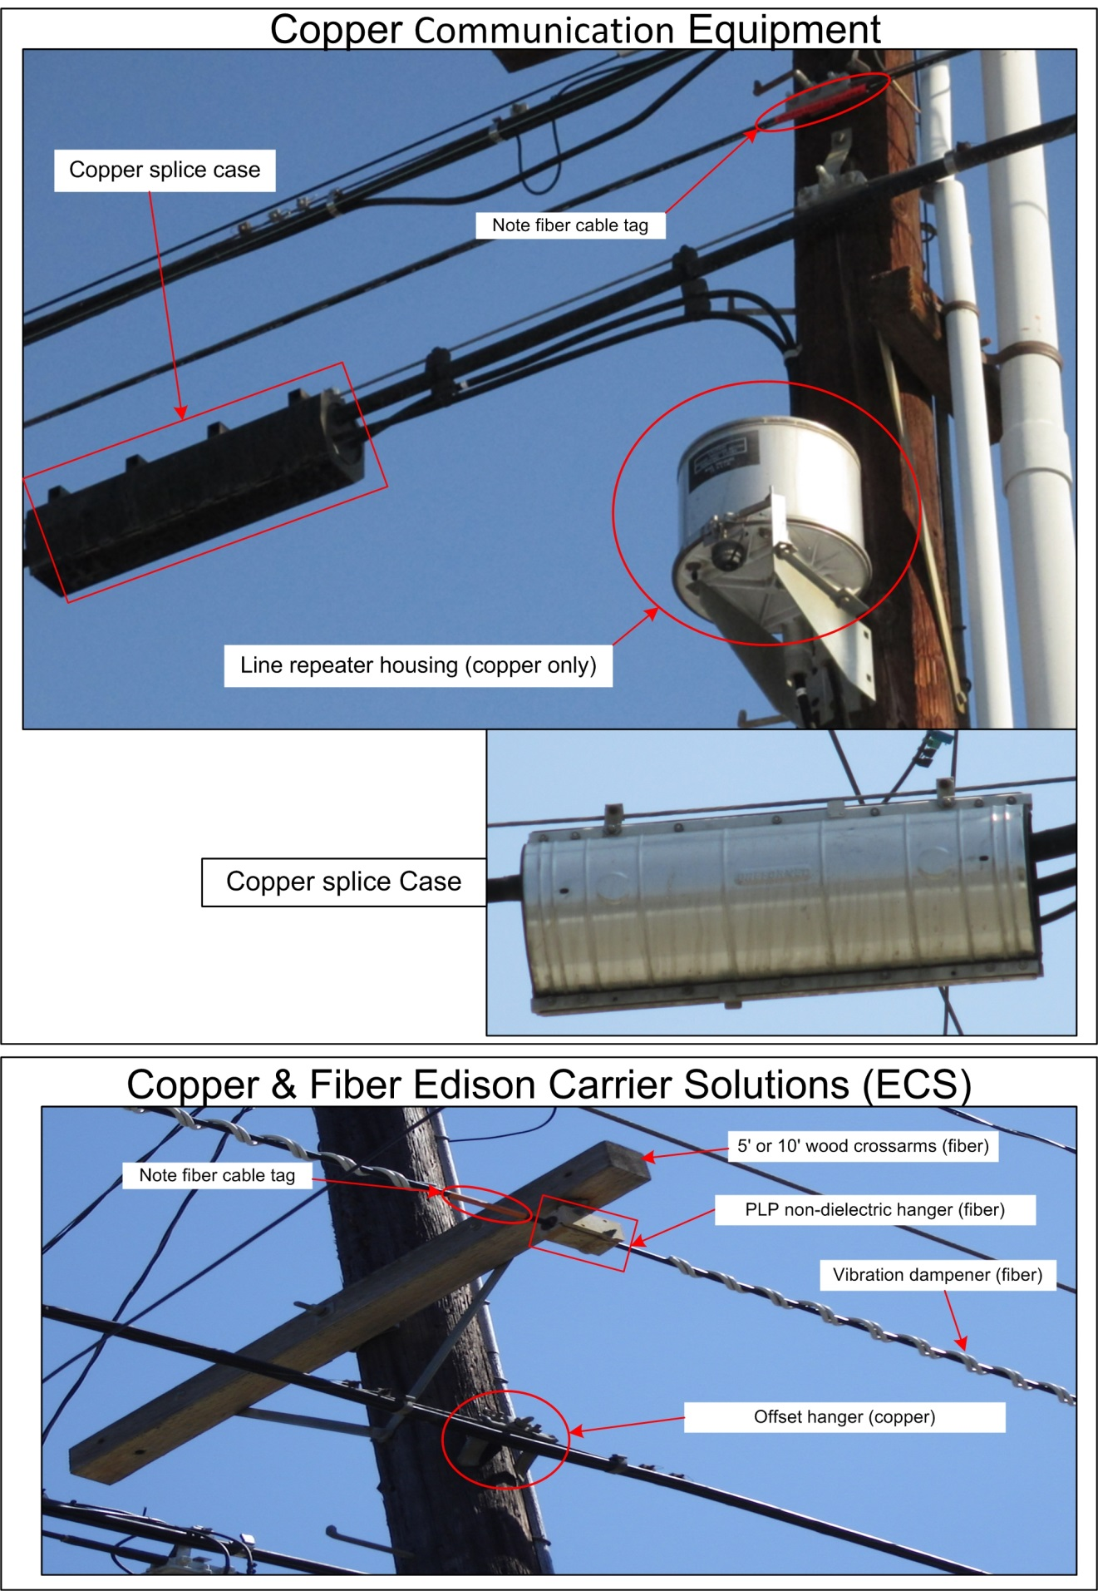

APPENDIX N: COMMUNICATION EQUIPMENT ID Continued

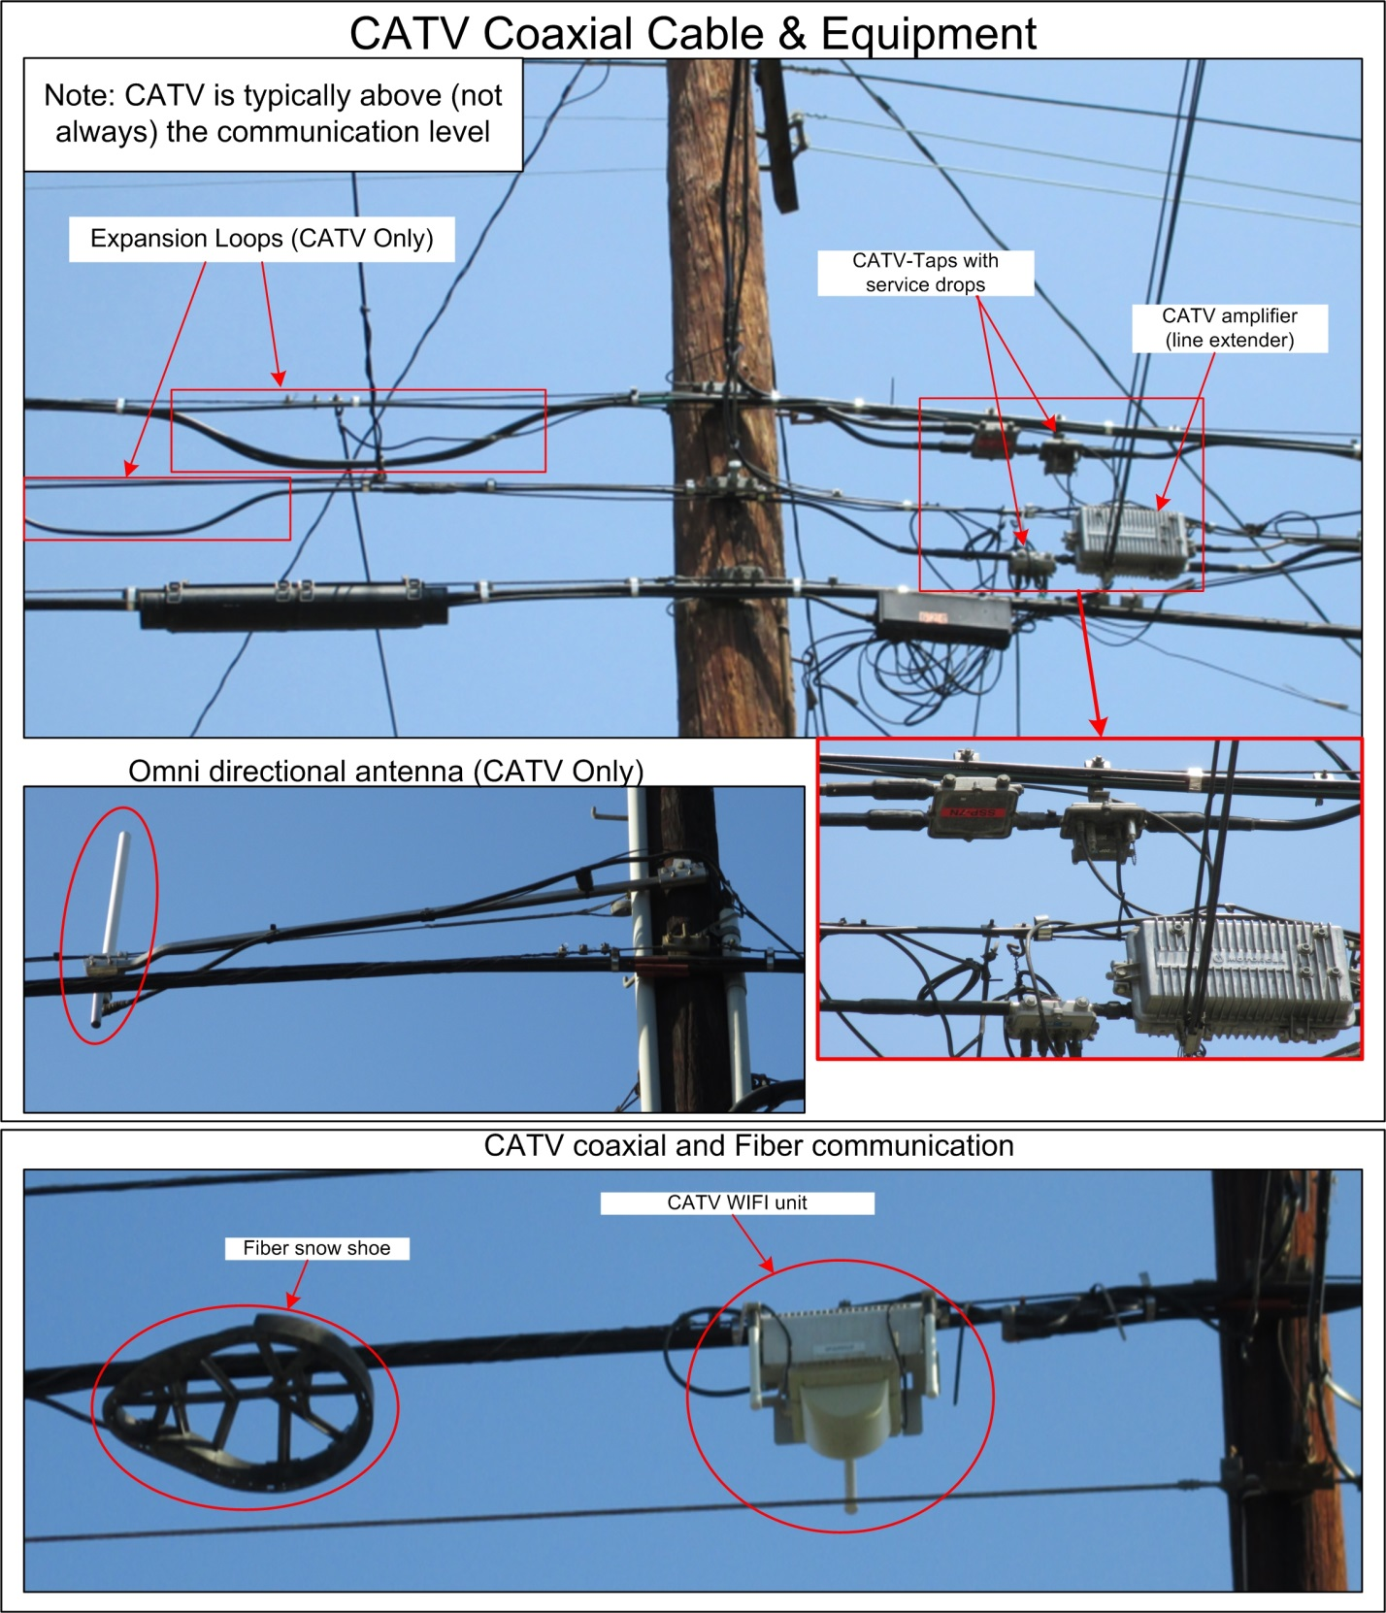

APPENDIX O: Communication Cable Markers

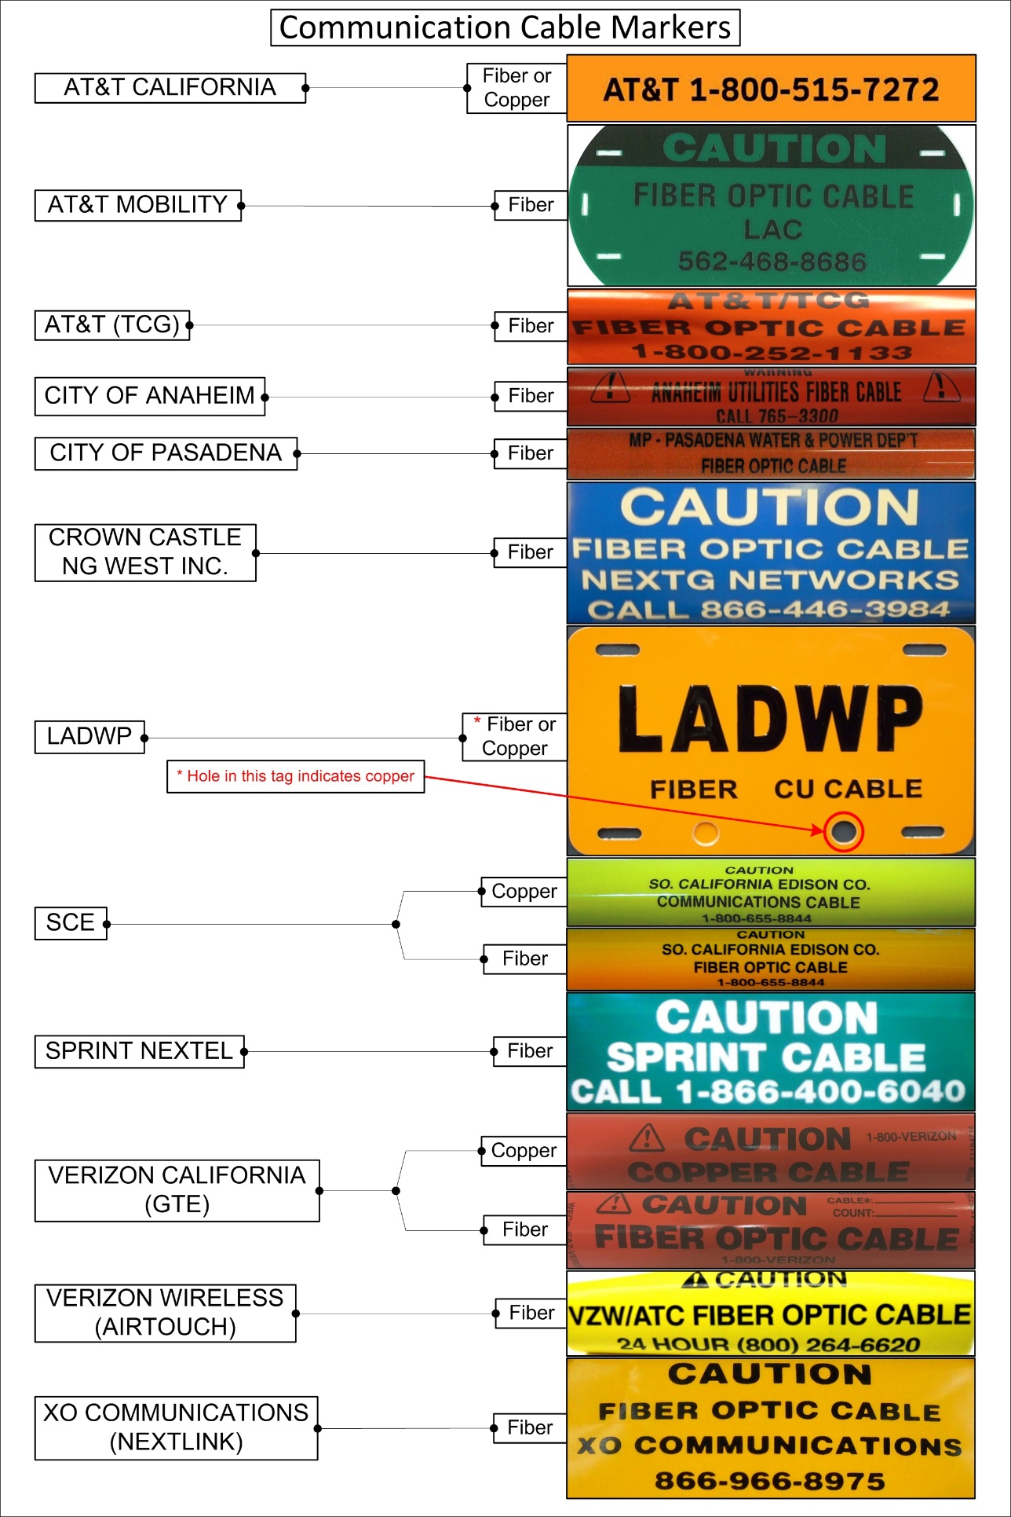

APPENDIX P: Measurement Point Attributes

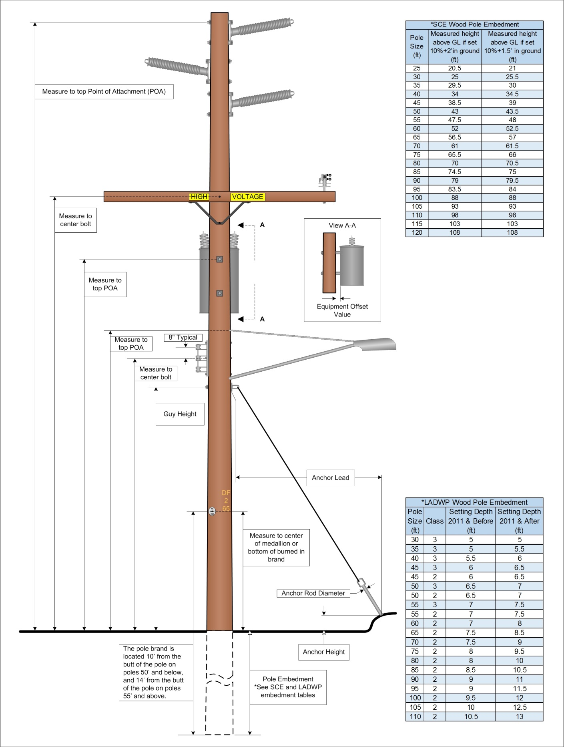

APPENDIX P: MEASUREMENT POINT ATTRIBUTES Continued

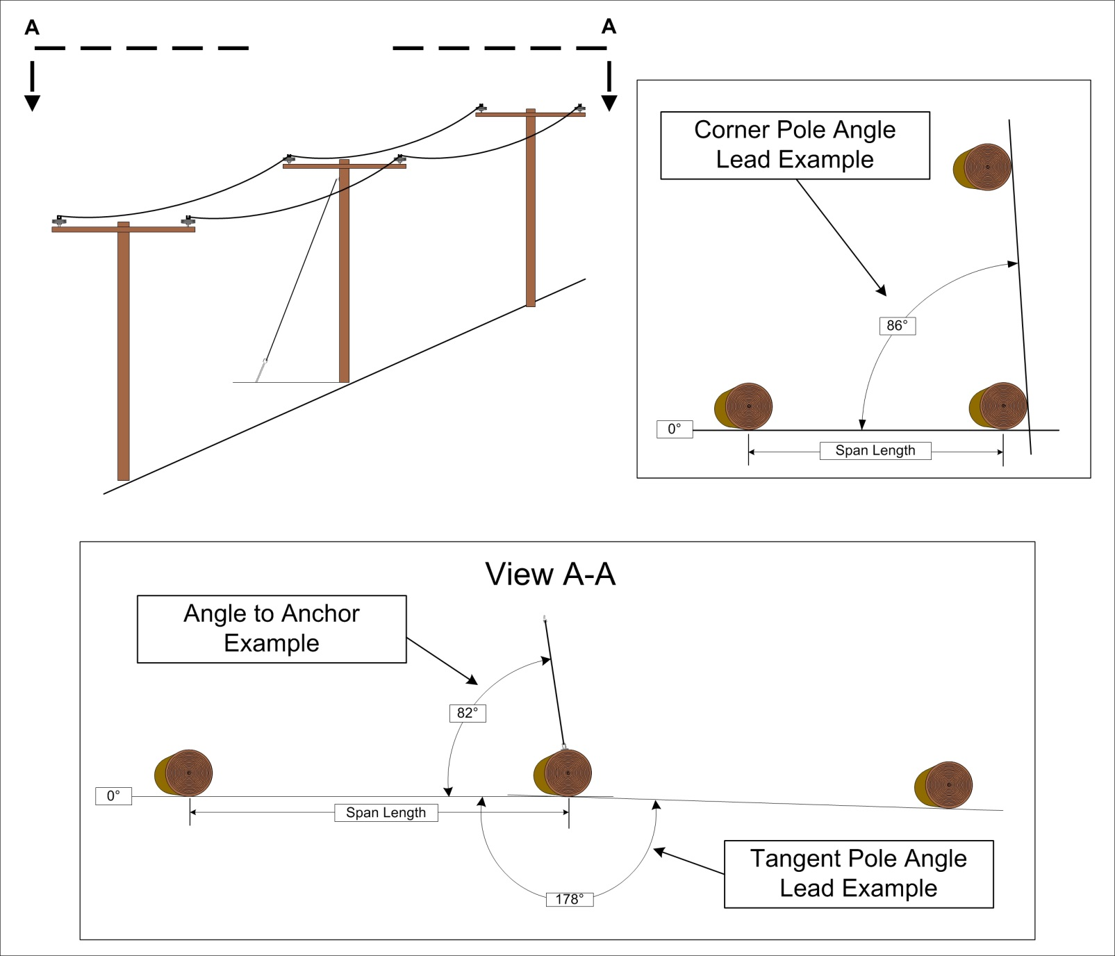

APPENDIX P: MEASUREMENT POINT ATTRIBUTES Continued

APPENDIX Q: Common Pole Attachment Dimensions

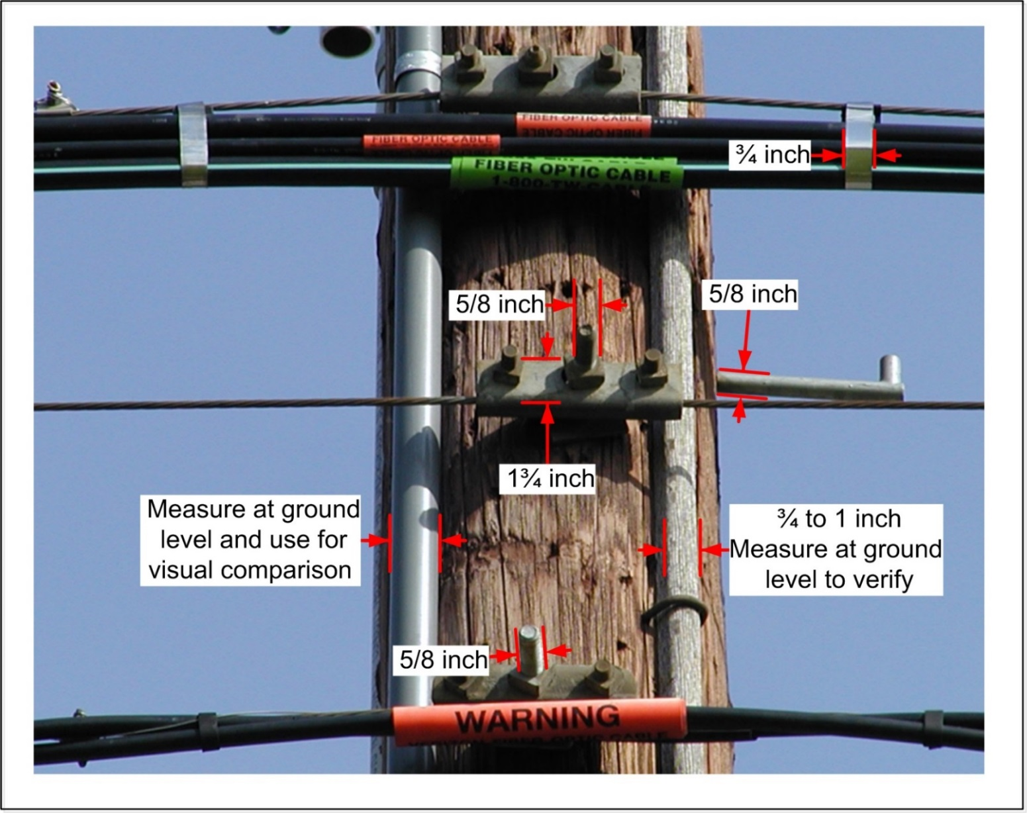

APPENDIX R: SCE Miscellaneous Equipment

APPENDIX R: SCE MISCELLANEOUS EQUIPMENT Continued

APPENDIX R: SCE MISCELLANEOUS EQUIPMENT Continued

APPENDIX S: LADWP Miscellaneous Equipment

APPENDIX S: LADWP MISCELLANEOUS EQUIPMENT Continued

APPENDIX S: LADWP MISCELLANEOUS EQUIPMENT Continued

APPENDIX S: LADWP MISCELLANEOUS EQUIPMENT Continued

APPENDIX S: LADWP MISCELLANEOUS EQUIPMENT Continued

