Final Form 2 JPA Electronic Submission Process
Effective April 6th, 2020, the SCJPC Office will only accept Final Form 2 by email.

How to Submit Final Form 2 to the SCJPC Office

If you’re planning to use the latest Form 2 Final Only Excel file from the SCJPC website, please go to page 2 for instructions.
If you’re using your own version of Final Form 2 Excel file, please go to page 6 for instructions.

Using SCJPC Final Form 2 Excel file
Download the latest Final Form 2 Excel file from the SCJPC website:
FORM2-1 Final Only excel file. After you typed your final, please delete blank pages (delete page tabs with no data),
Follow the file name format: and save as:
JPA Number_FF2.xlsx two owners on the Final.
JPA Number_FF2MULTI.xlsx three or more owners on the Final.
File name should match the JPA Number typed on the Final. Example: if JPA Number is U1234-5678 SUP1, file name should be U1234-5678 SUP1_FF2.xlsx.
If the Final was returned to you due to errors (Memo), please correct your errors and resubmit using the following file name format:
JPA Number_FF2MEMO.xlsx Memo with two owners.
JPA Number_FF2MULTIMEMO.xlsx Memo with three or more owners.

Protect your Form 2 Final sheets prior to submission:
The final must be sheet protected to prevent the changing of grade/space, and nature of work. To do so, complete the following:
- Click on the Review tab on the top ribbon, then click the Protect Sheet button.
- When prompted, ensure that the Protect worksheet checkbox is checked, and allow all users to:
- Select locked cells
- Select unlocked cells
- Format cells
- Edit objects
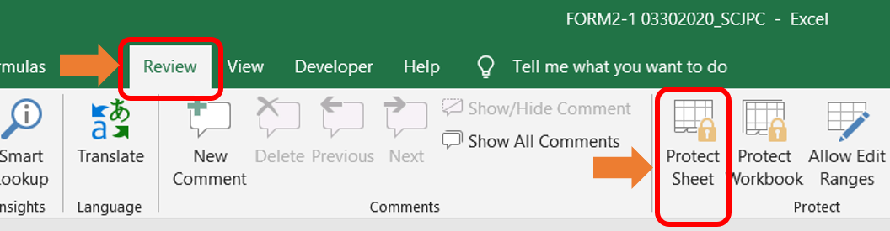
Continue to the next page.
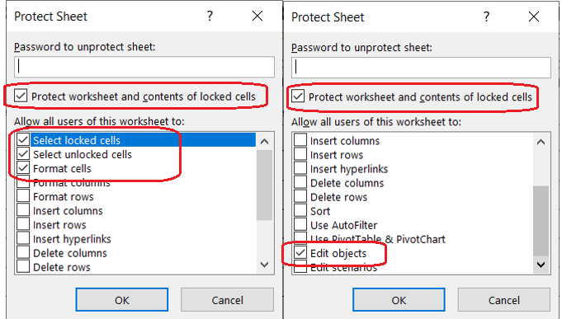
Enter your password and Click OK.
- Repeat these 2 steps for each page of the JPA.

With the sheets protected, the SCJPC will only be able to edit the highlighted fields.
Some unprotected cells will be used by the SCJPC billers for their internal notes using peach font color. Screenshots below are for reference only.
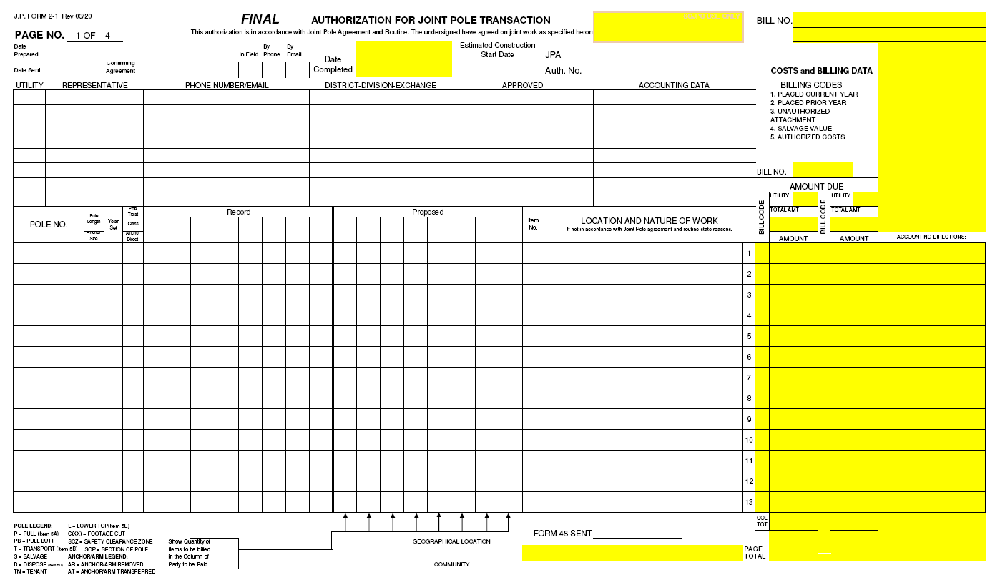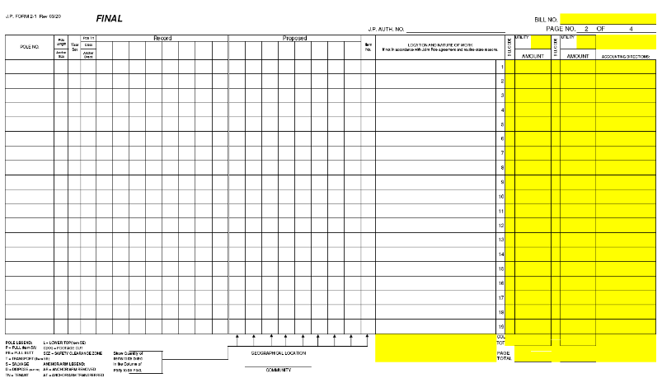

Email the Final files to the SCJPC
Submit your Final Form 2 to finaljpa@scjpc.net
Use Subject of Email: Date of submission (or today’s date) and Member Code
Example: 04/15/2020 ATC Final JPA
Please do not send any questions or other files to this email address. This inbox is only being used for Final JPA submissions. If you have any questions or comments, please email one of the SCJPC Billers. Example on the next page.
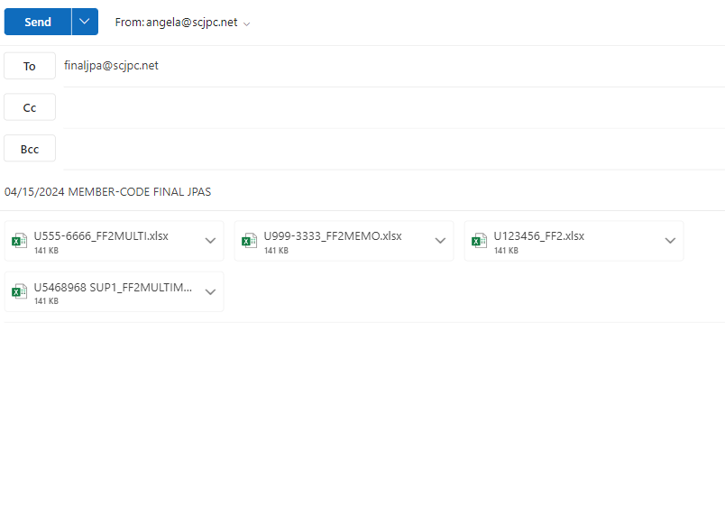

Using your own Final Form 2 Excel file
Option 1 (preferred by SCJPC): Submit your Finals in PDF format.
Set page size to legal on all pages and convert your JPA to PDF. Follow instructions on page 9 on how to email your PDF Finals.
Option 2: Submit your Finals in Excel format.
Please delete blank pages (delete page tabs with no data).
Follow the file name format – for both PDF and Excel files:
JPA Number_FF2.pdf (or .xlsx) two owners on the Final.
JPA Number_FF2MULTI.pdf (or .xlsx) three or more owners on the Final.
File name should match the JPA Number typed on the Final. Example: if JPA Number is U1234-5678 SUP1, file name should be U1234-5678 SUP1_FF2.pdf (or .xlsx)
If the Final was returned to you due to errors (Memo), please correct your errors and resubmit using the following file name format:
JPA Number_FF2MEMO.pdf (or .xlsx) Memo with two owners.
JPA Number_FF2MULTIMEMO.pdf (or .xlsx) Memo with three or more owners.
If you’re submitting Excel files: Unlock cells for SCJPC Staff: select highlighted cells below and unlock. Skip the following steps if you are submitting PDF files and go to page 10.
Page 1:
Other pages: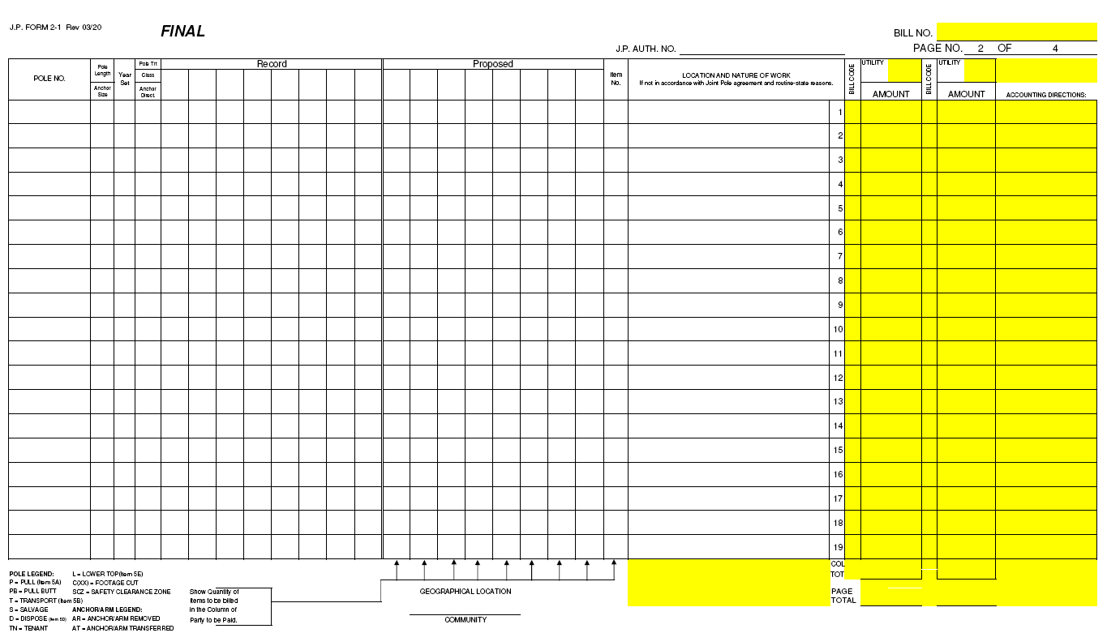
How to unlock selected cells: Right click and select Format Cells. In the Format Cells popup, in the Protection tab, uncheck the Locked box.
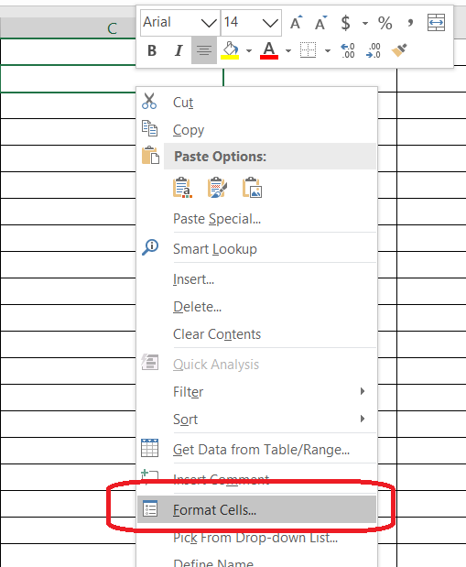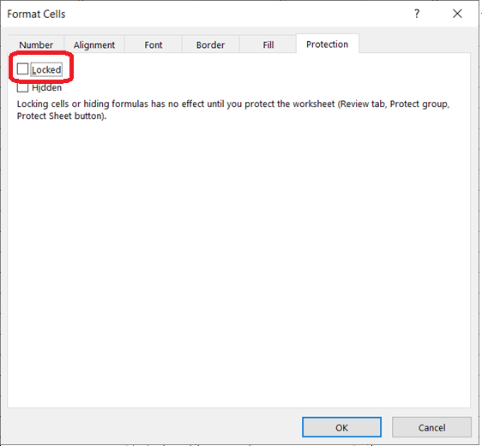

Change the font color for SCJPC Internal Notes for the following cells
Page 1: Other Pages:
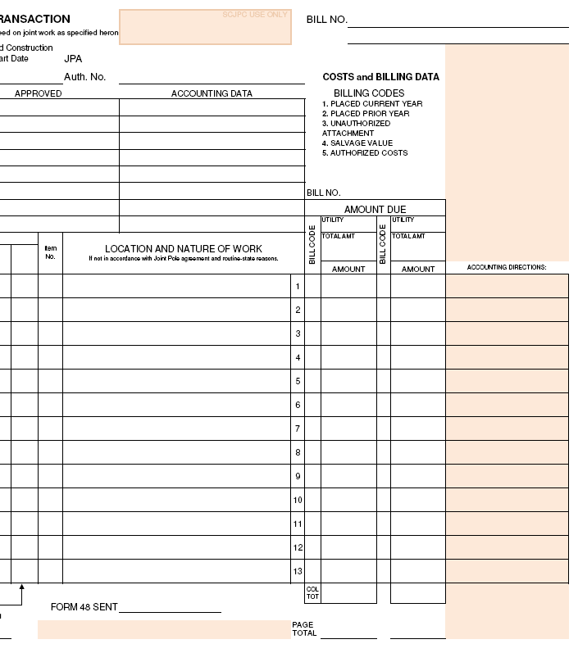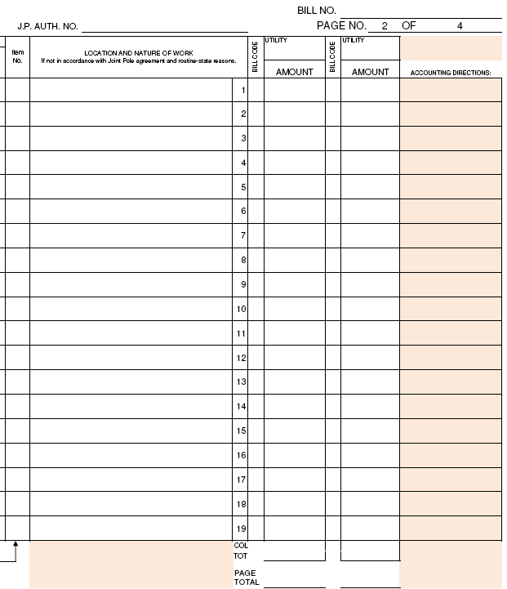
- Select the cell or range of cells. Click Home > Font Color arrow  > More Colors.
- On the Custom tab, in the Colors box, enter Red: 238 Green: 203 Blue: 173
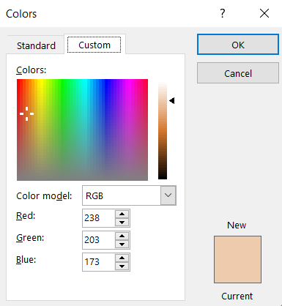
NOTE: You only need to unlock necessary cells and change font color for SCJPC staff once. If you saved your file as a template, the unlocked cells and font color settings will be saved for future usage.
Protect your Final Form 2 sheets prior to submission:
The final must be sheet protected to prevent the changing of grade/space, and nature of work. To do so complete the following:
- Click on the Review tab on the top ribbon, then click the Protect Sheet button.
- When prompted, ensure that the Protect worksheet checkbox is checked, and allow all users to:
- Select locked cells
- Select unlocked cells
- Format cells
- Edit objects
Continue to the next page.
Click OK.
- Repeat these 2 steps for each page of the JPA.
With the sheets protected, the SCJPC will only be able to edit the unlocked cells.
Some unprotected cells will be used by the SCJPC billers for their internal notes using the peach font color (Red: 238 Green: 203 Blue: 173).
Continue to the next page.

Email the Final files to the SCJPC
Submit your Final Form 2 to finaljpa@scjpc.net
Use Subject of Email: Date of submission (or today’s date) and Member Code
Example: 04/15/2020 ATC Final JPA
Please do not send any questions or other files to this email address. This inbox is only being used for Final JPA submissions. If you have any questions or comments, please email one of the SCJPC Billers.
Example:

