Final Form 2 JPA Electronic Submission Process
Using SCJPC Form 2 Preliminary to Final Excel Macro-enabled workbook

Effective April 6th, 2020, the SCJPC Office will only accept Final Form 2 by email.

Download the latest Preliminary to Final Form 2 Excel file from the SCJPC website:
FORM2-1 Preliminary to Final-withmacro
Enable macros when the Message Bar appears
When you open a file that has macros, a yellow message bar appears with a shield icon and the Enable Content button. Use the following instructions:
- On the Message Bar, click Enable Content.
The file opens and is a trusted document.
The following image is an example of the Message Bar when macros are in the file.

When you’re ready to convert your Preliminary JPA to Final JPA, follow steps from page 2 to 5.

Convert your Preliminary to Final using Macro:
Please verify that macro is enabled (see page 1) and you have Developer tab on the ribbon. If you don’t see Developer tab on the ribbon, go to page 5 and come back to this page.
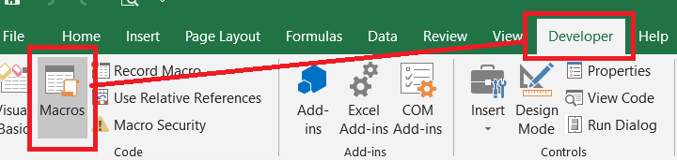
Developer tab > Macros. Run the CovertToFinalandProtect Macro. It may take up to 10 seconds to complete the macro (for older computers, it may take up to 30 seconds to complete).
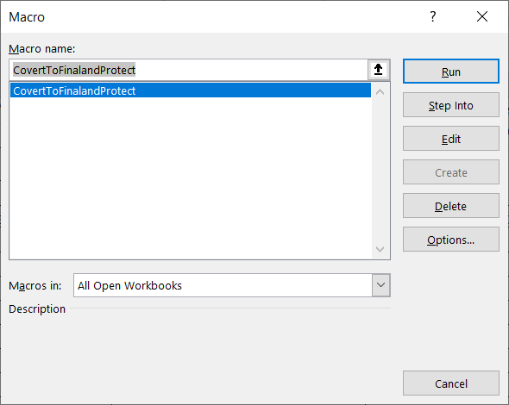

If you received an error message when trying to run the macro, see next page.

If you received an error message when trying to run the macro:
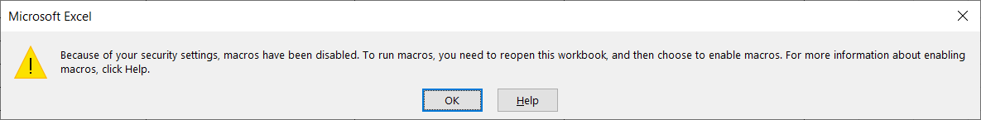
- Close the file
- Open the file again: When you open a file that has macros, the yellow message bar appears with a shield icon and the Enable Content button. Use the following instructions:
  - On the Message Bar, click Enable Content.
The file opens and is a trusted document.
The following image is an example of the Message Bar when macros are in the file.
- Try to run the macro again.
Save the file using the following file name format for Final:
JPA Number_FF2.xlsx two owners on the Final.
JPA Number_FF2MULTI.xlsx three or more owners on the Final.
File name should match the JPA Number typed on the Final. Example: if JPA Number is U1234-5678 SUP1, file name should be U1234-5678 SUP1_FF2.xlsx.
If the Final was returned to you due to errors (Memo), please correct your errors and resubmit using the following file name format:
JPA Number_FF2MEMO.xlsx Memo with two owners.
JPA Number_FF2MULTIMEMO.xlsx Memo with three or more owners.

Email the Final files to the SCJPC
Submit your Final Form 2 to finaljpa@scjpc.net
Use Subject of Email: Date of submission (or today’s date) and Member Code
Example: 04/15/2020 ATC Final JPAs
Please do not send any questions or other files to this email address. This inbox is only being used for Final JPA submissions. If you have any questions or comments, please email one of the SCJPC Billers.
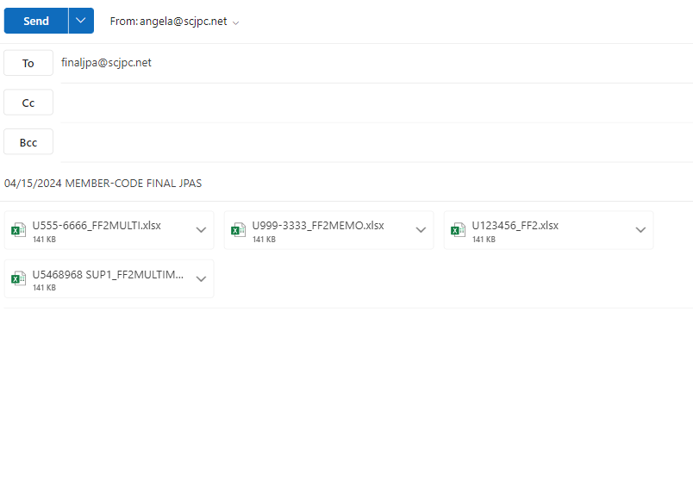

To enable the Developer tab.
- For Windows, go to File > Options > Customize Ribbon.
- For Mac, go to Excel > Preferences... > Ribbon & Toolbar.
- Then, in the Customize the Ribbon section, under Main Tabs, check the Developer check box, and press OK.

